**Silent Night**

**(Franz Xaver Gruber & Joseph Mohr, 1818;   
English lyrics by John Freeman Young, 1859)**

**C G G7 C**

Silent night, holy night! All is calm, all is bright,



C

**F C**

Round yon Virgin, Mother and Child,

**F C**

Holy infant so tender and mild,

**G G7 C Am C G7 C**



G

Sleep in heavenly pe - ace, sleep in heavenly peace.

**C G G7 C**

Silent night, holy night! Shepherds quake at the sight,

**F C**

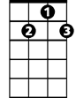

G7

Glories stream from heaven afar,

**F C**

Heavenly hosts sing Alleluia,

**G G7 C - Am C G7 C**

F



Christ the Savior is bo-rn! Christ the Savior is born!

**C G G7 C**

Silent night, holy night! Son of God, love's pure light,

**F C**

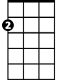

Am

Radiant beams from Thy holy face,

**F C**

With the dawn of redeeming grace,

**G G7 C - Am C G7 C**

Jesus Lord, at Thy bir - th, Jesus Lord, at Thy birth.

**BARITONE**

C



G



F

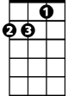

Am

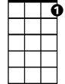

G7

**Silent Night**

C17 F

**(Franz Xaver Gruber & Joseph Mohr, 1818;   
English lyrics by John Freeman Young, 1859)**

**F C C7 F**

Silent night, holy night! All is calm, all is bright,

F



**Bb F**

Round yon Virgin, Mother and Child,

**Bb F**

Holy infant so tender and mild,



C

**C C7 F Dm F C7 F**

Sleep in heavenly pe - ace, sleep in heavenly peace.

**F C C7 F**

Silent night, holy night! Shepherds quake at the sight,



C7

**Bb F**

Glories stream from heaven afar,

**Bb F**

Heavenly hosts sing Alleluia,

**C C7 F - Dm F C7 F**



Bb

Christ the Savior is bo-rn! Christ the Savior is born!

**F C C7 F**

Silent night, holy night! Son of God, love's pure light,

**Bb F**



Dm

Radiant beams from Thy holy face,

**Bb F**

With the dawn of redeeming grace,

**C C7 F - Dm F C7 F**

Jesus Lord, at Thy bir - th, Jesus Lord, at Thy birth.

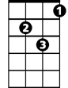

Dm

**BARITONE**

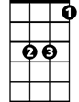

Bb

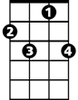

C7

C



F

**Silent Night**

C17 G

**(Franz Xaver Gruber & Joseph Mohr, 1818;   
English lyrics by John Freeman Young, 1859)**

**G D D7 G**



G

Silent night, holy night! All is calm, all is bright,

**C G**

Round yon Virgin, Mother and Child,

**C G**

Holy infant so tender and mild,

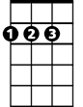

D

**D D7 G Em G D7 G**

Sleep in heavenly pe - ace, sleep in heavenly peace.

**G D D7 G**

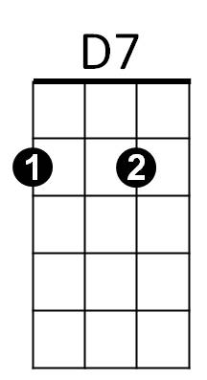Silent night, holy night! Shepherds quake at the sight,

**C G**

Glories stream from heaven afar,

**C G**

Heavenly hosts sing Alleluia,



C

**D D7 G - Em G D7 G**

Christ the Savior is bo-rn! Christ the Savior is born!

**G D D7 G**

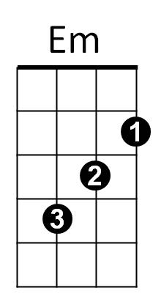Silent night, holy night! Son of God, love's pure light,

**C G**

Radiant beams from Thy holy face,

**C G**

With the dawn of redeeming grace,

**D D7 G - Em G D7 G**

Jesus Lord, at Thy bir - th, Jesus Lord, at Thy birth.



Em

C



D7



D



G

**BARITONE**