Silly Love Songs (Paul McCartney, 1976) (C)
125 bps
Intro C Em7 FΔ7 (3x)  C Em7 FΔ7  _You'd think that people would have had enough of silly love ___ songs.  C Em7 FΔ7  _I look around me and I see it isn't so.  C Em7 FΔ7  _Some people want to fill the world with silly love songs.  Chorus 1 Em7 FΔ7 G  And what's wrong with that? I'd like to know. 'Cause here I go again  Chorus 2 C Em7 FΔ7 C Em7 FΔ7 C Em7 FΔ7 C Em7 FΔ7  I love you, I love you, I love you, I love you.  C Em7 FΔ7  _I can't ex-plain, the feeling's plain to me. Can't you see?  C Em7 FΔ7  _Ah, she gave me more, she gave it all to me now can't you see? Chorus 1  Chorus 3 C Em7 FΔ7 C Em7 FΔ7  I love you, I love you.  Bridge  Em FΔ7  __Love doesn't come in a minute. ___Sometimes it doesn't come at all  Em7  ___I only know that when I'm in it.  FΔ7  ___It isn't silly, love isn't silly, love isn't silly at all.  Instrumental 1 C Em7 FΔ7 (4x)  C Em7 FΔ7  _How___can I tell ___ you about my loved one? (4x) Instrumental 1 Chorus 2  C Em7 FΔ7 C Em7 FΔ7  _How___can I tell ___ you about my loved one? (4x) (Instrumental)  Outro: C Em7 FΔ7  _You'd think that people would have had enough of silly love ___ songs. |  |  |  |  |  |  |  |  | 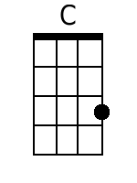
 |  |  |  |  |  |  |  |  | 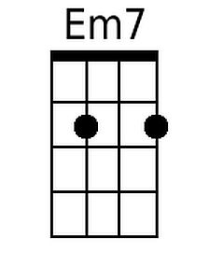
 |  |  |  |  |  |  |  |  | 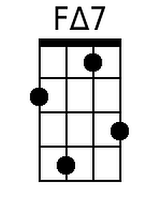
 |  |  |  |  |  |  |  |  | 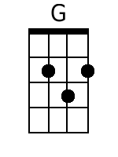
 |  |  |  |  |  |  |  |  | 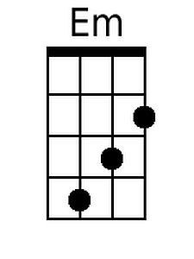
 |  |  |  |  |  |  |  |  | 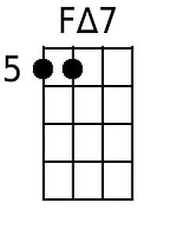
 |  |  | Bari | 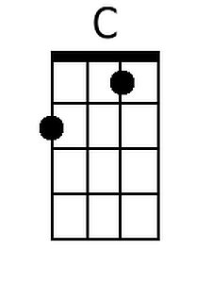 | 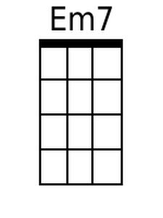 | 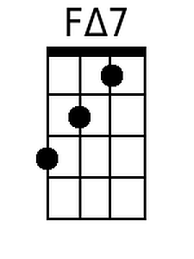 | 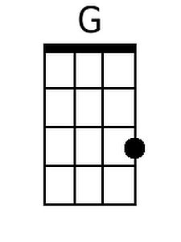 | 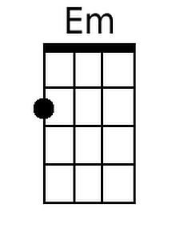

Silly Love Songs (Paul McCartney, 1976) (G)
125 bps
Intro G Bm7 CΔ7 (3x)

G Bm7 CΔ7
_You'd think that people would have had enough of silly love ___ songs.
G Bm7 CΔ7
_I look around me and I see it isn't so.
G Bm7 CΔ7
_Some people want to fill the world with silly love songs.

Chorus 1 Bm7 CΔ7 D
And what's wrong with that? I'd like to know. 'Cause here I go again

Chorus 2 G Bm7 CΔ7 G Bm7 CΔ7 G Bm7 CΔ7 G Bm7 CΔ7
I love you, I love you, I love you, I love you.

G Bm7 CΔ7
_I can't ex-plain, the feeling's plain to me. Can't you see?
G Bm7 CΔ7
_Ah, she gave me more, she gave it all to me now can't you see? Chorus 1

Chorus 3 G Bm7 CΔ7 G Bm7 CΔ7
I love you, I love you.

Bridge
Bm CΔ7
__Love doesn't come in a minute. ___Sometimes it doesn't come at all
Bm7
___I only know that when I'm in it.
CΔ7
___It isn't silly, love isn't silly, love isn't silly at all.

Instrumental 1 G Bm7 CΔ7 (4x)

G Bm7 CΔ7
_How___can I tell ___ you about my loved one? (4x). Instrumental 1 Chorus 2

G Bm7 CΔ7 G Bm7 CΔ7
_How___can I tell ___ you about my loved one? (4x). (Instrumental)

Outro G Bm7 CΔ7
_You'd think that people would have had enough of silly love ___ songs.

 |  |  |  |  |  |  |  |  | 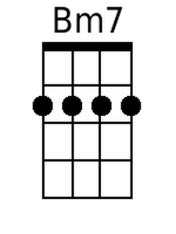
 |  |  |  |  |  |  |  |  | 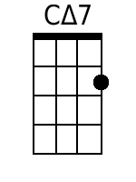
 |  |  |  |  |  |  |  |  | 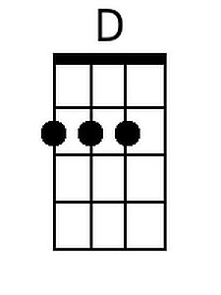
 |  |  |  |  |  |  |  |  | 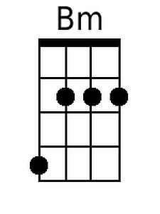
 |  | Bari |  | 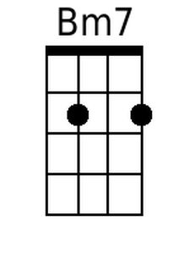 | 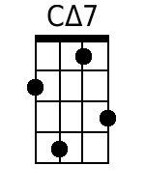 | 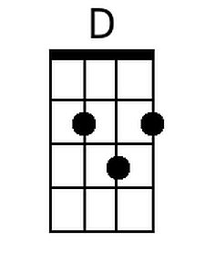 | 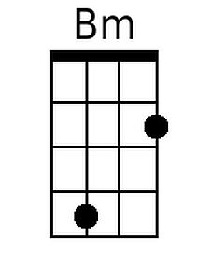 | 