
Silver Bells
C18 C
Jay Livingston and Ray Evans, 1950 – ¾ Time

Intro Chords for last line of Chorus  Chorus  C (A, E) (A, G)* F (A, E) (E, C)*  Silver bells (Silver bells), silver bells (silver bells),  G G7 C G7  It’s Christmas time in the city.  C (A, E) (A, G) F (A, E) (E, C)  Ring-a-ling (ring-a-ling), hear them ring (hear them ring),  G G7 C G7  Soon it will be Christmas day.  C C7 F  City sidewalks, busy sidewalks dressed in holiday style,  G G7 C G7  In the air there's a feeling of Christmas.  C C7 F  Children laughing, people passing, meeting smile after smile,  G G7 C G7  And on every street corner you hear. Chorus  C C7 F  Strings of street lights, even stop lights blink a bright red and green,  G G7 C G7  As the shoppers rush home with their treasures.  C C7 F  Hear the snow crunch, see the kids bunch, this is Santa's big scene,  G G7 C G7  And a-bove all this bustle you hear  C (A, E) (A, G)  Silver bells (the corner Santa Claus)  F (A, E) (E, C)  Silver bells (is busy just because),  G G7 C G7  It’s Christmas time in the city.  C (A, E) (A, G)  Ring-a-ling (it fills the winter air),  F (A, E) (E, C)  Hear them ring (you hear it everywhere),  G G7 C G G7 C  Soon it will be Christmas day … soon it will be Christmas day. | 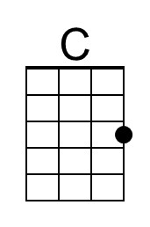 | 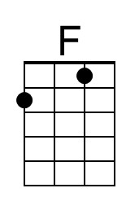
 | 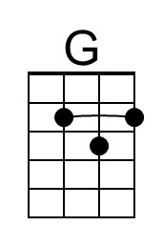 | 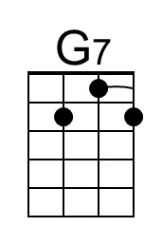
 | 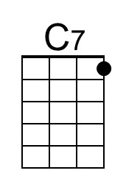
 | Baritone
 | 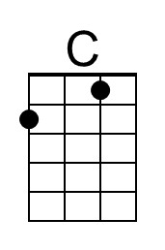 | 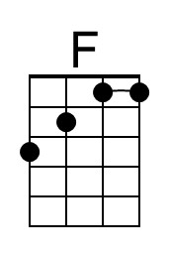
 | 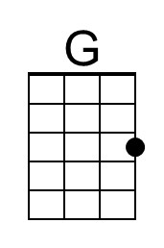 | 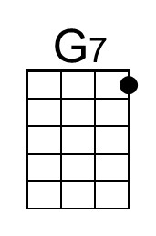
 | 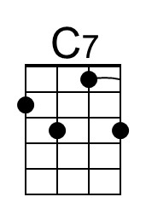

Optional for C-Tuned Ukes (GCEA): During “echos” (in italics), after a C chord simultaneously pluck the A & E and then the A & G strings; after an F Chord, pluck the A & E and then the E & C.

Optional Turnaround after 2nd and 4th lines of verses: F C Dm
Silver Bells
C18 G
Jay Livingston and Ray Evans, 1950 – ¾ Time

Intro Chords for last line of Chorus

Chorus
G (A, E) (E, C) C (A, E) (A, G)
Silver bells (Silver bells), silver bells (silver bells),
D D7 G D7
It’s Christmas time in the city.
G (A, E) (E, C) C (A, E) (A, G)
Ring-a-ling (ring-a-ling), hear them ring (hear them ring),
D D7 G D7
Soon it will be Christmas day.

G G7 C
City sidewalks, busy sidewalks dressed in holiday style,
D D7 G D7
In the air there's a feeling of Christmas.
G G7 C
Children laughing, people passing, meeting smile after smile,
D D7 G D7
And on every street corner you hear. Chorus

G G7 C
Strings of street lights, even stop lights blink a bright red and green,
D D7 G D7
As the shoppers rush home with their treasures.
G G7 C
Hear the snow crunch, see the kids bunch, this is Santa's big scene,
D D7 G D7
And a-bove all this bustle you hear

G (A, E) (E, C)
Silver bells (the corner Santa Claus)
C (A, E) (A, G)
Silver bells (is busy just because),
D D7 G D7
It’s Christmas time in the city.
G (A, E) (E, C)
Ring-a-ling (it fills the winter air),
C (A, E) (A, G)
Hear them ring (you hear it everywhere),
D D7 G D D7 G
Soon it will be Christmas day … soon it will be Christmas day.
 | 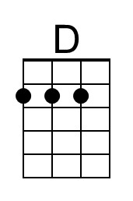 | 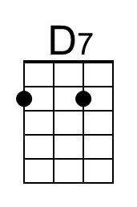
 | Baritone
 | 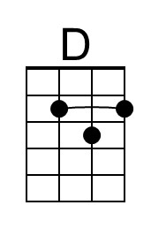 | 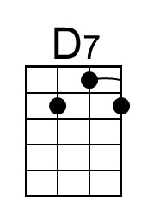

Optional for C-Tuned Ukes (GCEA): During “echos” (in italics), after a G chord simultaneously pluck the A & E and then the E & C strings; after an C Chord, pluck the A & E and then A & G.

Optional Turnaround after 2nd and 4th lines of verses: C G Am

