**Silver Threads And Golden Needles**

**(J. Rhodes/D. Reynolds)**

**G C**



G

I don't want your lonely mansion with a tear in every room

**G D D7**

All I want's the love you promised, beneath the silvery moon-oon.

**G C**

Do you think I could be happy with your money and your name

**G D G**



C

And drown myself in sorrow while you play your cheating game

**Chorus:**

**C G**

Silver threads and golden needles cannot mend this heart of mine

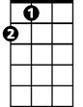

A

**A D**

And I dare not drown my sorrows in the warm glow of your wine

**G C**

You can't buy my love with money, ‘cause I never was that kind

**G D G**

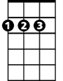

D

Silver threads and golden needles cannot mend this heart of mine.

**(Verse Chords)**

**(Chorus)**

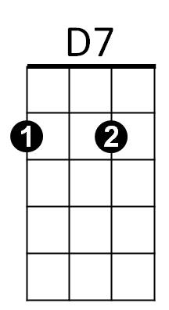



Bb

F



**Ending:**

**C G**

Silver threads and golden needles

**Bb C G F G F G**

Cannot me - nd this heart of mine-ine - ine - ine.

**BARITONE**

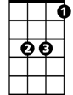

Bb

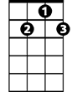

D7



F



D



G

C



A