Silver Threads And Golden Needles (C)
(J. Rhodes & D. Reynolds)

Intro: C F C G G7  C F  I don't want your lonely mansion with a tear in every room  C G G7  All I want's the love you promised, beneath the silvery moon-oon.  C F  Do you think I could be happy with your money and your name  C G C  And drown myself in sorrow while you play your cheating game  Chorus:  F C  Silver threads and golden needles cannot mend this heart of mine  D G  And I dare not drown my sorrows in the warm glow of your wine  C F  You can't buy my love with money, 'cause I never was that kind  C G C  Silver threads and golden needles cannot mend this heart of mine.  (Verse Chords)  (Chorus)  Outro:  F C  Silver threads and golden needles  Eb F C Bb C Bb C  Cannot me - nd this heart of mine - ine - ine – ine.  Bari |  |  |  |  |  | 
 |  |  |  |  |  | 
 |  |  |  |  |  | 
 |  |  |  |  |  | 
 |  |  |  |  |  | 
 |  |  |  |  | 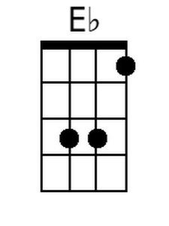
 |  |  |  |  | 
 | 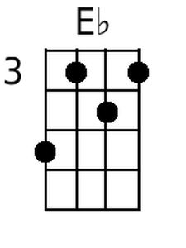 | 

