**Since I Fell For You (Buddy Johnson)**

**Intro:**

**Cmaj7 F Cmaj7 F**

When you just give love, and never get love,

**Cmaj7 Am Dm G7**

You'd better let love depart----

**F Fm Em A7**

I know it's so, and yet I know

**D7 G G7**

I can't get you out of my heart---

**Cmaj7 Am F**

You.......... .

**G7 Cmaj7 Am F**

Made me leave my happy home-.

**G7 F Fm**

You took my love, and now you're gone,......

**Am G Cmaj7 Am F G**

Since I fell....for you .........

-

**Cmaj7 Am F**

Love............ ...

**G7 Cmaj7 Am F**.

Brings such misery and pain.........

**G7**  **F Fm**

I guess I'll never be the same,....

**Am G Cmaj7 F C C7**

Since I fell....for you .........

**F Fm**

Well it's too bad, and it's too sad,

**Cmaj7 F C C7**

**BARITONE**

But I'm still in love with you

**F Fm**

First you love me, then you snub me.

**Cmaj7 Am**

But what can I do

**F G**

'Cause I'm still in love with you.

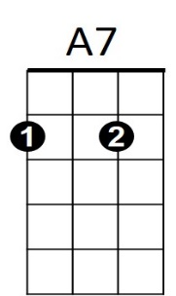

**Cmaj7 Am F**

Well I.....................

**G Cmaj7 Am F**

Guess I'll never see the light......

**G7 F Fm**

I get the blues most ev-ery night,.....

**Am G Cmaj7 Am F**

Since I fell....for you .........

**G C F Cmaj7**

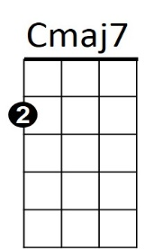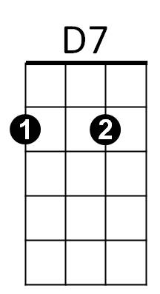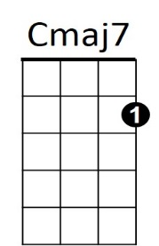Since I fell.....for you ...



G

C

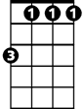

Fm

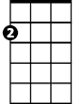

Em

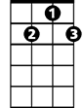

D7

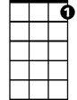

G7

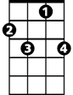

C7

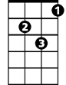

Dm

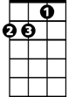

Am



F



C7



C



G

Em

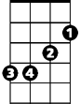

G7

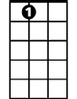

A7

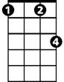

Fm



Am



Dm

F

