Since I Met You Baby
Ivory Joe Hunter, 1956
Since I Met You Baby (Ivory Joe Hunter, 1956) (C)
Since I Met You Baby by Ivory Joe Hunter

Intro C G7  C F C  Since I met you baby my whole life has changed  F C  Since I met you baby my whole life has changed  G7 C  And everybody tells me that I am not the same  C F C  I don't need nobody to tell my troubles to  F C  I don't need nobody to tell my troubles to  G7 C  Cause since I met you baby all I need is you  C F C  Since I met you baby I'm a happy man  F C  Since I met you baby I'm a happy man  G7 C  I'm gonna try to please you in every way I can  (Repeat first verse)  Outro  G7 C F C  And everybody tells me that I am not the same | 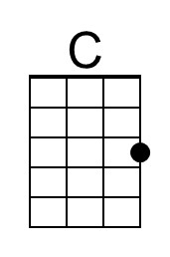
 | 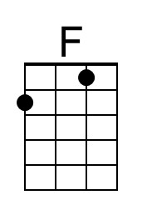
 | 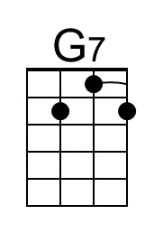
 | 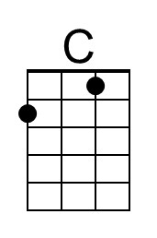
 | 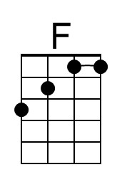
 | 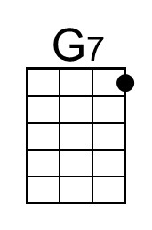

Since I Met You Baby (Ivory Joe Hunter, 1956) (G)
Since I Met You Baby by Ivory Joe Hunter

Intro G D7  G C G  Since I met you baby my whole life has changed  C G  Since I met you baby my whole life has changed  D7 G  And everybody tells me that I am not the same  G C G  I don't need nobody to tell my troubles to  C G  I don't need nobody to tell my troubles to  D7 G  Cause since I met you baby all I need is you  G C G  Since I met you baby I'm a happy man  C G  Since I met you baby I'm a happy man  D7 G  I'm gonna try to please you in every way I can  (Repeat first verse)  Outro  D7 G C G  And everybody tells me that I am not the same | 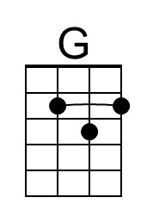
 | 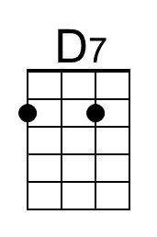
 | 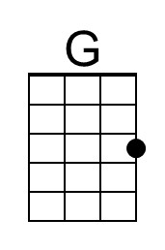
 | 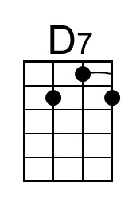

Since I Met You Baby (Ivory Joe Hunter, 1956) (F)
Since I Met You Baby by Ivory Joe Hunter

Intro F C7

F B♭ F
Since I met you baby my whole life has changed
B♭ F
Since I met you baby my whole life has changed
C7 F
And everybody tells me that I am not the same

F B♭ F
I don't need nobody to tell my troubles to
B♭ F
I don't need nobody to tell my troubles to
C7 F
Cause since I met you baby all I need is you

F B♭ F
Since I met you baby I'm a happy man
B♭ F
Since I met you baby I'm a happy man
C7 F
I'm gonna try to please you in every way I can

(Repeat first verse)

Outro
C7 F B♭ F
And everybody tells me that I am not the same
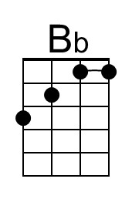
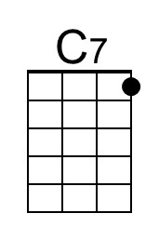
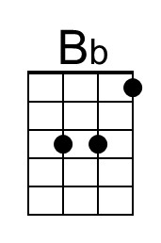
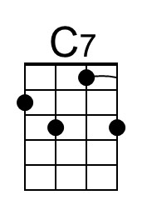

Since I Met You Baby (Ivory Joe Hunter, 1956) (C)
Since I Met You Baby by Ivory Joe Hunter

Intro C G7

C F C
Since I met you baby my whole life has changed
F C
Since I met you baby my whole life has changed
G7 C
And everybody tells me that I am not the same

C F C
I don't need nobody to tell my troubles to
F C
I don't need nobody to tell my troubles to
G7 C
Cause since I met you baby all I need is you

C F C
Since I met you baby I'm a happy man
F C
Since I met you baby I'm a happy man
G7 C
I'm gonna try to please you in every way I can

(Repeat first verse)

Outro
G7 C F C
And everybody tells me that I am not the same

This page is intentionally blank.

