**Singin’ in the Rain (Arthur Freed / Nacio Herb Brown) Key C**

**Intro: C Am C Am (2X)**

**C Am C Am**



C

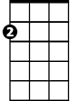

Am

I'm singing in the rain just singin' in the rain

**C Am Dm G7**

What a glorious feeling, I'm happy again

**Dm G7 Dm G7**

I'm laughing at clouds so dark up above

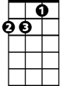

Dm

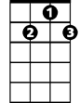

G7

**Dm G7 C**

The sun's in my heart and I'm ready for love

**C Am C Am**

Let the stormy clouds chase everyone from the place

**C Am Dm G7**

Come on with the rain, I've a smile on my face

**Dm G7 Dm G7**

I walk down the lane with a happy refrain

**Dm G7 C**

Just singin', singin' in the rain

**BARITONE**

C



Am

**C Am C Am (2X)**

**C Am C Am**

Dancing in the rain,

**C Am Dm (stop) G7**

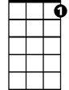

G7

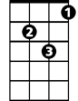

Dm

I'm happy again

**Dm G7 Dm G7**

**Dm G7 C**

I'm singin' and dancing in the rain

**(Second verse)**

**Dm G7 C**

I'm dancing and singin' in the rain

**Singin’ in the Rain (Arthur Freed / Nacio Herb Brown) Key G**

**Intro: G Em G Em (2X)**



G

Em

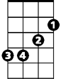

**G Em G Em**

I'm singing in the rain just singin' in the rain

**G Em Am D7**

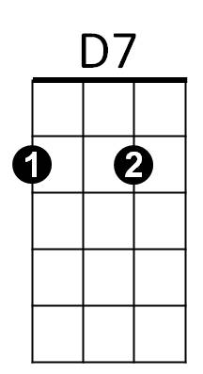What a glorious feeling, I'm happy again



Am

**Am D7 Am D7**

I'm laughing at clouds so dark up above

**Am D7 G**

The sun's in my heart and I'm ready for love

**G Em G Em**

Let the stormy clouds chase everyone from the place

**G Em Am D7**

Come on with the rain, I've a smile on my face

**Am D7 Am D7**

I walk down the lane with a happy refrain

**Am D7 G**

Just singin', singin' in the rain

**BARITONE**



D7



Em



G



Am

**G Em G Em (2X)**

**G Em G Em**

Dancing in the rain,

**G Em Am (stop) D7**

I'm happy again

**Am D7 Am D7**

**Am D7 G**

I'm singin' and dancing in the rain

**(Second verse)**

**Am D7 G**

I'm dancing and singin' in the rain