Singing in the Rain (Nacio Herb Brown and Arthur Freed)

Strum: F Am F Am F Am F Am
Intro tab: A---0-------------------------0-------------------------
E-------1---3---1-------1-----1---3---1---3-----1--
C----------------------2--------------------------2-----
G--------------------------------------------------------
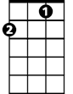
F
F Am F Am F Am F Am
I’m sing- in’ in the rain, just sing-in’ in the rain
F Am F Am Gm6 C7 Gm6 C7
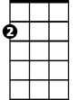
What a glori-ous feel-in, I’m hap- py a-gain
Am
Gm6 C7 Gm6 C7 Gm6 C7 Gm6 C7
I’m laugh-ing at clouds, so dark up a-bove
Gm6 C7 Gm6 C7 F Am F Am
The sun’s in my heart, and I’m rea-dy for love.
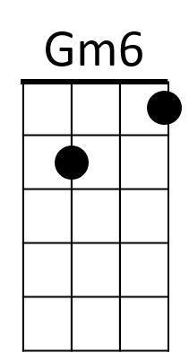
F Am F Am F Am F Am
Let the storm-y clouds chase, everyone from the place
F Am F Am Gm6 C7 Gm6 C7
Come on with the rain, there’s a smile on my face
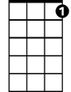
Gm6 C7 Gm6 C7 Gm6 C7 Gm6 C7
C7
I walk down the lane, with a hap - py re –frain
Gm6 C7 Gm6 C7 F
Just singin’ just singin’ in the rain
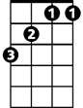
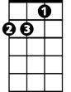
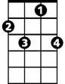
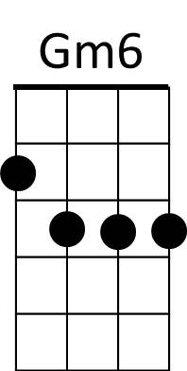
F
Am
C7
BARITONE

