**Sit Down, You're Rockin' the Boat (Frank Loesser)**

**Dm Cm6**

I dreamed last night I got on the boat to heaven

**Dm Cm6**

And by some chance I had brought my dice along

**Am Gm7 Am Gm7**

And there I stood and I hollered "Someone fade me"

**Am Dm Gm7 C7**

But the passengers, they knew right from wrong

**F F7 Gm7 Bbm6**

For the people all said sit down

**F G7 C7**

Sit down, you're rockin' the boat

**F F7 Gm7 Bbm6**

The people all said sit down

**F C7 F F7**

Sit down you're rockin' the boat

**Gm7**

And the devil will drag you under

**Bbm6**

By the sharp lapel of your checkered coat

**F F7 Gm7 Bbm6**

Sit down, sit down, sit down, sit down

**F C7 F A7**

Sit down you're rockin' the boat

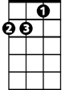

Dm

**Dm Cm6**

I sailed away on that little boat to heaven

**Dm Cm6**

And by some chance found a bottle in my fist

**Am Gm7**  **Am Gm7**

F



And there I stood nicely passin' out the whisky

**Am Dm Gm7 C7**

**BARITONE**

But the passengers were bound to resist

**F F7 Gm7 Bbm6**

For the people all said beware

**F G7 C7**

You're on a heavenly trip



Am

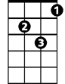

Dm

**F F7 Gm7 Bbm6**

The people all said beware

**F C7 F F7**

Beware, you'll scuttle the ship

**Gm7**

And the devil will drag you under



F

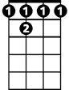

F7

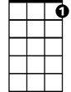

G7

**Bbm6**

By the fancy tie 'round your wicked throat

**F F7 Gm7 Bbm6**

Sit down, sit down, sit down, sit down

**F C7 F A7**

Sit down you're rockin' the boat

**Dm Cm6**

And as I laughed at those passengers to heaven

**Dm Cm6**

A great big wave came and washed me over board

**Am Gm7 Am Gm7**

And as I sank and I hollered "someone save me"

**Am Dm Gm7 C7**

That's the moment I woke up, thank the Lord

**F F7 Gm7 Bbm6**

And I said to myself sit down

**F G7 C7**

Sit down, you're rockin' the boat

**F F7 Gm7 Bbm6**

I said to myself sit down

**F C7 F F7**

Sit down you're rockin' the boat

**Gm7**

And the devil will drag you under

**Bbm6**

With a soul so heavy you'd never float

**(3x) F F7 Gm7 Bbm6**

Sit down, sit down, sit down, sit down

**F C7 F**

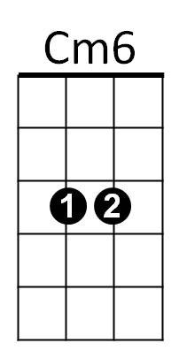 Sit down you're rockin' the boat



C7

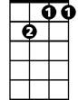

Gm7

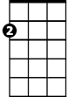

Am

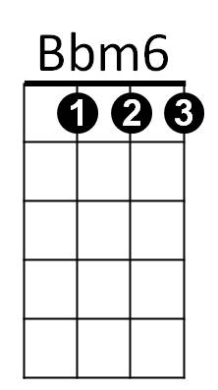

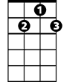

G7

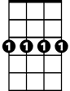

Gm7

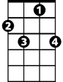

C7



F7