**Sixteen Tons (Merle Travis) Key Am**

**Intro: Am G E7 Am (2X)**

**Am G F E7**

Some people say a man is made outa mud

**Am G F E7**

A poor man's made outa muscle 'n blood...

**Am Dm**

Muscle an' blood an' skin an' bone

**Am E7**

A mind that's weak and a back that's strong

**Chorus:**

**Am G F E7**

You load sixteen tons an' whaddya get?

**Am G F E7**

Another day older an' deeper in debt

**Am C Dm**

Saint Peter doncha call me 'cause I can't go

**Am G E7 Am Am G E7 Am**

I owe my soul to th e company sto'

**Am G F E7**

I was born one mornin' when the sun didn't shine

**Am G F E7**

I picked up my shovel and I went to the mine

**Am Dm**

Loaded sixteen tons of number nine coal

**Am E7**

And the Strawboss said, "Well, Bless my soul

**(Chorus)**

**Am G F E7**

I was born one morning it was drizzlin' rain

**Am G F E7**

Fightin' and trouble are my middl e name

**Am Dm**

I was raised in a cane-break by an' ol' mama lion

**Am E7**

Ain't no high-tone woman make me walk the line.

**(Chorus)**

**BARITONE**

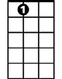

E7



G

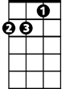

Am

**Am G F E7**

If ya see me a-comin' better step aside

**Am G F E7**

A lotta men din't an' a lotta men died

**Am Dm**

I got one fist of iron an' the other of steel

**Am E7**

If the right one don' getcha then the left one will.

**Am G F E7**

You load sixteen tons an' whaddya get?

**Am G F E7**

Another day older an' deeper in debt

**Am C Dm (hold)**

Saint Peter doncha call me 'cause I can't go ….

**Am E7 Am**

I owe - my soul - to the comp-a-ny sto'

**Am G E7 Am**

E7

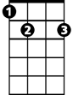

G

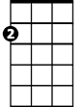

Am



C



Dm

F

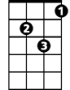

Dm

C



F

**Sixteen Tons (Merle Travis) Key Dm**

**Intro: Dm C A7 Dm (2X)**

**Dm C Bb A7**

Some people say a man is made outa mud

**Dm C Bb A7**

A poor man's made outa muscle 'n blood...

**Dm Gm**

Muscle an' blood an' skin an' bone

**Dm A7**

A mind that's weak and a back that's strong

**Chorus:**

**Dm C Bb A7**

You load sixteen tons an' whaddya get?

**Dm C Bb A7**

Another day older an' deeper in debt

**Dm F Gm**

Saint Peter doncha call me 'cause I can't go

**Dm A7 Dm Dm A7 Dm**

I owe my soul to the company sto'

**Dm C Bb A7**

I was born one mornin' when the sun didn't shine

**Dm C Bb A7**

I picked up my shovel and I went to the mine

**Dm Gm**

Loaded sixteen tons of number nine coal

**Dm A7**

And the Strawboss said, "Well, Bless my soul

**(Chorus)**

**Dm C Bb A7**

I was born one morning it was drizzlin' rain

**Dm C Bb A7**

Fightin' and trouble are my middle name

**Dm Gm**

I was raised in a cane-break by an' ol' mama lion

**Dm A7**

Ain't no high-tone woman make me walk the line.

**(Chorus)**

**BARITONE**

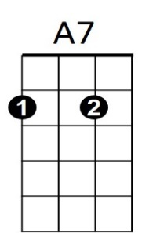

C



Dm

**Dm C Bb A7**

If ya see me a-comin' better step aside

**Dm C Bb A7**

A lotta men din't an' a lotta men died

**Dm Gm**

I got one fist of iron an' the other of steel

**Dm A7**

If the right one don' getcha then the left one will.

**Dm C Bb A7**

You load sixteen tons an' whaddya get?

**Dm C Bb A7**

Another day older an' deeper in debt

**Dm F Gm (hold)**

Saint Peter doncha call me 'cause I can't go ….

**Dm A7 Dm**

I owe - my soul - to the comp-a-ny sto'

**Dm A7 Dm**



A7



Dm



C



Bb



Gm

F

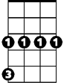

Gm



F

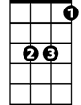

Bb