Skin and Bones (Traditional) (Am)
Variant of "The Hearse Song" or “The Worms Crawl In, etc.”
Arrangement by Lisa Kljaich, The Ukulele Fool, Using A Swing Rhythm & Roll Strum
Skin and Bones by Lisa, The Ukulele Fool (Dm)
Skin and Bones Tutorial by Lisa, The Ukulele Fool
Skin and Bones by Jean Ritchie (1952)

Am C Am - Esus4 Am  Intro: Ooo - oo - oo.oo - ooh  Am  There was an old woman of skin and bones  Am C Am - Esus4 Am  Ooo - oo - oo.oo - ooh  Am  She lived down by the old grave yard  Am C Am - Esus4 Am  Ooo - oo - oo.oo - ooh  Am  One night she thought she'd take a walk  Am C Am - Esus4 Am  Ooo - oo - oo.oo - ooh  Am  She walked down by the old grave yard  Am C Am - Esus4 Am  Ooo - oo - oo.oo - ooh  Am  She saw the bones a'laying around  Am C Am - Esus4 Am  Ooo - oo - oo.oo - ooh  Am  She went to the closet to get a broom  Am C Am - Esus4 Am  Ooo - oo - oo.oo - ooh  Am  She opened the door and . . . BOO! | 
 | 
 | 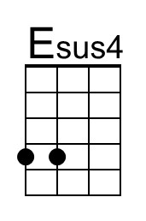
 | Bari
 | 
 | 
 | 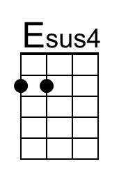

Skin and Bones (Traditional) (Dm)
Variant of "The Hearse Song" or “The Worms Crawl In, etc.”
Arrangement by Lisa Kljaich, The Ukulele Fool, Using A Swing Rhythm & Roll Strum
Skin and Bones by Lisa, The Ukulele Fool (Dm)
Skin and Bones Tutorial by Lisa, The Ukulele Fool
Skin and Bones by Jean Ritchie (1952)

Dm F Dm - Asus4 Dm  Intro: Ooo - oo - oo.oo - ooh  Dm  There was an old woman of skin and bones  Dm F Dm - Asus4 Dm  Ooo - oo - oo.oo - ooh  Dm  She lived down by the old grave yard  Dm F Dm - Asus4 Dm  Ooo - oo - oo.oo - ooh  Dm  One night she thought she'd take a walk  Dm F Dm - Asus4 Dm  Ooo - oo - oo.oo - ooh  Dm  She walked down by the old grave yard  Dm F Dm - Asus4 Dm  Ooo - oo - oo.oo - ooh  Dm  She saw the bones a'laying around  Dm F Dm - Asus4 Dm  Ooo - oo - oo.oo - ooh  Dm  She went to the closet to get a broom  Dm F Dm - Asus4 Dm  Ooo - oo - oo.oo - ooh  Dm  She opened the door and . . . BOO! | 
 | 
 | 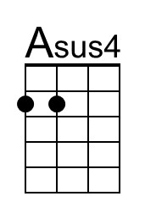
 | Bari
 | 
 | 
 | 

