Sleigh Ride (Mitchell Parish & Leroy Anderson) – Version 3 (C)

Intro: C Am Dm G7, C Am Dm G7 G7#5
Just hear those

C Am Dm G7 C Am Dm
(Just hear those) sleigh bells jingling, ring ting tingling too
G7 C Am Dm G7 C Am Dm
Come on, it's lovely weather for a sleigh ride to-gether with you,
G7 C Am Dm G7 C Am Dm
Out-side the snow is falling and friends are calling "Yoo hoo,"
G7 C Am Dm G7 C (Dm-C Dm-C)
Come on, it's lovely weather for a sleigh ride to-gether with you.

F#m B E
Giddy up, giddy up, giddy up, let's go, Let's look at the show,
F#m B E
__ We're riding in a wonder-land of snow.
Em A D Bm7
Giddy up, giddy up, giddy up, it's grand, Just holding your hand,
Dm G Dm7 G7
We're gliding along with a song of a wintry fairy land.

G7#5 C Am Dm G7 C Am Dm
Our cheeks are nice and rosy and comfy cozy are we
G7 C Am Dm G7 C Am Dm
We're snuggled up to-gether like two birds of a feather would be
G7 C Am Dm G7 C Am Dm
Let's take that road be-fore us and sing a chorus or two
G7 C Am Dm G7 C (Dm-C Dm-C)
Come on, it's lovely weather for a sleigh ride to-gether with you.

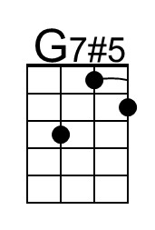 |  | Baritone | 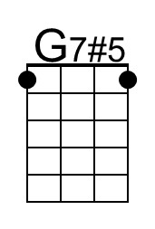

Sleigh Ride (C) - p. 2

G Cmaj7
There's a birthday party at the home of __ Farmer Gray
Em Am
It'll be the perfect ending a __ perfect day
C Dm G7 E7 Am
We'll be singing the songs we love to sing with-out a single stop,
E F#m B E G Dm G7
At the fireplace while we watch the chestnuts pop. Pop! Pop! pop!

G Cmaj7
There's a happy feeling nothing in the ___ world can buy,
Em Am
When they pass around the coffee and the __ pumpkin pie
C Dm G7 E7 Am
It'll nearly be like a picture print by Currier and Ives
G7 Dm G7 Dm7 G7
__ These wonderful things are the things we re-member all through our lives!

G7#5 C Am Dm G7 C Am Dm
Just hear those sleigh bells jingling, ring ting tingling too
G7 C Am Dm G7 C Am Dm
Come on, it's lovely weather for a sleigh ride to-gether with you,
G7 C Am Dm G7 C Am Dm
Outside the snow is falling and friends are calling "Yoo hoo,"
G7 C Am Dm G7
Come on, it's lovely weather for a sleigh ride to-gether with,
C Am Dm G7
lovely weather for a sleigh ride to-gether with,

Outro: slower
C Am Dm G7 C Am Dm G7 C ↓
Lovely weather for a sleigh ride to-gether with you.

Sleigh Ride (Mitchell Parish & Leroy Anderson) – Version 3 (F)

Intro: F Dm Gm C7, F Dm Gm C7 C7#5
Just hear those

F Dm Gm C7 F Dm Gm
(Just hear those) sleigh bells jingling, ring ting tingling too
C7 F Dm Gm C7 F Dm Gm
Come on, it's lovely weather for a sleigh ride to-gether with you,
C7 F Dm Gm C7 F Dm Gm
Out-side the snow is falling and friends are calling "Yoo hoo,"
C7 F Dm Gm C7 F (Gm-C Gm-C)
Come on, it's lovely weather for a sleigh ride to-gether with you.

Bm E A
Giddy up, giddy up, giddy up, let's go, Let's look at the show,
Bm E A
__ We're riding in a wonder-land of snow.
Am D G Em7
Giddy up, giddy up, giddy up, it's grand, Just holding your hand,
Gm C Gm7 C7
We're gliding along with a song of a wintry fairy land.

C7#5 F Dm Gm C7 F Dm Gm
Our cheeks are nice and rosy and comfy cozy are we
C7 F Dm Gm C7 F Dm Gm
We're snuggled up to-gether like two birds of a feather would be
C7 F Dm Gm C7 F Dm Gm
Let's take that road be-fore us and sing a chorus or two
C7 F Dm Gm C7 F (Gm-C Gm-C)
Come on, it's lovely weather for a sleigh ride to-gether with you.

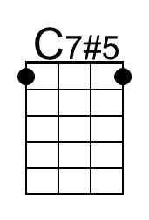 |  | Baritone | 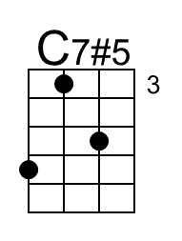

Sleigh Ride (F) - p. 2

C Fmaj7
There's a birthday party at the home of __ Farmer Gray
Am Dm
It'll be the perfect ending a __ perfect day
F Gm C7 A7 Dm
We'll be singing the songs we love to sing with-out a single stop,
A Bm E A C Gm C7
At the fireplace while we watch the chestnuts pop. Pop! Pop! pop!

C Fmaj7
There's a happy feeling nothing in the ___ world can buy,
Am Dm
When they pass around the coffee and the __ pumpkin pie
F Gm C7 A7 Dm
It'll nearly be like a picture print by Currier and Ives
C7 Gm C7 Gm7 C7
__ These wonderful things are the things we re-member all through our lives!

C7#5 F Dm Gm C7 F Dm Gm
Just hear those sleigh bells jingling, ring ting tingling too
C7 F Dm Gm C7 F Dm Gm
Come on, it's lovely weather for a sleigh ride to-gether with you,
C7 F Dm Gm C7 F Dm Gm
Outside the snow is falling and friends are calling "Yoo hoo,"
C7 F Dm Gm C7
Come on, it's lovely weather for a sleigh ride to-gether with,
F Dm Gm C7
lovely weather for a sleigh ride to-gether with,

Outro: slower
F Dm Gm C7 F Dm Gm C7 F ↓
Lovely weather for a sleigh ride to-gether with you.

Sleigh Ride (Mitchell Parish & Leroy Anderson) – Version 3 (G)

Intro: G Em Am D7, G Em Am D7 D7#5
Just hear those

G Em Am D7 G Em Am
(Just hear those) sleigh bells jingling, ring ting tingling too
D7 G Em Am D7 G Em Am
Come on, it's lovely weather for a sleigh ride to-gether with you,
D7 G Em Am D7 G Em Am
Out-side the snow is falling and friends are calling "Yoo hoo,"
D7 G Em Am D7 G (Am-C Am-C)
Come on, it's lovely weather for a sleigh ride to-gether with you.

C#m F# B
Giddy up, giddy up, giddy up, let's go, Let's look at the show,
C#m F# B
__ We're riding in a wonder-land of snow.
Bm E A F#m7
Giddy up, giddy up, giddy up, it's grand, Just holding your hand,
Am D Am7 D7
We're gliding a-long with a song of a wintry fairy land.

D7#5 G Em Am D7 G Em Am
Our cheeks are nice and rosy and comfy cozy are we
D7 G Em Am D7 G Em Am
We're snuggled up to-gether like two birds of a feather would be
D7 G Em Am D7 G Em Am
Let's take that road be-fore us and sing a chorus or two
D7 G Em Am D7 G (Am-C Am-C)
Come on, it's lovely weather for a sleigh ride to-gether with you.

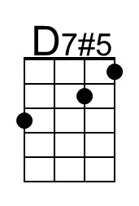 |  | Baritone | 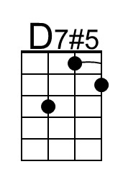

Sleigh Ride (G) - p. 2

D Gmaj7
There's a birthday party at the home of __ Farmer Gray
Bm Em
It'll be the perfect ending a __ perfect day
G Am D7 B7 Em
We'll be singing the songs we love to sing with-out a single stop,
B C#m F# B D Am D7
At the fireplace while we watch the chestnuts pop. Pop! Pop! pop!

D Gmaj7
There's a happy feeling nothing in the ___ world can buy,
Bm Em
When they pass around the coffee and the __ pumpkin pie
G Am D7 B7 Em
It'll nearly be like a picture print by Currier and Ives
D7 Am D7 Am7 D7
__ These wonderful things are the things we re-member all through our lives!

D7#5 G Em Am D7 G Em Am
Just hear those sleigh bells jingling, ring ting tingling too
D7 G Em Am D7 G Em Am
Come on, it's lovely weather for a sleigh ride to-gether with you,
D7 G Em Am D7 G Em Am
Outside the snow is falling and friends are calling "Yoo hoo,"
D7 G Em Am D7
Come on, it's lovely weather for a sleigh ride to-gether with,
G Em Am D7
lovely weather for a sleigh ride to-gether with,

Outro: slower
G Em Am D7 G Em Am D7 G ↓
Lovely weather for a sleigh ride to-gether with you.

