**Sleigh Ride (Anderson / Parish)**

**C Am Dm (x3) F C Dm G**

**G C Am**

Just hear those sleigh bells jing-a-ling

**Dm G C**

Ring ting ting-a-ling too

**G C Am**

Come on its lovely weather

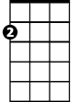

Am

**Dm G C**

For a sleigh ride together with you

**G C Am**

Outside the snow is falling

**Dm G C**

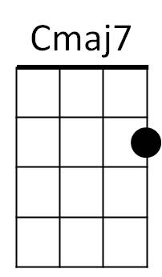And friends are calling yoo-hoo

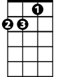

Dm



G

**G C Am**

Come on its lovely weather

**Dm G C**

For a sleigh ride together with you

**F#m B**

Giddy-up giddy-up giddy-up let's go

**E7**

Let's look at the show

**F#m B E7**

We're riding in a wonderland of snow

**Em A**

Giddy-up giddy-up giddy-up it's grand

**D**

Just holding your hand

**Dm**

We're riding along with a song

**G**

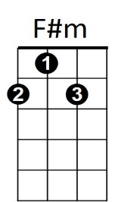Of a wintery fairyland

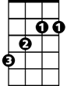

B

**G C Am**

Our cheeks are nice and rosy

**Dm G C**

And comfy coz y are we

**G C Am**

We snuggle close together

E

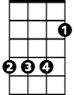

F



**Dm G C**

Like two birds of a feather would be

**G C Am**

Let's take that road before us

**Dm G C**

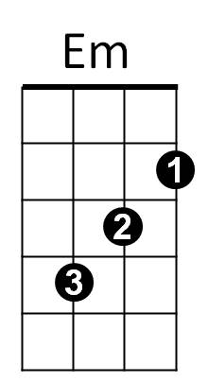And sing a chorus or two

**G C Am**

Come on its lovely weather

**Dm G C**

For a sleigh ride together with you

**G**

There's a birthday party at the home of Farmer Grey

**Em Am**

It'll be the perfect ending of a perfect day

**C F**

We'll be singing the songs we love to sing

**G Am**

Without a single stop

**E7 F#m E**

At the fireplace where we'll watch the chestnuts pop

**Dm G**

Pop! Pop! Pop!

**G**

There's a happy feeling nothing in this world can buy

**Em**

When they pass around the coffee

**Am**

and the pumpkin pie

**C F G Am**

It'll nearly be like a picture print by Currier & lives

**G**

These wonderful things are the things

**Dm G**

We remember all through our lives

**Dm**

These wonderful things are the things

**G**

We remember all through our lives

**Repeat first three verses**

**Outro (repeat 3x)**

**G C Am**

Come on its lovely weather

**Dm G C Am Dm G C**

For a sleigh ride together with you

**BARITONE**

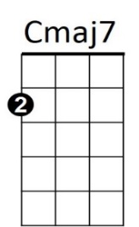

B



F



Em

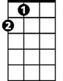

E



Am

C

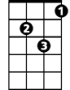

Dm



G

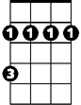

F#m