Sleigh Ride
Music by Leroy Anderson (1948) & Words by Mitchell Parish (1950)
Key of C; Cut-time; “Briskly;” Arrangement by Pete McCarty (Alt.). Advanced 4.

CGEA          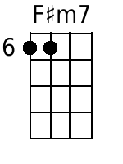  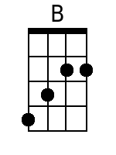  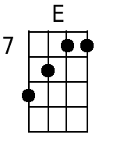  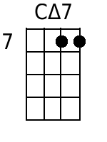  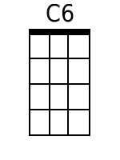     | 4 Measure Introduction:  C Am Dm G7  § A1  C Am Dm G7 C Am  Just hear those sleigh bells jing-a-ling, Ring ting ting-a-ling too.  Dm G7 C Am Dm G7 C Am  Come on it's lovely weather for a sleigh ride together with you  Dm G7 C Am Dm G7 C Am  Out-side the snow is falling and friends are calling ‘you hoo!’  Dm G7 C Am Dm G7 C  Come on it's lovely weather for a sleigh ride to-gether with you.  § B1  F#m B  Giddy-up giddy-up giddy-up let's go  E  Let's look at the show.  F#m B E  We're riding in a wonder-land of snow  Em A  Giddy-up giddy-up giddy-up it's grand  D  Just holding your hand  Dm G7 G7  We're riding along with a song of a wintery fairy land.  § A2  C Am Dm G7 C Am  Our cheeks are nice and rosy and comfy cozy are we  Dm G7 C Am Dm G7 C Am  We’re snuggled up to-gether like two birds of a feather would be.  Dm G7 C Am Dm G7 C Am  Let's take that road be-fore us and sing a chorus or two  Dm G7 C Am Dm G7 C  Come on it's lovely weather for a sleigh ride to-gether with you.  § C  CΔ7 C6  There's a birthday party at the home of farmer Grey  CΔ7 C6  It'll be the perfect ending of a perfect day  C Dm G7 E7 Am  We'll be singing the songs we love to sing with-out a single stop  E7 A Dm G7  At the fireplace while we watch the chestnuts pop Pop! Pop! Pop!  CΔ7 C6  There's a happy feeling nothing in this world can buy  CΔ7 C6  When they pass around the cider and the pumpkin pie  C Dm G7 E7 Am  It'll nearly be like a picture print by Currier & Ives  G G7  These wonderful things are the things we re-member all through our lives.  § A3  C Am Dm G7 C Am  Just hear those sleigh bells jing-a-ling, Ring ting ting-a-ling too.  Dm G7 C Am Dm G7 C Am  Come on it's lovely weather for a sleigh ride together with you  Dm G7 C Am Dm G7 C Am  Out-side the snow is falling and friends are calling ‘you hoo!’  Dm G7 C Am Dm G7 C  Come on it's lovely weather for a sleigh ride to-gether with you.  § B2  F#m B  Giddy-up giddy-up giddy-up let's go  E  Let's look at the show.  F#m B E  We're riding in a wonder-land of snow  Em A  Giddy-up giddy-up giddy-up it's grand  D  Just holding your hand  Dm G7 G7  We're riding along with a song of a wintery fairy land.  § A4  C Am Dm G7 C Am  Our cheeks are nice and rosy and comfy cozy are we  Dm G7 C Am Dm G7 C Am  We’re snuggled up to-gether like two birds of a feather would be  G7 C Am Dm G7 C Am  Let's take that road be-fore us and Sing a chorus or two  G7 C Am Dm G7 C  Come on it's lovely weather for a sleigh ride to-gether with you.  C Am Dm G7 C-Hold  It's lovely weather for a sleigh ride to-gether with you. | Bari        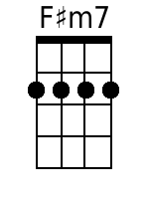  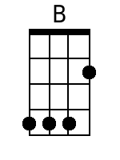  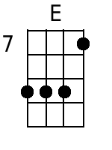  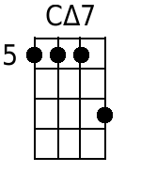  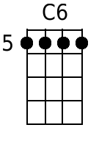    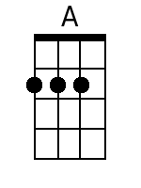

Note: CΔ7 = Cmaj7

Alternate Introductions for GCEA & DGBE Ukes
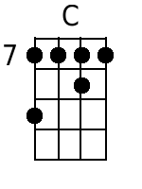 | 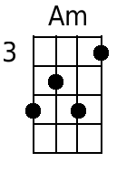 |  |  |  | 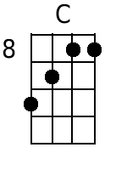 | 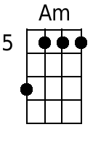 |  | 

