Sleigh Ride
Music by Leroy Anderson (1948) & Lyrics by Mitchell Parish (1950)
Cut Time – Moderately Bright – Keys of C, F & G – Advanced (14 Chords)
From Wikipedia, the free encyclopedia, https://en.wikipedia.org/wiki/Sleigh_Ride,
The Leroy Anderson Foundation, http://www.leroyandersonfoundation.org/sleigh_ride.php,
The Rondo Form, Wikipedia, https://en.wikipedia.org/wiki/Rondo, and
The Rondo Form, Open Music Theory, http://openmusictheory.com/rondo.html
"Sleigh Ride" is a popular light orchestra instrumental composed by Leroy Anderson. The composer had the original idea for the piece during a heat wave in July 1946 and finished the work in February 1948. “Sleigh Ride” was first performed on May 4, 1948, in Symphony Hall, Boston, as an 'extra' at a Pops concert conducted by Arthur Fiedler and was first recorded in 1949 by Arthur Fiedler and the Boston Pops Orchestra; it has become one of the orchestra's signature songs. It was recorded by Leroy Anderson & His Pops Concert Orchestra in 1950; this more “upbeat” recording has become the most popular instrumental version.
The lyrics were written by Mitchell Parish in 1950 and immediately recorded by the Andrews Sisters. The most popular “pop” version was recorded in 1958 by Johnny Mathis, while the 1963 recording by the Ronettes has become the most popular version outside the traditional “pop” genre, charting yearly in Billboard's Top Ten U.S. Holiday 100. It features the well-known "Ring-a-ling-a-ling, ding-dong-ding" background vocals, and the clip-clop and whinny of a horse at its beginning and end.
According to the American Society of Composers, Authors and Publishers (ASCAP) review of Christmas music, "Sleigh Ride" consistently ranks as one of the top 10 most-performed songs written by ASCAP members. In his 2004 book Leroy Anderson: A Bio-Bibliography, Steve Metcalf says "'Sleigh Ride' ... has been performed and recorded by a wider array of musical artists than any other piece in the history of Western music." ASCAP named "Sleigh Ride" the most popular piece of Christmas music in the U.S. in 2009–2012, based on performance data from over 2,500 radio stations.
According to the composer’s widow Eleanor Anderson, "Leroy didn’t set out to write a Christmas piece when he wrote 'Sleigh Ride.' His intentions were to convey the entire winter season through the imagery of a sleigh ride, much in the way that Mozart did with his piece of the same name." Similar pieces have been composed by Gustav Mahler, Sergei Prokofiev, and Jacques Ibert. Some recordings of Anderson's “Sleigh Ride,” such as those by the Carpenters, Walter Schumann and Air Supply, substitute "Christmas party" for "birthday party" in the song's third (C) section.
"Sleigh Ride" is in a 7-part rondo form, A B A C A B A. The second section (B), beginning “Giddy up, giddy up, giddy up, let's go,” utilizes an unusual modulation to III (E Major), then II (D Major). The difficulty of singing this section has caused several artists to omit it, including the Ronettes. Other arrangements also omit Section “C,” which begins “There's a birthday party ...”
- First Instrumental recording: Arthur Fiedler & The Boston Pops (1949)
YouTube: https://www.youtube.com/watch?v=R9jKyI6N9rg
- Leroy Anderson & His Pops Concert Orchestra (1950)
YouTube: https://www.youtube.com/watch?v=EDRFmn_KqfA
- Words and Music first recorded by the Andrews Sisters (1950)
YouTube: https://www.youtube.com/watch?v=cgCmUrfZ9Jw
- Johnny Mathis (1958): https://www.youtube.com/watch?v=6b9BKK27HuQ
- The Ronettes (1963): https://www.youtube.com/watch?v=Y6rDA2Czz0E
- Karen Carpenter (1978): https://www.youtube.com/watch?v=WXuVQEjhABM
Sleigh Ride
Music by Leroy Anderson (1948) & Words by Mitchell Parish (1950)
Cut Time – Moderately Bright – Key of C – Advanced (14 Chords)

Note: The basic pattern is for two strums on each of these four chords: C, Am, Dm, G7.
Pete McCarty would write it like this: [C] [C] [Am] [Am] [Dm] [Dm] [G7] [G7]
If you're having trouble, strum the C four times, skip the Am, strum the Dm four times, and skip the G7.
The Introduction is four strums of each note, as written.

GCEA |  | Intro: | Bari
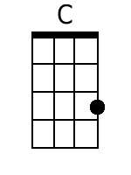  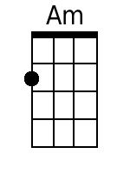  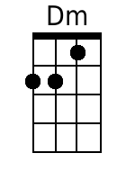  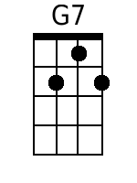 |  | C-C-C-C Am-Am-Am-Am Dm-Dm-Dm-Dm G7-G7-G7-G7-Hold  C Am  Just hear those sleigh bells jing-a-ling  Dm G7 C Am  Ring ting ting-a-ling too  Dm G7 C Am  Come on it's lovely weather for a  Dm G7 C Am  Sleigh ride together with you  Dm G7 C Am  Out-side the snow is falling and  Dm G7 C Am  Friends are calling ‘you hoo!’  Dm G7 C Am  Come on it's lovely weather for a  Dm G7 C  Sleigh ride to-gether with you. | 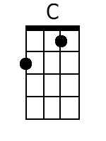  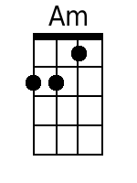  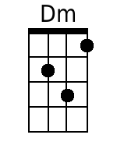  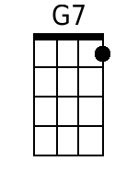
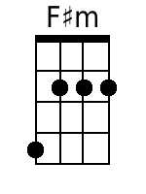  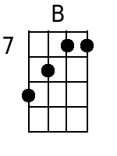  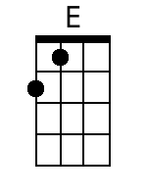 | 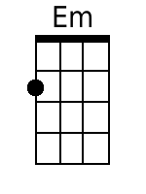  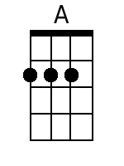  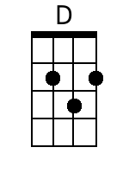 | Bridge (Section B)  F#m B  Giddy-up giddy-up giddy-up let's go  E  Let's look at the show  F#m B E  We're riding in a wonderland of snow  Em A  Giddy-up giddy-up giddy-up it's grand  D  Just holding your hand  Dm  We're riding along with a song of a  G7 G7-Hold  Wintery fairy land.

C Am Dm G7 C Am
Our cheeks are nice and rosy and comfy cozy are we.
Dm G7 C Am
We’re snuggled up to-gether like two
Dm G7 C Am
Birds of a feather would be
Dm G7 C Am
Let's take that road be-fore us and
Dm G7 C Am
Sing a chorus or two
Dm G7 C Am
Come on it's lovely weather for a
Dm G7 C
Sleigh ride to-gether with you

Ending Last Time Through:
Retard [i.e., slow down]
Am Dm
It's lovely weather for a sleigh ride
G7 C-Hold
To-gether with you.
Instrumental:
F-F-F-F Dm-Dm-Dm-Dm Gm-Gm-Gm-Gm C7-C7-C7-C7

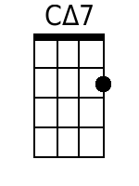  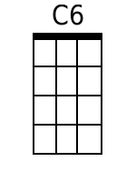  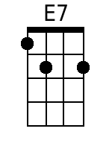  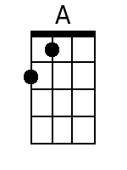  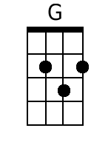 | Interlude (Section C)  Cmaj7 C6  There's a birthday party at the home of farmer Grey  Cmaj7 C6  It'll be the perfect ending of a perfect day  C Dm G7  We'll be singing the songs we love to sing  E7 Am  With-out a single stop  E7 A  At the fireplace while we watch the chestnuts pop.  Dm G7  Pop! Pop! Pop!  Cmaj7 C6  There's a happy feeling nothing in this world can buy  Cmaj7 C6  When they pass around the cider and the pumpkin pie  C Dm G7 E7 Am  It'll nearly be like a picture print by Currier & Ives  G  These wonderful things are the things  G7 G7-Hold  We re-member all through our lives.  Repeat From Beginning | 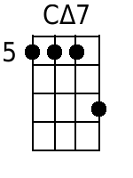  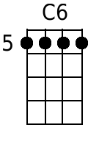  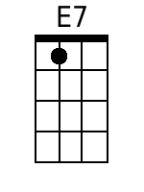  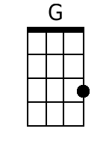

Note: C∆7 = C major 7th (Notes: C E F B – 1 3 5 7).
C7 = C dominant 7th (Notes: C E F B♭ – 1 3 5 ♭7).
Sleigh Ride
Music by Leroy Anderson (1948) & Words by Mitchell Parish (1950)
Cut Time – Moderately Bright – Key of F – Advanced (14 Chords)

Note: The basic pattern is for two strums on each of these four chords: F, Dm, Gm, C7.
Pete McCarty would write it like this: [F] [F] [Dm] [Dm] [Gm] [Gm] [C7] [C7]
If you're having trouble, strum the F four times, skip the Dm, strum the Gm four times, and skip the C7.
The Introduction is four strums of each note, as written.

GCEA |  | Intro: | Bari
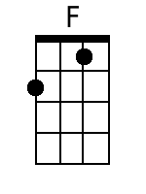  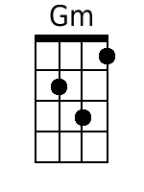  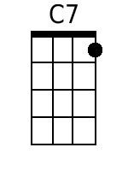 |  | F-F-F-F Dm-Dm-Dm-Dm Gm-Gm-Gm-Gm C7-C7-C7-C7-Hold  F Dm  Just hear those sleigh bells jing-a-ling  Gm C7 F Dm  Ring ting ting-a-ling too  Gm C7 F Dm  Come on it's lovely weather for a  Gm C7 F Dm  Sleigh ride together with you  Gm C7 F Dm  Out-side the snow is falling and  Gm C7 F Dm  Friends are calling ‘you hoo!’  Gm C7 F Dm  Come on it's lovely weather for a  Gm C7 F  Sleigh ride to-gether with you. | 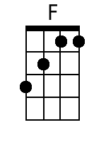  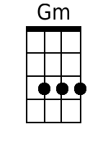  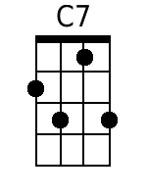
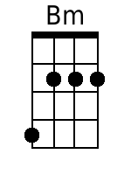  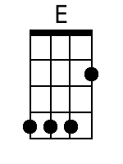 | 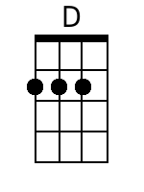 | Bridge (Section B)  Bm E  Giddy-up giddy-up giddy-up let's go  A  Let's look at the show  Bm E A  We're riding in a wonderland of snow  Am D  Giddy-up giddy-up giddy-up it's grand  G  Just holding your hand  Gm  We're riding along with a song  C7 C7-Hold  Of a wintery fairy land. | 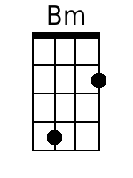

F Dm
Our cheeks are nice and rosy and
Gm C7 F Dm
Comfy cozy are we
Gm C7 F Dm
We’re snuggled up to-gether like two
Gm C7 F Dm
Birds of a feather would be
Gm C7 F Dm
Let's take that road be-fore us and
Gm C7 F Dm
Sing a chorus or two
Gm C7 F Dm
Come on it's lovely weather for a
Gm C7 F
Sleigh ride to-gether with you.

Last Time Through, Add:
Retard [i.e., slow down]
F Dm Gm C7 F
It's lovely weather for a sleigh ride to-gether with you.
Instrumental:
F-F-F-F Dm-Dm-Dm-Dm Gm-Gm-Gm-Gm C7-C7-C7-C7

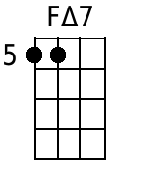  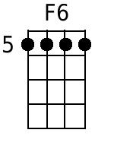  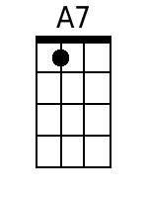 | Interlude (Section C):  F∆7 F6  There's a birthday party at the home of farmer Grey  F∆7 F6  It'll be the perfect ending of a perfect day  F Gm C7  We'll be singing the songs we love to sing  A7 Dm  With-out a single stop  A7 D  At the fireplace while we watch the chestnuts pop.  Gm C7  Pop! Pop! Pop!  F∆7 F6  There's a happy feeling nothing in this world can buy  F∆7 F6  When they pass around the cider and the pumpkin pie  F Gm C7 A7 Dm  It'll nearly be like a picture print by Currier & Ives  C  These wonderful things are the things  C7 C7-Hold  We re-member all through our lives.  Repeat From Beginning | 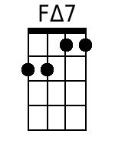  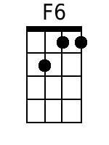  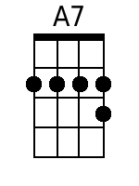

Note: F∆7 = F major 7th (Notes: F A C E – 1 3 5 7).
F7 = F dominant 7th (Notes: F A C E♭ – 1 3 5 ♭7).
Sleigh Ride
Music by Leroy Anderson (1948) & Words by Mitchell Parish (1950)
Cut Time – Moderately Bright – Key of G – Advanced (14 Chords)

Note: The basic pattern is for two strums on each of these four chords: G, Em, Am, D7.
Pete McCarty would write it like this: [G] [G] [Em] [Em] [Am] [Am] [D7] [D7]
If you're having trouble, strum the C four times, skip the Am , strum the Dm four times, and skip the G7.
The Introduction is four strums of each note, as written.

GCEA |  | Intro: | Bari
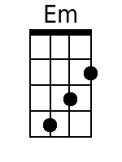  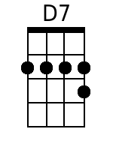 |  | G-G-G-G Em-Em-Em-Em Am-Am-Am-Am D7-D7-D7-D7-Hold  G Em  Just hear those sleigh bells jing-a-ling  Am D7 G Em  Ring ting ting-a-ling too  Am D7 G Em  Come on it's lovely weather for a  Am D7 G Em  Sleigh ride together with you  Am D7 G Em  Out -side the snow is falling and  Am D7 G Em  Friends are calling ‘you hoo!’  Am D7 G Em  Come on it's lovely weather for a  Am D7 G  Sleigh ride to-gether with you | 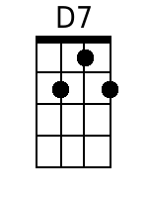
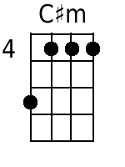  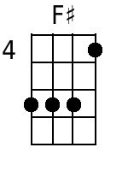  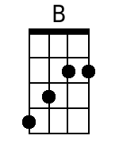 | 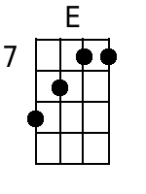 | Bridge (Section B)  C#m F#  Giddy-up giddy-up giddy-up let's go  B  Let's look at the show  C#m F# B  We're riding in a wonderland of snow  Bm E  Giddy-up giddy-up giddy-up it's grand  A  Just holding your hand  Am  We're riding along with a song of a  D7 D7-Hold  Wintery fairy land. | 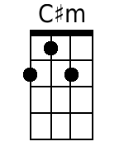  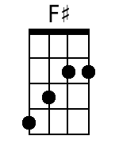  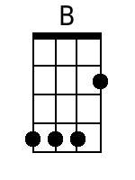

G Em Am D7 G Em
Our cheeks are nice and rosy and comfy cozy are we
Am D7 G Em
We’re snuggled up to-gether
Am D7 G Em
Like two birds of a feather would be
Am D7 G Em
Let's take that road be-fore us and
Am D7 G Em
Sing a chorus or two.
Am D7 G Em
Come on it's lovely weather for a
Am D7 G
Sleigh ride to-gether with you.

Ending Last Time Through:
Retard [i.e., slow down]
Em Am
It's lovely weather for a sleigh ride
D7 G
To-gether with you.
Instrumental:
G-G-G-G Em-Em-Em-Em Am-Am-Am-Am D7-D7-D7-D7

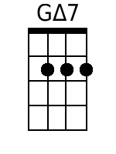  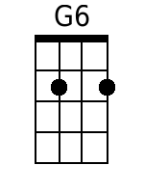  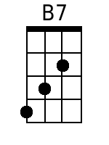  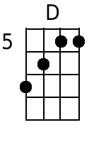 | Interlude (Section C)  G∆7 G6  There's a birthday party at the home of farmer Grey  G∆7 G6  It'll be the perfect ending of a perfect day  G Am D7  We'll be singing the songs we love to sing  B7 Em  With-out a single stop.  B7 E  At the fireplace while we watch the chestnuts pop  Am D7  Pop! Pop! Pop!  G∆7 G6  There's a happy feeling nothing in this world can buy  G∆7 G6  When they pass around the cider and the pumpkin pie  G Am D7 B7 Em  It'll nearly be like a picture print by Currier & Ives  D  These wonderful things are the things  D7 D7-Hold  We re-member all through our lives.  Repeat From Beginning | 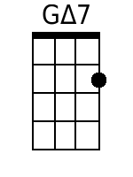  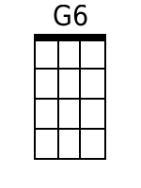  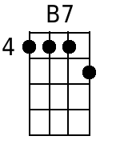

Note: G∆7 = G major 7th (Notes: G B D F – 1 3 5 7).
G7 = G dominant 7th (Notes: G B D E – 1 3 5 ♭7).
Alternate Introductions – Soprano, Concert & Tenor Ukes
Key of C

Major Seventh Alternate Introduction
Four Strokes For Each Chord
Gmaj7 Emaj7 Amaj7 Emaj7
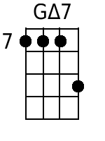 | 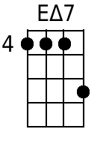 | 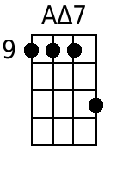

Note: G∆7 = Gmaj7^{th.}

Major Key Alternate Introduction
Four Strokes For Each Chord
G E A E
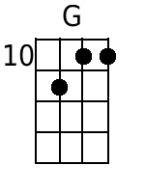

Alternate Introduction – The Ronettes
C Am Dm G (3X) F C Dm G

Alternate Introductions – Soprano, Concert & Tenor Ukes
Key of F

Major Seventh Alternate Introduction
Four Strokes For Each Chord
Cmaj7 Amaj7 Dmaj7 Amaj7
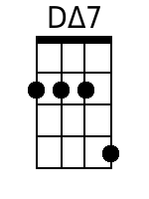

Note: G∆7 = Gmaj7^{th.}

Major Key Alternate Introduction
Four Strokes For Each Chord
C A D A
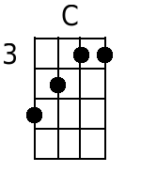

Alternate Introduction – The Ronettes – Key of F
F Dm Gm C (3X) B♭ F Gm C
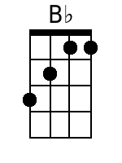

Alternate Introductions – Soprano, Concert & Tenor Ukes
Key of G

Major Seventh Alternate Introduction
Four Strokes For Each Chord
Dmaj7 Bmaj7 Emaj7 Bmaj7
 | Error: Should be same form @ 11 |  | Error: Should be same form @ 11

Note: G∆7 = Gmaj7^{th.}

Major Key Alternate Introduction
Four Strokes For Each Chord
D B E B
 | Error: Should be same form @ 11 |  | Error: Should be same form @ 11

Alternate Introduction – The Ronettes
G Em Am D (3X) C G Am D

– This Page Left Intentionally Blank –
Alternate Introductions – Baritone Uke
Key of C

Major Seventh Alternate Introduction
Four Strokes For Each Chord
Gmaj7 Emaj7 Amaj7 Emaj7
 | 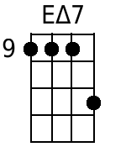 | 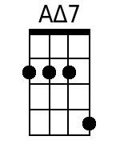

Note: G∆7 = Gmaj7^{th.}

Major Key Alternate Introduction
Four Strokes For Each Chord
G E A E
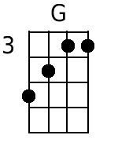 |  | 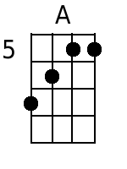

Alternate Introduction – The Ronettes
C Am Dm G (3X) F C Dm G

Alternate Introductions – Baritone Uke
Key of F

Major Seventh Alternate Introduction
Four Strokes For Each Chord
Cmaj7 Amaj7 Dmaj7 Amaj7
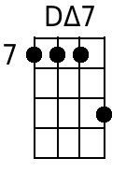

Note: G∆7 = Gmaj7^{th.}

Major Key Alternate Introduction
Four Strokes For Each Chord
C A D A
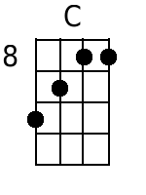 |  | 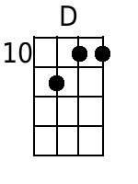

Alternate Introduction – The Ronettes
F Dm Gm C (3X) B♭ F Gm C
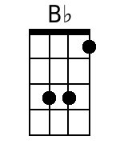

Alternate Introductions – Baritone Uke
Key of G

Major Seventh Alternate Introduction
Four Strokes For Each Chord
Dmaj7 Bmaj7 Emaj7 Bmaj7
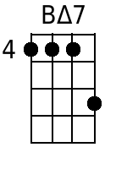

Note: G∆7 = Gmaj7^{th.}

Major Key Alternate Introduction
Four Strokes For Each Chord
D B E B

Alternate Introduction – The Ronettes
G Em Am D (3X) C G Am D

– This Page Left Intentionally Blank –

