Sleigh Ride
Music by Leroy Anderson (1948) & Words by Mitchell Parish (1950)
Key of C; Cut-time; “Briskly.” [EZ_1 – 6 Chords]
Omits Section B – Similar to the Ronettes version of 1963

CGEA  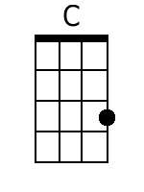  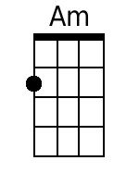  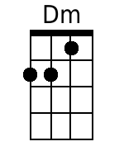  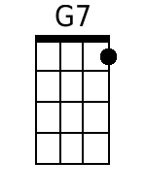  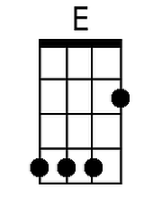  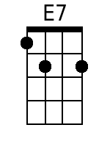 | 4 Measure Introduction:  Cv Cv Cv Cv Amv Amv Amv Amv Dmv Dmv Dmv Dmv Gv Gv Gv Gv  G7v G7v G7v C Dm C  Just hear those sleigh bells jing-a-ling, Ring ting ting-a-ling too.  Dm C Dm C  Come on it's lovely weather for a sleigh ride together with you.  Dm C Dm C  Out-side the snow is falling and friends are calling ‘you hoo!’  Dm C Dm C  Come on it's lovely weather for a sleigh ride to-gether with you.  G7 C Dm C  Our cheeks are nice and rosy and comfy cozy are we.  Dm C Dm C  We’re snuggled up to-gether like two birds of a feather would be.  Dm C Dm C  Let's take that road be-fore us and sing a chorus or two.  Dm C Dm C  Come on it's lovely weather for a sleigh ride to-gether with you.  Stop here 2nd time through.  C  There's a birthday party at the home of farmer Grey  It'll be the perfect ending of a perfect day  C Dm  We'll be singing the songs we love to sing  E7 Am  with-out a single stop  E G7  At the fireplace while we watch the chestnuts pop. Pop! Pop! Pop!  C  There's a happy feeling nothing in this world can buy,  When they pass around the cider and the pumpkin pie.  C Dm E7 Am  It'll nearly be like a picture print by Currier & Ives.  G  These wonderful things are the things  G7  We remember all through our lives.  Repeat From Beginning | Bari  