Sleigh Ride
Music by Leroy Anderson (1948) & Lyrics by Mitchell Parish (1950)
From Wikipedia, the free encyclopedia, https://en.wikipedia.org/wiki/Sleigh_Ride, and
The Leroy Anderson Foundation, http://www.leroyandersonfoundation.org/sleigh_ride.php
"Sleigh Ride" is a popular light orchestra instrumental composed by Leroy Anderson. The composer had the original idea for the piece during a heat wave in July 1946 and finished the work in February 1948. “Sleigh Ride” was first performed on May 4, 1948, in Symphony Hall, Boston, as an 'extra' at a Pops concert conducted by Arthur Fiedler and was first recorded in 1949 by Arthur Fiedler and the Boston Pops Orchestra; it has become one of the orchestra's signature songs. It was recorded by Leroy Anderson & His Pops Concert Orchestra in 1950; this more “upbeat” recording has become the most popular instrumental version.
The lyrics were written by Mitchell Parish in 1950 and immediately recorded by the Andrews Sisters. The most popular “pop” version was recorded in 1958 by Johnny Mathis, while the 1963 recording by the Ronettes has become the most popular version outside the traditional “pop” genre, charting yearly in Billboard's Top Ten U.S. Holiday 100. It features the well-known "Ring-a-ling-a-ling, ding-dong-ding" background vocals, and the clip-clop and whinny of a horse at its beginning and end.
According to the American Society of Composers, Authors and Publishers (ASCAP) review of Christmas music, "Sleigh Ride" consistently ranks as one of the top 10 most-performed songs written by ASCAP members. In his 2004 book Leroy Anderson: A Bio-Bibliography, Steve Metcalf says "'Sleigh Ride' ... has been performed and recorded by a wider array of musical artists than any other piece in the history of Western music." ASCAP named "Sleigh Ride" the most popular piece of Christmas music in the U.S. in 2009–2012, based on performance data from over 2,500 radio stations.
According to the composer’s widow Eleanor Anderson, "Leroy didn’t set out to write a Christmas piece when he wrote 'Sleigh Ride.' His intentions were to convey the entire winter season through the imagery of a sleigh ride, much in the way that Mozart did with his piece of the same name." Similar works were composed by Gustav Mahler, Sergei Prokofiev, and Jacques Ibert. Some recordings, such as those by the Carpenters, Walter Schumann and Air Supply, substitute "Christmas party" for "birthday party" in the song's third (C) section.
"Sleigh Ride" is in a 7-part rondo form, A B A C A B A. The second section (B), beginning “Giddy up, giddy up, giddy up, let's go,” utilizes an unusual modulation to III (E Major), then II (D Major). The difficulty of singing this section has caused several artists to omit it, including the Ronettes. Other arrangements also omit Section “C,” which begins “There's a birthday party ...”
- First Instrumental recording: Arthur Fiedler & The Boston Pops (1949)
YouTube: https://www.youtube.com/watch?v=R9jKyI6N9rg
- Leroy Anderson & His Pops Concert Orchestra (1950)
YouTube: https://www.youtube.com/watch?v=EDRFmn_KqfA
- Words and Music first recorded by the Andrews Sisters (1950)
YouTube: https://www.youtube.com/watch?v=cgCmUrfZ9Jw
- Johnny Mathis (1958): https://www.youtube.com/watch?v=6b9BKK27HuQ
- The Ronettes (1963): https://www.youtube.com/watch?v=Y6rDA2Czz0E
- Karen Carpenter (1978): https://www.youtube.com/watch?v=WXuVQEjhABM
Sleigh Ride
Words by Mitchell Parish (1950) & Music by Leroy Anderson (1948)
Key of C

Intro:
C C Am Am Dm Dm G7 G7 C C Am Am Dm Dm G7-Hold

C Am
Just hear those sleigh bells jing-a-ling
Dm G7 C Am Am Dm
Ring ting ting-a-ling too
Dm G7 C Am
Come on it's lovely weather for a
Dm G7 C Am Am Dm
Sleigh ride together with you
Dm G7 C Am
Out-side the snow is falling and
Dm G7 C Am Am Dm
Friends are calling ‘you hoo!’
Dm G7 C Am
Come on it's lovely weather for a
Dm G7 C C C C
Sleigh ride to-gether with you

F#m B
Giddy-up giddy-up giddy-up let's go
E
Let's look at the show
F#m B E
We're riding in a wonderland of snow
Em A
Giddy-up giddy-up giddy-up it's grand
D
Just holding your hand
Dm G7 G7-Hold
We're riding along with a song of a wintery fairy land.

C Am Dm G7 C Am Am Dm
Our cheeks are nice and rosy and comfy cozy are we.
Dm G7 C Am
We’re snuggled up to-gether like two
Dm G7 C Am Am Dm
Birds of a feather would be
Dm G7 C Am
Let's take that road be-fore us and
Dm G7 C Am Am Dm
Sing a chorus or two
Dm G7 C Am
Come on it's lovely weather for a
Dm G7 C C C C
Sleigh ride to-gether with you

Ending Last Time Through:
Am Dm G7 C-Hold
It's lovely weather for a sleigh ride to-gether with you.

Interlude:
Cmaj7 C6
There's a birthday party at the home of farmer Grey
Cmaj7 C6
It'll be the perfect ending of a perfect day
C Dm G7 E7 Am
We'll be singing the songs we love to sing with-out a single stop
E7 A Dm G7
At the fireplace while we watch the chestnuts pop. Pop! Pop! Pop!

Cmaj7 C6
There's a happy feeling nothing in this world can buy
Cmaj7 C6
When they pass around the cider and the pumpkin pie
C Dm G7 E7 Am
It'll nearly be like a picture print by Currier & Ives
G
These wonderful things are the things
G7 G7-Hold
We re-member all through our lives.

Repeat From Beginning

Sleigh Ride
Words by Mitchell Parish (1950) & Music by Leroy Anderson (1948)
Key of F

Intro:
F F Dm Dm Gm Gm C7 C7 F F Dm Dm Gm Gm C7-Hold

F Dm
Just hear those sleigh bells jing-a-ling
Gm C7 F Dm Dm
Ring ting ting-a-ling too
Gm Gm C7 F Dm
Come on it's lovely weather for a
Gm C7 F Dm Dm
Sleigh ride together with you
Gm Gm C7 F Dm
Out-side the snow is falling and
Gm C7 F Dm Dm
Friends are calling ‘you hoo!’
Gm Gm C7 F Dm
Come on it's lovely weather for a
Gm C7 F F F F
Sleigh ride to-gether with you.

Bm E
Giddy-up giddy-up giddy-up let's go
A
Let's look at the show
Bm E A
We're riding in a wonderland of snow
Am D
Giddy-up giddy-up giddy-up it's grand
G
Just holding your hand
Gm C7 C7-Hold
We're riding along with a song of a wintery fairy land.

F Dm Gm C7 F Dm Dm Gm
Our cheeks are nice and rosy and comfy cozy are we
Gm C7 F Dm
We’re snuggled up to-gether like two
Gm C7 F Dm Dm
Birds of a feather would be
Gm Gm C7 F Dm
Let's take that road be-fore us and
Gm C7 F Dm Dm Gm
Sing a chorus or two
Gm C7 F Dm
Come on it's lovely weather for a
Gm C7 F F F F
Sleigh ride to-gether with you.

Ending Last Time Through
Dm Gm C7 F
It's lovely weather for a sleigh ride to-gether with you.

Bridge:
Fmaj7 F6
There's a birthday party at the home of farmer Grey
Fmaj7 F6
It'll be the perfect ending of a perfect day
F Gm C7 A7 Dm
We'll be singing the songs we love to sing with-out a single stop
A7 D Gm C7
At the fireplace while we watch the chestnuts pop. Pop! Pop! Pop!

Fmaj7 F6
There's a happy feeling nothing in this world can buy
Fmaj7 F6
When they pass around the cider and the pumpkin pie
F Gm C7 A7 Dm
It'll nearly be like a picture print by Currier & Ives
C
These wonderful things are the things
C7 C7-Hold
We re-member all through our lives.

Repeat From Beginning

Sleigh Ride
Words by Mitchell Parish (1950) & Music by Leroy Anderson (1948)
Key of F
Intro:
F-F-F-F Dm-Dm-Dm-Dm Gm-Gm-Gm-Gm C7

GCEA      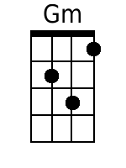  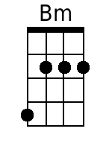  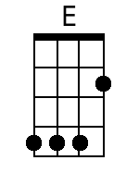               | C7 C7 C7 F  Just hear those sleigh bells jing-a-ling  Gm F  Ring ting ting-a-ling too  Gm F  Come on it's lovely weather for a  Gm F  Sleigh ride together with you.  Gm F  Out-side the snow is falling and  Gm F  Friends are calling ‘you hoo!’  Gm F  Come on it's lovely weather for a  Gm F  Sleigh ride to-gether with you.  Bm E  Giddy-up giddy-up giddy-up let's go  A  Let's look at the show  Bm E A  We're riding in a wonderland of snow.  Am D  Giddy-up giddy-up giddy-up it's grand  G  Just holding your hand  Gm  We're riding along with a song  C7 C7-Hold  Of a wintery fairy land.  [NC] F  Our cheeks are nice and rosy  Gm F  And comfy cozy are we  Gm F  We’re snuggled up together like two  Gm F  Birds of a feather would be.  Gm F  Let's take that road before us and  Gm F Gm  Sing a chorus or two  F  Come on it's lovely weather for a  Gm F  Sleigh ride together with you.  Ending Last Time Through:  Gm  It's lovely weather for a sleigh ride  F  To-gether with you.  Interlude:  F  There's a birthday party at the home of farmer Grey. It'll be the perfect ending of a perfect day  F Gm  We'll be singing the songs we love to sing  A7 Dm  With-out a single stop.  A7  At the fireplace while we  D Gm  Watch the chestnuts pop. Pop! Pop! Pop!  F  There's a happy feeling nothing in this world can buy. When they pass around the cider and the pumpkin pie.  F Gm  It'll nearly be like a picture print  A7  By Currier & Ives  C  These wonderful things are the things  C7  We re-member all through our lives.  Repeat From Beginning | Bari      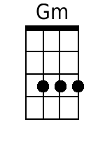  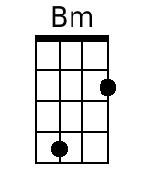  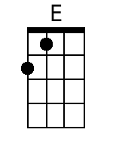  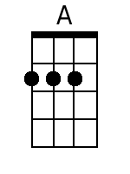            

Sleigh Ride
Words by Mitchell Parish (1950) & Music by Leroy Anderson (1948)
Key of G

Intro:
G G Em Em Am Am D7 D7 G G Em Em Am Am D7-Hold

G Em
Just hear those sleigh bells jing-a-ling
Am D7 G Em Em Am
Ring ting ting-a-ling too
Am D7 G Em
Come on it's lovely weather for a
Am D7 G Em Em Am
Sleigh ride together with you
Am D7 G Em
Out -side the snow is falling and
Am D7 G Em Em Am
Friends are calling ‘you hoo!’
Am D7 G Em
Come on it's lovely weather for a
Am D7 G G G G
Sleigh ride to-gether with you

C#m F#
Giddy-up giddy-up giddy-up let's go
B
Let's look at the show
C#m F# B
We're riding in a wonderland of snow
Bm E
Giddy-up giddy-up giddy-up it's grand
A
Just holding your hand
Am D7 D7-Hold
We're riding along with a song of a wintery fairy land.

G Em Am D7 G Em Em Am
Our cheeks are nice and rosy and comfy cozy are we
Am D7 G Em
We’re snuggled up to-gether
Am D7 G Em Em Am
Like two birds of a feather would be
Am D7 G Em
Let's take that road be-fore us and
Am D7 G Em Em Am
Sing a chorus or two
Am D7 G Em
Come on it's lovely weather for a
Am D7 G G G G
Sleigh ride to-gether with you

Ending Last Time Through:
Em Am D7 G
It's lovely weather for a sleigh ride to-gether with you.

Bridge
Gmaj7 G6
There's a birthday party at the home of farmer Grey
Gmaj7 G6
It'll be the perfect ending of a perfect day
G Am D7 B7 Em
We'll be singing the songs we love to sing with-out a single stop
B7 E Am D7
At the fireplace while we watch the chestnuts pop Pop! Pop! Pop!

Gmaj7 G6
There's a happy feeling nothing in this world can buy
Gmaj7 G6
When they pass around the cider and the pumpkin pie
G Am D7 B7 Em
It'll nearly be like a picture print by Currier & Ives
D
These wonderful things are the things
D7 D7-Hold
We re-member all through our lives.

Repeat From Beginning

Minor Seventh Alternate Introduction

?????Minor????? Seventh Alternate Introduction – Key of C:
Gm7 Em7 Am7 Em7
Soprano – Concert – Tenor Uke:
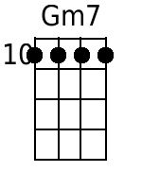 | 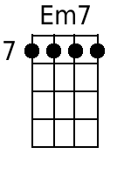 | 
Baritone Uke:
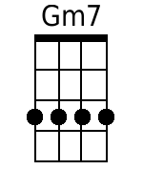 | 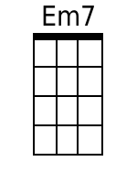 | 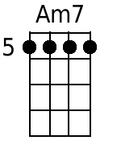

Minor Seventh Alternate Introduction – Key of F:
Cm7 Am7 Dm7 Am7
Soprano – Concert – Tenor Uke:
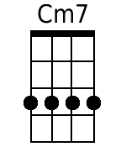 |  | 
Baritone Uke:
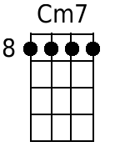 |  | 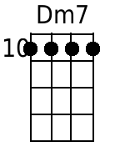

Minor Seventh Alternate Introduction – Key of G:
Dm7 Bm7 Em7 Bm7
Soprano – Concert – Tenor Uke:
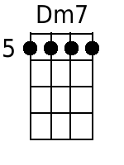 | 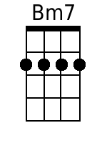
Baritone Uke:
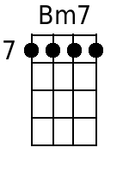

Major Seventh Alternate Introduction

Major Seventh Alternate Introduction – Key of C:
Gmaj7 Emaj7 Amaj7 Emaj7
Soprano – Concert – Tenor Uke:
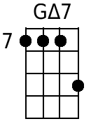 | 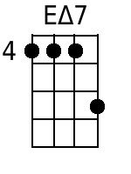 | 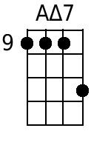
Baritone Uke:
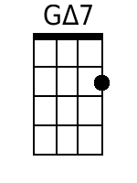 | 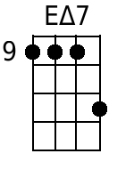 | 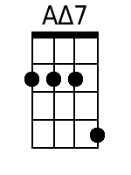

Major Seventh Alternate Introduction – Key of F:
Cmaj7 Amaj7 Dmaj7 Amaj7
Soprano – Concert – Tenor Uke:
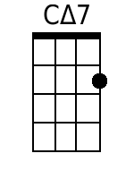 |  | 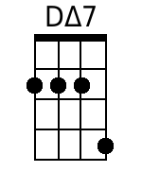
Baritone Uke:
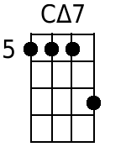 |  | 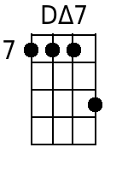

Major Seventh Alternate Introduction – Key of G:
Dmaj7 Bmaj7 Emaj7 Bmaj7
Soprano – Concert – Tenor Uke:
 | Error: Should be same form @ 11 |  | Error: Should be same form @ 11
Baritone Uke:
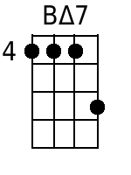

Major Key Alternate Introduction

Major Alternate Introduction – Key of C:
G E A E
Soprano – Concert – Tenor Uke:
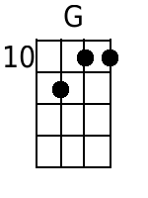 | 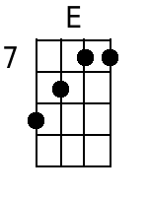
Baritone Uke:
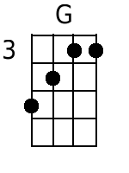 |  | 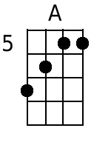

Major Alternate Introduction – Key of F:
C A D A
Soprano – Concert – Tenor Uke:
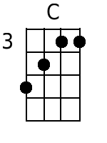 |  | 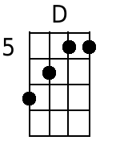
Baritone Uke:
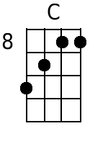 |  | 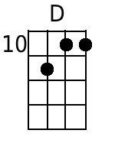

Major Alternate Introduction – Key of G:
D B E B
Soprano – Concert – Tenor Uke:
 | 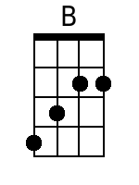  Error: Should be same form @ 11 |  | Error: Should be same form @ 11
Baritone Uke:


