Sleigh Ride (C)
Music by Leroy Anderson (1948) & Words by Mitchell Parish (1950)
As performed by The Ronettes

4 Measure Introduction: C Am Dm G7  G7 C Dm C  Just hear those sleigh bells jing-a-ling, Ring ting ting-a-ling too.  Dm C Dm C  Come on it's lovely weather for a sleigh ride together with you.  Dm C Dm C  Out-side the snow is falling and friends are calling ‘you hoo!’  Dm C Dm C  Come on it's lovely weather for a sleigh ride to-gether with you.  G7 C Dm C  Our cheeks are nice and rosy and comfy cozy are we.  Dm C Dm C  We’re snuggled up to-gether like two birds of a feather would be.  Dm C Dm C  Let's take that road be-fore us and sing a chorus or two.  Dm C Dm C  Come on it's lovely weather for a sleigh ride to-gether with you.  2nd time through, repeat last line 3x.  CΔ7 C6  There's a birthday party at the home of farmer Grey  CΔ7 C6  It'll be the perfect ending of a perfect day  C Dm C E7 Am  We'll be singing the songs we love to sing with-out a single stop  E7 Em G7  At the fireplace while we watch the chestnuts pop. Pop! Pop! Pop!  CΔ7 C6  There's a happy feeling nothing in this world can buy,  CΔ7 C6  When they pass around the cider and the pumpkin pie.  C Dm E7  It'll nearly be like a picture print by Currier & Ives.  G G7  These wonderful things are the things we re-mem-ber all through our lives.  Repeat From Beginning |  |  |  |  |  |  |  | 
 |  |  |  |  |  |  |  | 
 |  |  |  |  |  |  |  | 
 |  |  |  |  |  |  |  | 
 |  |  |  |  |  |  |  | 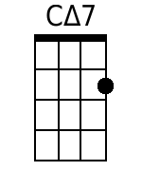
 |  |  |  |  |  |  |  | 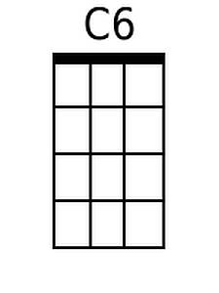
 |  |  |  |  |  |  |  | 
 |  |  |  |  |  |  |  | 
Baritone
 |  |  |  | 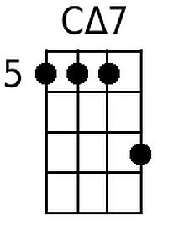 | 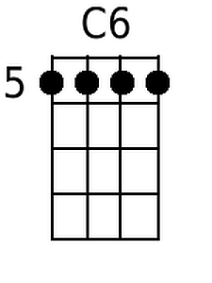 |  | 

Sleigh Ride (G)
Music by Leroy Anderson (1948) & Words by Mitchell Parish (1950)
As performed by The Ronettes

4 Measure Introduction: G Em Am D7  D7 G Am G  Just hear those sleigh bells jing-a-ling, Ring ting ting-a-ling too.  Am G Am G  Come on it's lovely weather for a sleigh ride together with you.  Am G Am G  Out-side the snow is falling and friends are calling 'you hoo!'  Am G Am G  Come on it's lovely weather for a sleigh ride to-gether with you.  D7 G Am G  Our cheeks are nice and rosy and comfy cozy are we.  Am G Am G  We're snuggled up to-gether like two birds of a feather would be.  Am G Am G  Let's take that road be-fore us and sing a chorus or two.  Am G Am G  Come on it's lovely weather for a sleigh ride to-gether with you.  2nd time through, repeat last line 3x.  GΔ7 G6  There's a birthday party at the home of farmer Grey  GΔ7 G6  It'll be the perfect ending of a perfect day  G Am G B7 Em  We'll be singing the songs we love to sing with-out a single stop  B7 Bm D7  At the fireplace while we watch the chestnuts pop. Pop! Pop! Pop!  GΔ7 G6  There's a happy feeling nothing in this world can buy,  GΔ7 G6  When they pass around the cider and the pumpkin pie.  G Am B7  It'll nearly be like a picture print by Currier & Ives.  D D7  These wonderful things are the things we re-mem-ber all through our lives.  Repeat From Beginning |  |  |  |  |  |  |  | 
 |  |  |  |  |  |  |  | 
 |  |  |  |  |  |  |  | 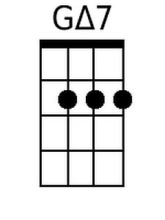
 |  |  |  |  |  |  |  | 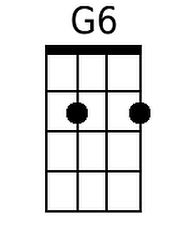
 |  |  |  |  |  |  |  | 
 |  |  |  |  |  |  |  | 
Baritone
 |  |  |  | 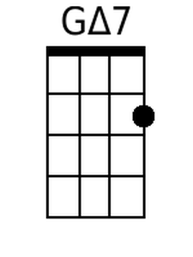 | 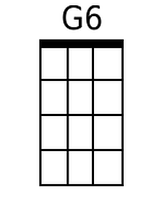 |  | 

