Sleigh Ride (C)
Music by Leroy Anderson (1948) & Words by Mitchell Parish (1950)

4 Measure Introduction: C | Am | Dm | G7 |  G7 C Dm C - Dm  Just hear those sleigh bells jing-a-ling, Ring ting ting-a-ling too.  C Dm C - Dm  Come on it's lovely weather for a sleigh ride together with you.  C Dm C - Dm  Outside the snow is falling and friends are calling ‘you hoo!’  C Dm C - G7  Come on it's lovely weather for a sleigh ride to-gether with you.  C Dm C - Dm  Our cheeks are nice and rosy and comfy cozy are we.  C Dm C - Dm  We’re snuggled up together like two birds of a feather would be.  C Dm C - Dm  Let's take that road before us and sing a chorus or two.  C Dm C - G7  Come on it's lovely weather for a sleigh ride together with you.  2nd time through, repeat last line 3x.  Outro with C | Am | Dm | G7 | C (Hold)  CΔ7 C6  There's a birthday party at the home of farmer Grey  CΔ7 C6  It'll be the perfect ending of a perfect day  C Dm C E7 Am  We'll be singing the songs we love to sing with-out a single stop  E7 Em G7  At the fireplace while we watch the chestnuts pop. Pop! Pop! Pop!  CΔ7 C6  There's a happy feeling nothing in this world can buy,  CΔ7 C6  When they pass around the cider and the pumpkin pie.  C Dm C E7 Am  It'll nearly be like a picture print by Curri-er & Ives.  G G7  These wonderful things are the things we re-mem-ber all through our lives.  Repeat From Beginning |  |  |  |  |  |  | 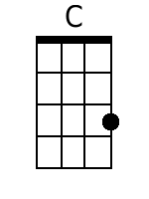 | 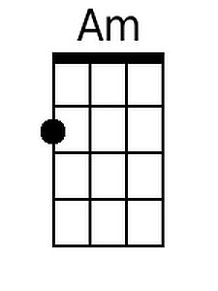
 |  |  |  |  |  |  | 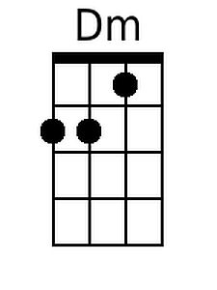 | 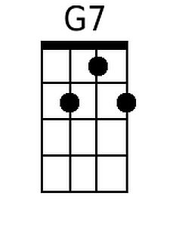
 |  |  |  |  |  |  | 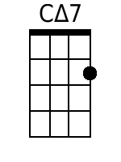 | 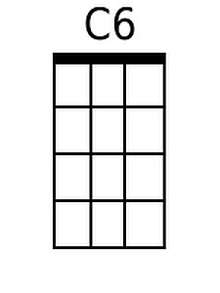
 |  |  |  |  |  |  | 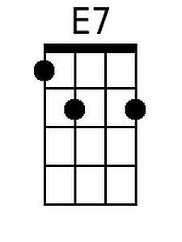 | 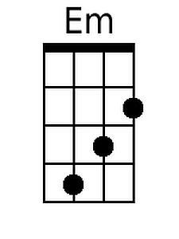
 |  |  |  |  |  |  | 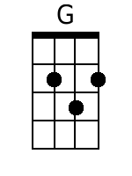
Baritone
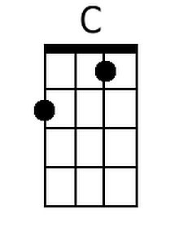 | 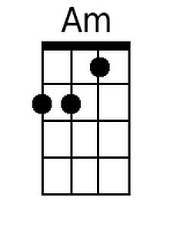 | 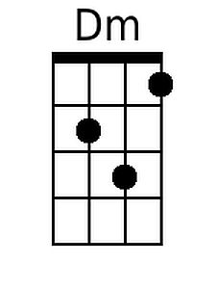 | 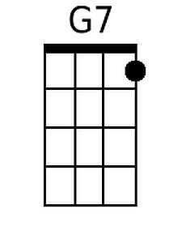 | 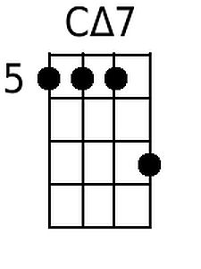 | 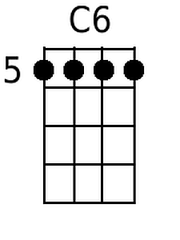 | 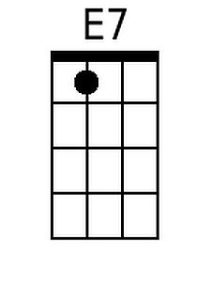 | 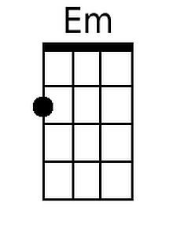 | 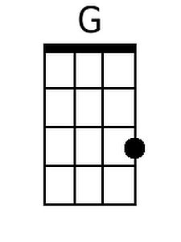

Sleigh Ride (D)
Music by Leroy Anderson (1948) & Words by Mitchell Parish (1950)

4 Measure Introduction: D | Bm | Em | A7 |  A7 D Em D - Em  Just hear those sleigh bells jing-a-ling, Ring ting ting-a-ling too.  D Em D - Em  Come on it's lovely weather for a sleigh ride together with you.  D Em D - Em  Out-side the snow is falling and friends are calling 'you hoo!'  D Em D - A7  Come on it's lovely weather for a sleigh ride to-gether with you.  D Em D - Em  Our cheeks are nice and rosy and comfy cozy are we.  D Em D - Em  We're snuggled up together like two birds of a feather would be.  D Em D - Em  Let's take that road before us and sing a chorus or two.  D Em D - A7  Come on it's lovely weather for a sleigh ride together with you.  2nd time through, repeat last line 3x.  Outro with D | Bm | Em | A7 | D (Hold)  DΔ7 D6  There's a birthday party at the home of farmer Grey  DΔ7 D6  It'll be the perfect ending of a perfect day  D Em D F#7 Bm  We'll be singing the songs we love to sing with-out a single stop  F#7 F#m A7  At the fireplace while we watch the chestnuts pop. Pop! Pop! Pop!  DΔ7 D6  There's a happy feeling nothing in this world can buy,  DΔ7 D6  When they pass around the cider and the pumpkin pie.  D Em D F#7 Bm  It'll nearly be like a picture print by Curri - er & Ives.  A A7  These wonderful things are the things we re-mem-ber all through our lives.  Repeat From Beginning |  |  |  |  |  |  | 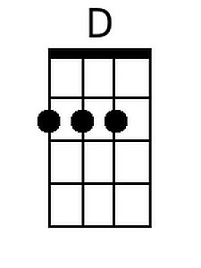 | 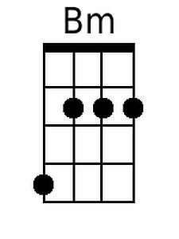
 |  |  |  |  |  |  |  | 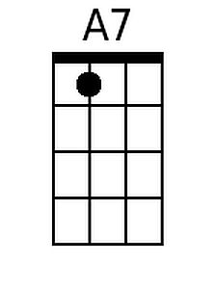
 |  |  |  |  |  |  | 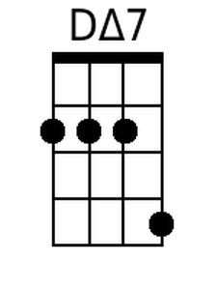
 |  |  |  |  |  |  | 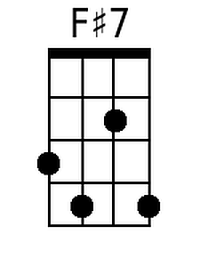 | 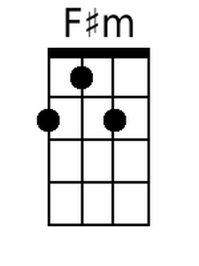
 |  |  |  |  |  |  | 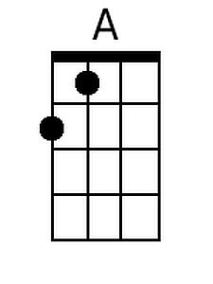
Baritone
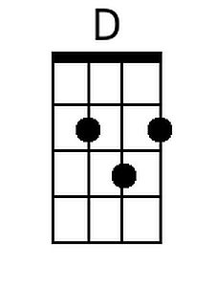 | 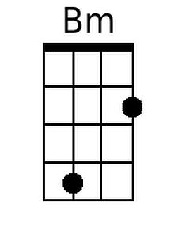 |  | 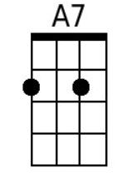 | 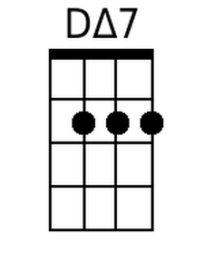 | 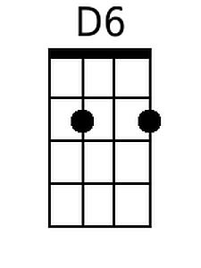 | 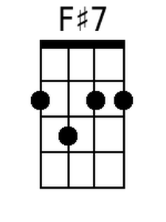 | 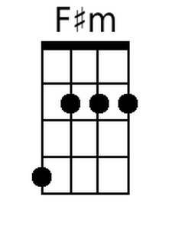 | 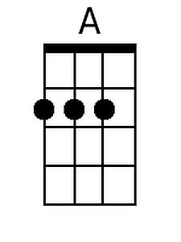

Sleigh Ride (G)
Music by Leroy Anderson (1948) & Words by Mitchell Parish (1950)

4 Measure Introduction: G | Em | Am | D7 |

D7 G Am G - Am
Just hear those sleigh bells jing-a-ling, Ring ting ting-a-ling too.
G Am G - Am
Come on it's lovely weather for a sleigh ride together with you.
G Am G - Am
Out-side the snow is falling and friends are calling 'you hoo!'
G Am G - D7
Come on it's lovely weather for a sleigh ride together with you.

G Am G - Am
Our cheeks are nice and rosy and comfy cozy are we.
G Am G - Am
We're snuggled up together like two birds of a feather would be.
G Am G - Am
Let's take that road before us and sing a chorus or two.
G Am G - D7
Come on it's lovely weather for a sleigh ride together with you.
2nd time through, repeat last line 3x.
Outro with G | Em | Am | D7 | G (Hold)

GΔ7 G6
There's a birthday party at the home of farmer Grey
GΔ7 G6
It'll be the perfect ending of a perfect day
G Am G B7 Em
We'll be singing the songs we love to sing with-out a single stop
B7 Bm D7
At the fireplace while we watch the chestnuts pop. Pop! Pop! Pop!
GΔ7 G6
There's a happy feeling nothing in this world can buy,
GΔ7 G6
When they pass around the cider and the pumpkin pie.
G Am G B7 Em
It'll nearly be like a picture print by Curri-er & Ives.
D D7
These wonderful things are the things we re-mem-ber all through our lives.
Repeat From Beginning

 |  |  |  |  |  |  |  | 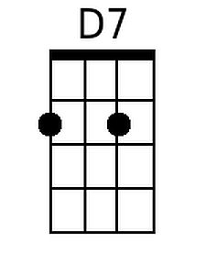
 |  |  |  |  |  |  | 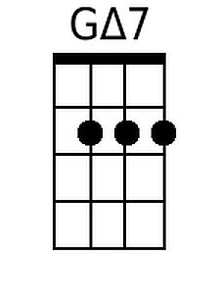 | 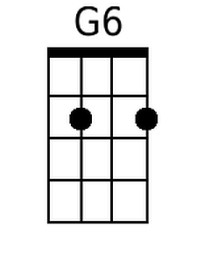
 |  |  |  |  |  |  | 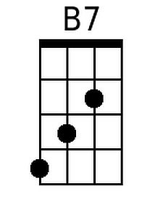
Baritone
 |  |  | 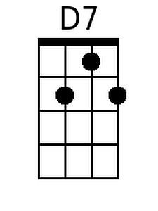 | 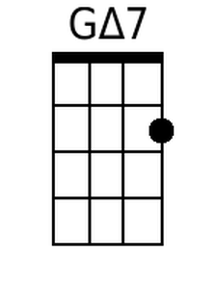 | 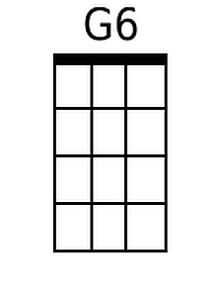 | 