Sleigh Ride (D)
Music by Leroy Anderson (1948) & Words by Mitchell Parish (1950)
As performed by The Ronettes

4 Measure Introduction: D Bm Em A7  A7 D Em D  Just hear those sleigh bells jing-a-ling, Ring ting ting-a-ling too.  Em D Em D  Come on it's lovely weather for a sleigh ride together with you.  Em D Em D  Out-side the snow is falling and friends are calling 'you hoo!'  Em D Em D  Come on it's lovely weather for a sleigh ride to-gether with you.  A7 D Em D  Our cheeks are nice and rosy and comfy cozy are we.  Em D Em D  We're snuggled up to-gether like two birds of a feather would be.  Em D Em D  Let's take that road be-fore us and sing a chorus or two.  Em D Em D  Come on it's lovely weather for a sleigh ride to-gether with you.  2nd time through, repeat last line 3x.  DΔ7 D6  There's a birthday party at the home of farmer Grey  DΔ7 D6  It'll be the perfect ending of a perfect day  D Em D F#7 Bm  We'll be singing the songs we love to sing with-out a single stop  F#7 F#m A7  At the fireplace while we watch the chestnuts pop. Pop! Pop! Pop!  DΔ7 D6  There's a happy feeling nothing in this world can buy,  DΔ7 D6  When they pass around the cider and the pumpkin pie.  D Em F#7  It'll nearly be like a picture print by Currier & Ives.  A A7  These wonderful things are the things we re-mem-ber all through our lives.  Repeat From Beginning |  |  |  |  |  |  |  | 
 |  |  |  |  |  |  |  | 
 |  |  |  |  |  |  |  | 
 |  |  |  |  |  |  |  | 
 |  |  |  |  |  |  |  | 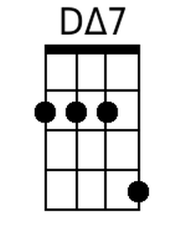
 |  |  |  |  |  |  |  | 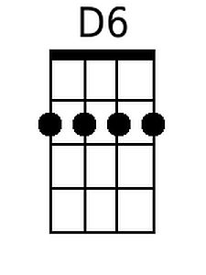
 |  |  |  |  |  |  |  | 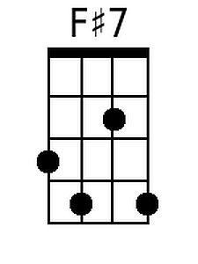
Baritone |  |  |  |  |  |  |  | 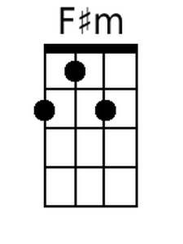
 |  |  |  | 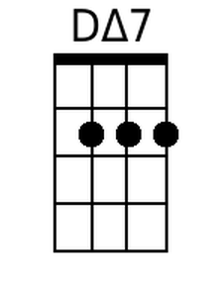 | D6 | F#7 | F#m

