**Smoke Gets in Your Eyes**

**C Am Dm G C Am F**

They asked me how I knew, my true love was true, oh, oh,

**Dm Em A7 Dm G C Am Dm G**

I of course replied, something here inside cannot be denied.

**C Am Dm G C Am F**

They said, someday you'll find all who love are blind, oh, oh,

**Dm Em A7 Dm G C**

When your heart's on fire, you must realize smoke gets in your eyes.



C

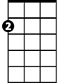

G

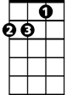

Dm

**Eb C Eb**

**Ab**

So I chaffed them and I gaily laughed,

**Eb D Eb**

Em

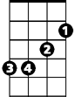

F

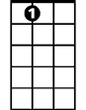

A7

To think they could doubt my love.

**Ab Fm**

Yet today my love has flown away,

**C Am Dm G**

I am without my love.

**C Am Dm G C Am F**

Now laughing friends deride tears I cannot hide, oh, oh

**Dm Em A7 Dm**

So I smile and say, when a lovely flame dies,

**G C Dm**

Smoke gets in your eyes, your eyes,

**Dm F C**

Smoke gets in your eyes.

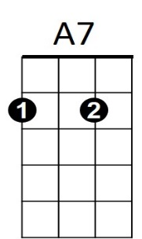

**BARITONE**

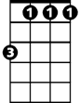

Fm

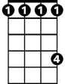

Ab

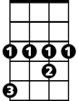

Eb



EmAm



F



G

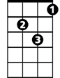

Dm



Am

C



**Smoke Gets in Your Eyes**

**D Bm Em A D Bm G**

They asked me how I knew, my true love was true, oh, oh,

**Em F#m B7 Em A D -Bm-Em-A**

I of course replied, something here inside cannot be denied.

**D Bm Em A D Bm G**

They said, someday you'll find all who love are blind, oh, oh,

**Em F#m B7 Em A D**

when your heart's on fire, you must realize smoke gets in your eyes.

**- G - D - F**

**Bb**

So I chaffed them and I gaily laughed,

**F E F**

to think they could doubt my love.

**Bb** Gm

Yet today my love has flown away,

**D Bm Em - A**

I am without my love.

**D Bm Em A D Bm G**

Now laughing friends deride tears I cannot hide, oh, oh

**Em F#m B7 Em**

so I smile and say, when a lovely flame dies,

**A D Em**

smoke gets in your eyes, your eyes,

**D Em G Em G D**

smoke gets in your eyes, smoke gets in your eyes.