Smoke Gets in Your Eyes (Jerome Kern & Otto Harbach, 1933) (G)

G Em Am D G Em C  They asked me how I knew, my true love was true, oh, oh,  Am Bm E7 Am D G Em Am D  I of course replied, something here inside cannot be denied.  G Em Am D G Em C  They said, someday you'll find all who love are blind, oh, oh,  Am Bm E7 Am D G  When your heart's on fire, you must realize smoke gets in your eyes.  Bb G Bb  Eb  So I chaffed them and I gaily laughed,  Bb A Bb  To think they could doubt my love.  Eb Cm  Yet today my love has flown away,  G Em Am D  I am without my love.  G Em Am D G Em C  Now laughing friends deride tears I cannot hide, oh, oh  Am Bm E7 Am  So I smile and say, when a lovely flame dies,  D G Am  Smoke gets in your eyes, your eyes,  Am C G  Smoke gets in your eyes. |  |  |  |  |  | 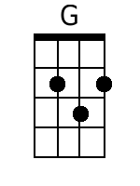 | 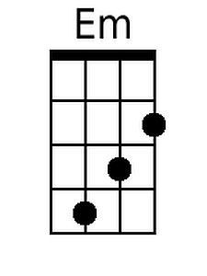
 |  |  |  |  |  | 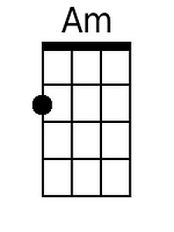 | 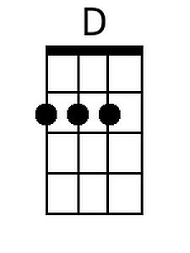
 |  |  |  |  |  | 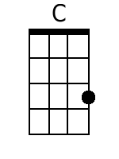 | 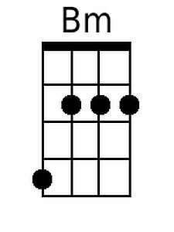
 |  |  |  |  |  | 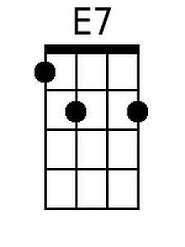 | 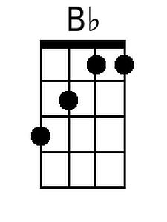
 |  |  |  |  |  | 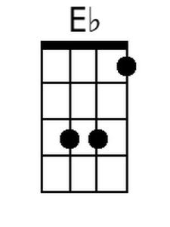 | 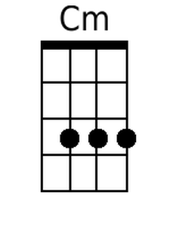
Bari
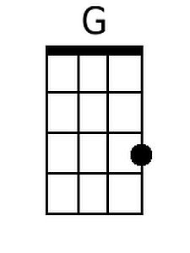 | 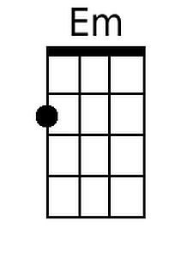 | 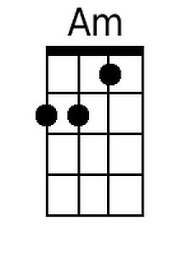 | 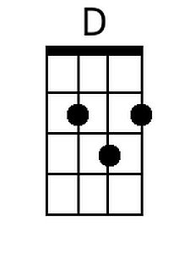 | 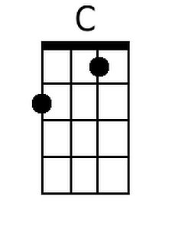
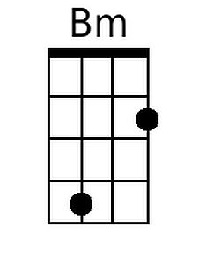 | 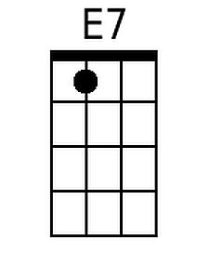 | 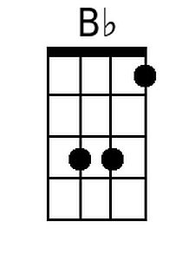 | 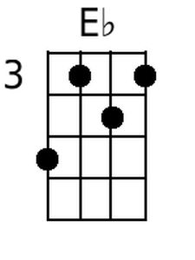 | 