**Smooth (Robert Thomas / Itaal Shur)**

**Intro: Am F E E7**

**Am F E**

Man, it's a hot one

**E7 Am F E**

Like seven inches from the midday sun

**E7 Dm7**

Well, I hear you whisper and the words melt everyone

**E7**

But you stay so cool

**Am F E E7 Am F E**

My muñequita, my Spanish Harlem Mona Lisa

**E7 Dm7**

You' re my reason for reason

**E7**

The step in my groove

**Chorus:**

**Am E E7**

And if you say this life ain't good enough

**Am F E E7**

I would give my world to lift you up

**Am F E E7 Dm7**

I could change my life to better suit your mood

**E7**

Because you're so smooth

**Am E E7**

And it's just like the ocean under the moon

**Am F E E7**

Oh, it's the same as the emotion that I get from you

**Am F E E7**

You got the kind of lovin' that can be so smooth, yeah

**F Dm7 E7**

Give me your heart, make it real or else forget about it

**Am F E E7 (4X)**

**Am F E**

But I'll tell you one thing

**E7 Am F E**

If you would leave it'd be a crying shame

**E7 Dm7**

In every breath and every word

**E7**

I hear your name calling me out

**BARITONE**

**Am F E**

Out from the barrio

**E7 Am F E**

You hear my rhythm on your radio

**E7 Dm7**

You feel the turning of the world, so soft and slow

**E7**

It's turning you round and round

**(Chorus)**

**Am E E7**

Oh, and it's just like the ocean under the moon

**Am F E E7**

Oh, it's the same as the emotion that I get from you

**Am F E E7**

You got the kind of lovin' that can be so smooth, yeah

**F Dm7 E7**

Give me your heart, make it real or else forget about it

**(Repeat to fade)**

**Am F E E7**

Or else forget about it

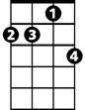

Dm7

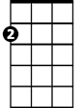

Am

F



E

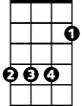

E7

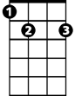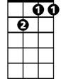

Dm7

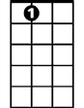

E7



F

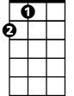

E

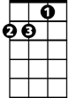

Am

**Smooth (Robert Thomas / Itaal Shur)**

**Intro: Dm Bb A A7**

**Dm Bb A**

Man, it's a hot one

**A7 Dm Bb A**

Like seven inches from the midday sun

**A7 Gm7**

Well, I hear you whisper and the words melt everyone

**A7**

But you stay so cool

**Dm Bb A A7 Dm Bb A**

My muñequita, my Spanish Harlem Mona Lisa

**A7 Gm7**

You're my reason for reason

**A7**

The step in my groove

**Chorus:**

**Dm A A7**

And if you say this life ain't good enough

**Dm Bb A A7**

I would give my world to lift you up

**Dm Bb A A7 Gm7**

I could change my life to better suit your mood

**A7**

Because you're so smooth

**Dm A A7**

And it's just like the ocean under the moon

**Dm Bb A A7**

Oh, it's the same as the emotion that I get from you

**Dm Bb A A7**

You got the kind of lovin' that can be so smooth, yeah

**Bb Gm7 A7**

Give me your heart, make it real or else forget about it

**Dm Bb A A7 (4X)**

**Dm Bb A**

But I'll tell you one thing

**A7 Dm Bb A**

If you would leave it'd be a crying shame

**A7 Gm7**

In every breath and every word

**A7**

I hear your name calling me out

**BARITONE**

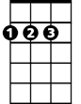

A

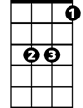

Bb

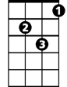

Dm

**Dm Bb A**

Out from the barrio

**A7 Dm Bb A**

You hear my rhythm on your radio

**A7 Gm7**

You feel the turning of the world, so soft and slow

**A7**

It's turning you round and round

**(Chorus)**

**Dm A A7**

Oh, and it's just like the ocean under the moon

**Dm Bb A A7**

Oh, it's the same as the emotion that I get from you

**Dm Bb A A7**

You got the kind of lovin' that can be so smooth, yeah

**Bb Gm7 A7**

Give me your heart, make it real or else forget about it

**(Repeat to fade)**

**Dm Bb A A7**

Or else forget about it



Gm7



Dm



Bb



A



A7

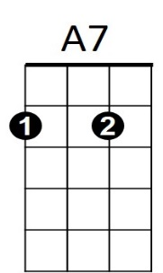

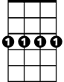

Gm7