Snoopy vs The Red Baron (Phil Gernhard, Dick Holler) (C)
Snoopy vs The Red Baron by The Royal Guardsmen (In F#)

Intro C  C F  After the turn of the century,  C G7  In the clear blue skies over Germany.  C F  Came a roar and a thunder men had never heard,  G7 C  Like the screamin' sound of a big war bird.  C F  Up in the sky, a man in a plane,  C G7  Baron von Richthoven was his name.  C F  Eighty men tried and eighty men died,  G7 C  Now they're buried together on the country side.  Chorus 1  C F  Ten, twenty, thirty, forty, fifty and more,  C G7  The bloody Red Baron was rollin' up the score.  C F  Eighty men died tryin' to end that spree,  G7 C  Of the bloody Red Baron of Germany.  C F  In the nick of time, a hero arose,  C G7  A funny lookin' dog, with a big black nose.  C F  He flew into the sky to seek revenge,  G7  But the Baron shot him down;  C | C  "Curses! Foiled again!" Chorus 1 |  |  |  | C F  Now Snoopy'd swore that he'd get that man,  C G7  So he asked the great pumpkin for a new battle  C F plan.  He challenged the German to a real dog fight,  G7 C  While the Baron was laughing, he got him in his  sight.  C F G F (2x) C (Key Change) D  D G  The bloody Red Baron was in a fix;  D A7  He tried everything, but he'd run out of tricks.  D G  Snoopy fired once, then he fired twice,  A7 D  And the bloody Red Baron was spinnin' out of sight.  Chorus 2  D G  Ten, twenty, thirty, forty, fifty and more,  D A7  The bloody Red Baron was rollin' up the score.  D G  Eighty men died tryin' to end that spree,  A7 D  Of the bloody Red Baron of Germany.  Repeat Chorus 2 (Turnaround: Well...)  Outro  A7 D A7 D  Of the bloody Red Baron of Germany.
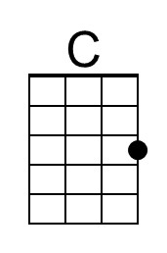 | 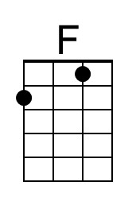 | 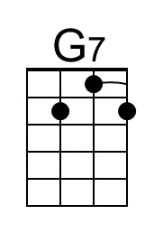 | 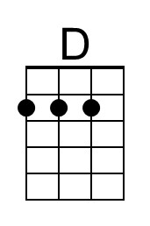 | 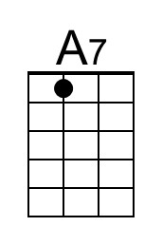
 |  | Bari | 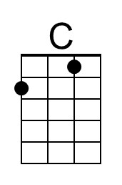 | 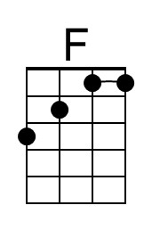 | 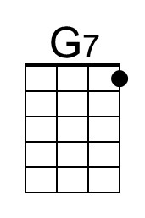 | 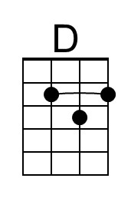 | 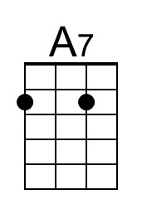

Snoopy vs The Red Baron (Phil Gernhard, Dick Holler) (G)
Snoopy vs The Red Baron by The Royal Guardsmen (In F#)

Intro G  G C  After the turn of the century,  G D7  In the clear blue skies over Germany.  G C  Came a roar and a thunder men had never heard,  D7 G  Like the screamin' sound of a big war bird.  G C  Up in the sky, a man in a plane,  G D7  Baron von Richthoven was his name.  G C  Eighty men tried and eighty men died,  D7 G  Now they're buried together on the country side.  Chorus 1  G C  Ten, twenty, thirty, forty, fifty and more,  G D7  The bloody Red Baron was rollin' up the score.  G C  Eighty men died tryin' to end that spree,  D7 G  Of the bloody Red Baron of Germany.  G C  In the nick of time, a hero arose,  G D7  A funny lookin' dog, with a big black nose.  G C  He flew into the sky to seek revenge,  D7  But the Baron shot him down;  G | G  "Curses! Foiled again!" Chorus 1 |  |  |  | G C  Now Snoopy'd swore that he'd get that man,  G D7  So he asked the great pumpkin for a new battle  G C plan.  He challenged the German to a real dog fight,  D7 G  While the Baron was laughing, he got him in his  sight.  G C D C (2x) G (Key Change) A  A D  The bloody Red Baron was in a fix;  A E7  He tried everything, but he'd run out of tricks.  A D  Snoopy fired once, then he fired twice,  E7 A  And the bloody Red Baron was spinnin' out of sight.  Chorus 2  A D  Ten, twenty, thirty, forty, fifty and more,  A E7  The bloody Red Baron was rollin' up the score.  A D  Eighty men died tryin' to end that spree,  E7 A  Of the bloody Red Baron of Germany.  (Turnaround: Well...)  Chorus 2  Outro  E7 A E7 A  Of the bloody Red Baron of Germany.
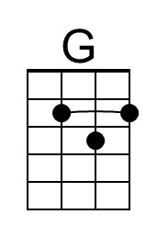 |  | 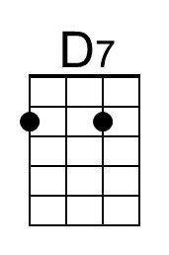 | 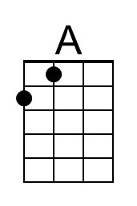 | 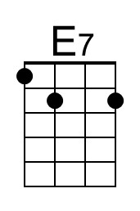
 |  | Bari | 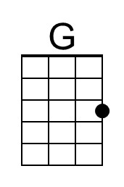 |  | 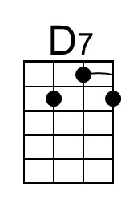 | 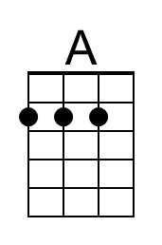 | 