**So Far Away (Carole King)**

**D D6**

So far away -

**D D6 G Em7**

Doesn't anybody stay in one place anymore

**A D G D**

It would be so fine to see your face at my door

**G F#m Em7**

Doesn't help to know

**A D D6**

You're just time away –

**D D6**

Long ago I reached for you

**G Em7**

And there you stood

**A D G D**

Holding you again could only do me good

**G F#m Em7 A D D6 D A**

How I wish I could - but you're s o - far away

**Bm D G D**

One more song about moving along the highway

**Em7 A D**

Can't say much of anything that's n ew

**F#m Em7**

If I could only work this life out my way

**A Bm Em7**

I'd rather spend it bein' close to you

**A D D6**

But you're so far away -

**D D6 G Em7**

Doesn't anybody stay in one place anymore

**A D G D**

It would be so fine to see your face at my door

**G F#m Em7**

Doesn't help to know

**A D D6 D**

You're so far away –

**D6 G Em7 A**

Yeah you're so far away

**BARITONE**

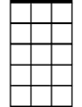

Em7

D6

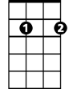

**G D Em7 G**

Travelin' around sure gets me down and lonely

**Em7 A D**

Nothin' else to do but close my mind

**F#m Em7**

I sure hope the road don't come to own me

**A Bm Em7 A7**

There's so many dreams I've yet to find

**A D D6**

But you're so far away -

**D D6 G Em7**

Doesn't anybody stay in one place anymore

**A D G D**

It would be so fine to see your face at my door

**G F#m Em7**

Doesn't help to know

**A D D6 D**

You're so far away, yeah -

**D6 G Em7 A**

You're so far away yeah

**D D6 D**

You're so fa - ar away …

**G Em7 D D6 FADE**

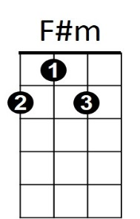

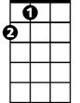

A

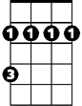

Bm

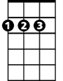

D

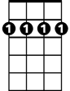

D6



G

Em7



A



F#m



D



G

Bm

