**Softly as I Leave You (Hal Shaper & A. de Vita)**

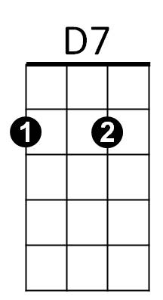**Intro: G Am D7 G Am**

Em

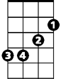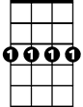

Cm7

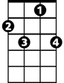

F7



Bb



G

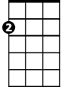

Am



C

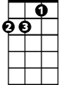

Dm

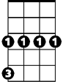

Cm

**G Am D7**

Softly, I will leave you,

**G Am D7 G**

Softly, for my heart would break,

**C G Am**

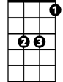

Eb

If you should wake, and, see me go.

**D7**

So I leave you

**G Cm7 F7 Bb**

Softly, Long before you, miss me,

Em7

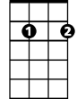

**F7 Bb Eb**

Long before, your arms, can make me stay,

**Dm F7 G Am**

For one more hour, or, one more day.

**D7 G Cm**

After all the years,

**BARITONE**

**D7 Em Em7 C**

C

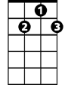

D7

I can't bear the tears, to fall,



Am



G

**Eb Cm7 D7 G Am D7**

So softly, as I leave you there.

**(Repeat from beginning)**

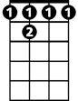

F7

Cm7

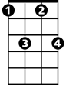

**D7 G Am**



Bb

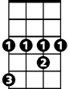

Eb

As I leave you there.

**D7 Cm7 G**

As I leave you the - re.



Em

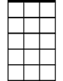

Em7

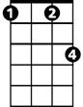

Cm

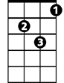

Dm