Some Enchanted Evening (Rodgers & Hammerstein) (C)
Some Enchanted Evening by Perry Como

C D G  Some enchanted evening, you may see a stranger.  C F  You may see a stranger a-cross a crowded room.  C Dm Am  And somehow you know, you know even then,  F Dm G C G  That somewhere you'll see her a-gain and a-gain.  C D G  Some enchanted evening, someone may be laughing.  C F  You may hear her laughing, across a crowded room.  C Dm G C  And night after night, as strange as it seems,  F Dm G C  The sounds of her laughter will sing in your dreams.  Em Dm C F G C F  G Em C  Who can ex-plain it, who can tell you why?  G C D G  Fools give you reasons, wise men never try.  C D G  Some enchanted evening, when you find your true love  C C F  When you feel her call you a-cross a crowded room.  Em Dm G C  Then fly to her side and make her your own,  Em Dm C  Or all through your life you may dream all a-lone. |  |  |  |  |  |  | 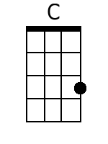
 |  |  |  |  |  |  | 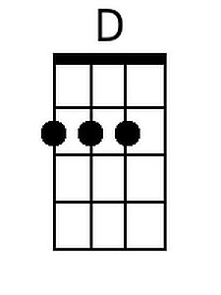
 |  |  |  |  |  |  | 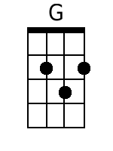
 |  |  |  |  |  |  | 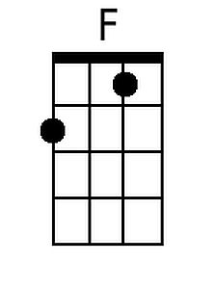
 |  |  |  |  |  |  | 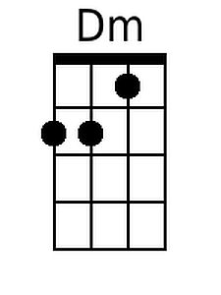
 |  |  |  |  |  |  | 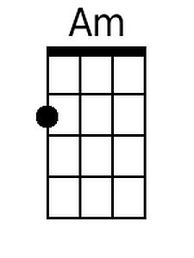
 |  |  |  |  |  |  | 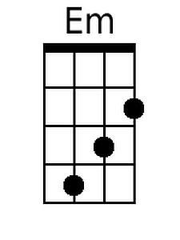
Baritone
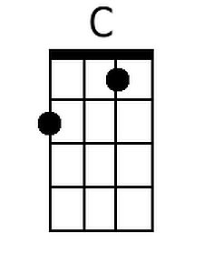 | 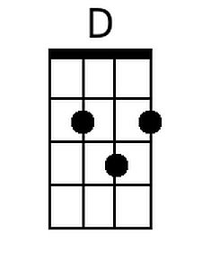 | 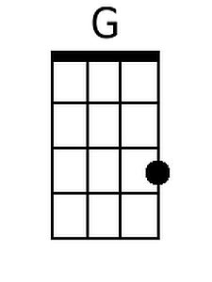 | 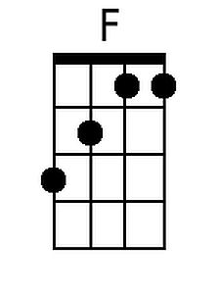 | 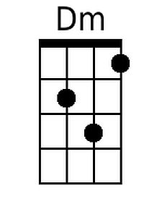 | 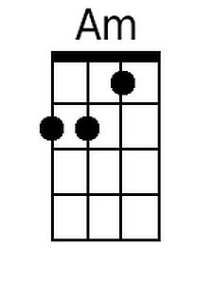 | 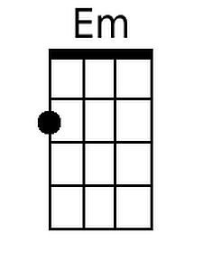

Some Enchanted Evening (Rodgers & Hammerstein) (G)
Some Enchanted Evening by Perry Como

G A D
Some enchanted evening, you may see a stranger.
G C
You may see a stranger a-cross a crowded room.
G Am Em
And somehow you know, you know even then,
C Am D G D
That somewhere you'll see her a-gain and a-gain.

G A D
Some enchanted evening, someone may be laughing.
G C
You may hear her laughing, across a crowded room.
G Am D G
And night after night, as strange as it seems,
C Am D G
The sounds of her laughter will sing in your dreams.

Bm Am G C D G C

D Bm G
Who can ex-plain it, who can tell you why?
D G A D
Fools give you reasons, wise men never try.

G A D
Some enchanted evening, when you find your true love
G G C
When you feel her call you a-cross a crowded room.
Bm Am D G
Then fly to her side and make her your own,
Bm Am G
Or all through your life you may dream all a-lone.

 |  |  |  |  |  |  | 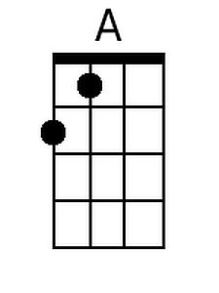
 |  |  |  |  |  |  | 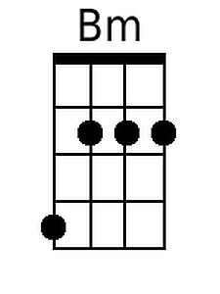
Baritone
 | 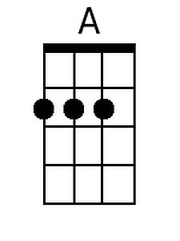 |  |  |  |  | 