Some Enchanted Evening (Rodgers & Hammerstein, 1949) (C)
Some Enchanted Evening by Ezio Pinza (Original Broadway cast recording)

Intro | C | C7 | F | Dm G7 |  C | C C | C C |  Some enchanted evening  G7 G | G G | G G |  You may see a stranger  C C7 F | F F | F F |  You may see a stranger __ across a crowded room  G Dm | Dm G | Dm Dm |  And somehow you know  G Am F | F G | Am Am |  You'll know even then  Am Dm  That somewhere you'll see her,  G C | F C | C C |  Again and a - gain  C | C C | C C |  Some enchanted evening  G7 G | G G | G G |  Someone may be laughin'  C C7 F | FF | F F |  You may hear her laughin' __ across a crowded room  G Dm | Dm G | Dm Dm |  And night after night  G Am | Am F | Am Am |  As strange as it seems  Am Dm  The sound of her laughter  G C | C C | CC|  Will sing in __ your dreams |  |  |  |  |  | 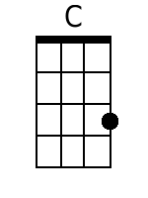 | 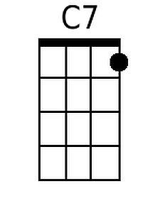
 |  |  |  |  |  | 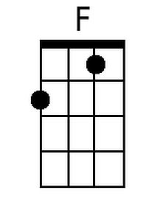 | 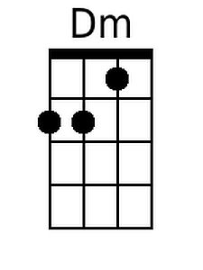
 |  |  |  |  |  | 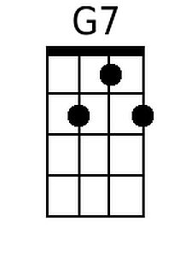 | 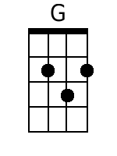
 |  |  |  |  |  | 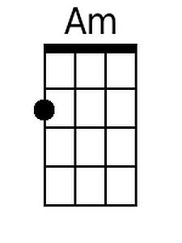
Baritone
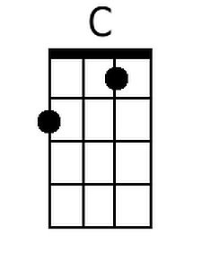 | 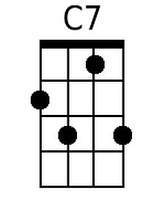 | 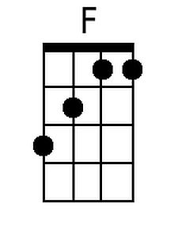 | 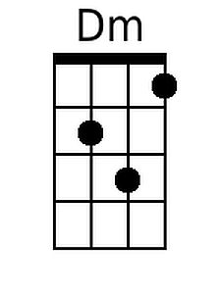
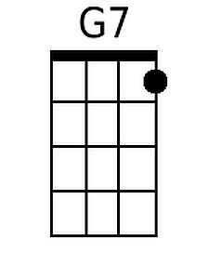 | 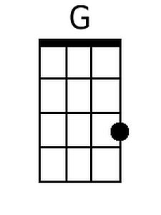 | 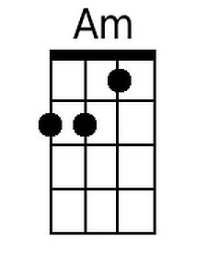

Some Enchanted Evening (C) – Page 2
F C Dm C C
Who can explain it? Who can tell you why?
F C
Fools give you reasons,
Am D G G7 | G7 G7 | G7 G7 |
Wise men never try_______________

C | C C | C C |
Some enchanted evening
G7 G | G G | G G |
When you find your true love
C C7 F | FF | F F |
When you feel her call you __ across a crowded room
G Dm | Dm G | Dm Dm |
Then fly to her side
G Am | FF | Dm Dm |
And make her your own_
Am Dm G7 C | C C | C C |
Or, all through your life, you may dream all a - lone

F C Dm G C | C C |
Once you have found her, never let her go
F C F Dm G7 C | G G | C C | C C|
Once you have found her, neeever let her gooo!

Some Enchanted Evening (Rodgers & Hammerstein, 1949) (G)
Some Enchanted Evening by Ezio Pinza (Original Broadway cast recording)

Intro | G | G7 | C | Am D7 |

G | G G | G G |
Some enchanted evening
D7 D | D D | D D |
You may see a stranger
G G7 C | C C | C C |
You may see a stranger __ across a crowded room
D Am | Am D | Am Am |
And somehow you know
D Em C | C D | Em Em |
You'll know even then
Em Am
That somewhere you'll see her,
D G | C G | G G |
Again and a - gain

G | G G | G G |
Some enchanted evening
D7 D | D D | D D |
Someone may be laughin'
G G7 C | CC | C C |
You may hear her laughin' __ across a crowded room
D Am | Am D | Am Am |
And night after night
D Em | Em C | Em Em |
As strange as it seems
Em Am
The sound of her laughter
D G | G G | GG|
Will sing in __ your dreams

 |  |  |  |  |  | 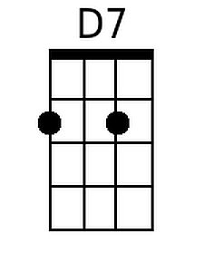 | 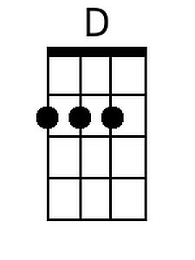
 |  |  |  |  |  | 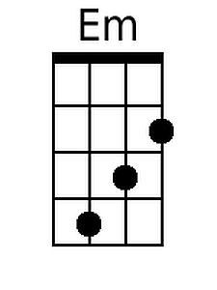
Baritone
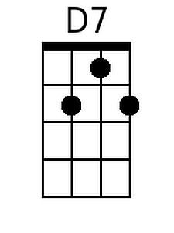 | 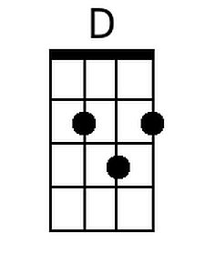 | 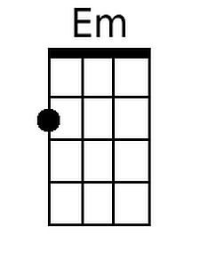

Some Enchanted Evening (G) – Page 2

C G Am G G
Who can explain it? Who can tell you why?
C G
Fools give you reasons,
Em A D D7 | D7 D7 | D7 D7 |
Wise men never try_______________

G | G G | G G |
Some enchanted evening
D7 D | D D | D D |
When you find your true love
G G7 C | CC | C C |
When you feel her call you __ across a crowded room
D Am | Am D | Am Am |
Then fly to her side
D Em | CC | Am Am |
And make her your own_
Em Am D7 G | G G | G G |
Or, all through your life, you may dream all a - lone

C G Am D G | G G |
Once you have found her, never let her go
C G C Am D7 G | D D | G G | G G|
Once you have found her, neeever let her gooo!

