Some Enchanted Evening (Rodgers & Hammerstein, 1949)
Some Enchanted Evening by Ezio Pinza (Original Broadway cast recording)

Intro | G | B | C | Am D |  G | G G | G G |  Some enchanted evening  D | D D | D D |  You may see a stranger  G B C | G G | B B | C C |  You may see a stranger __ across a crowded room  G Am | Am G | Am Am |  And somehow you know  B Em C | C B | Em Em |  You'll know even then  G Am  That somewhere you'll see her,  D G | C G | Am Am | D D | G G | D D |  Again and a - gain  G | G G | G G |  Some enchanted evening  D | D D | D D |  Someone may be laughin'  G B C | G G | B B | C C |  You may hear her laughin' __ across a crowded room  G Am | Am G | Am Am |  And night after night  B Em | Em B | Em Em |  As strange as it seems  G Am  The sound of her laughter  D G | C G | Am Am | D D | G G | D D |  Will sing in __ your dreams |  |  |  |  |  | 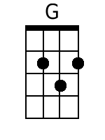 | 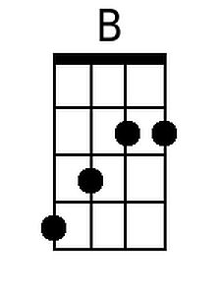
 |  |  |  |  |  | 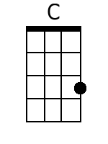 | 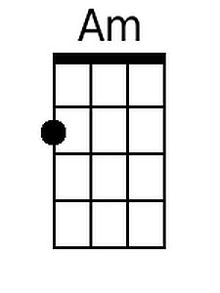
 |  |  |  |  |  | 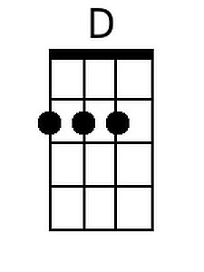 | 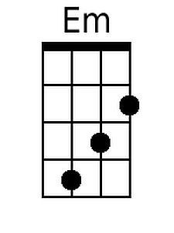
 |  |  |  |  |  | 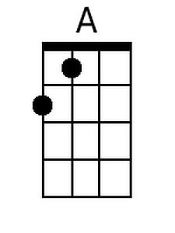 | 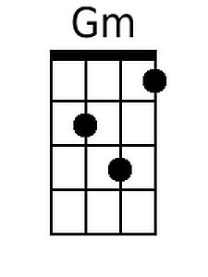
 |  |  |  |  |  | 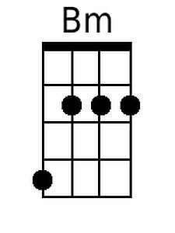 | 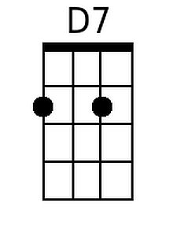
Baritone
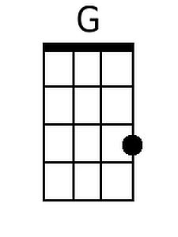 | 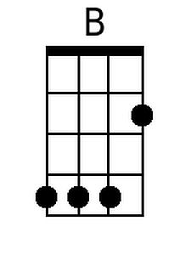 | 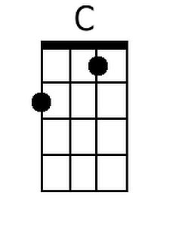 | 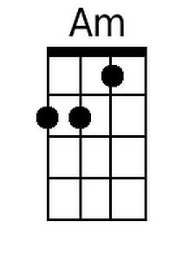 | 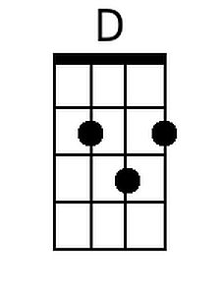
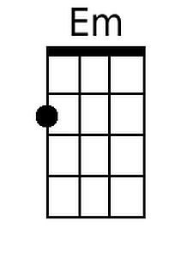 | 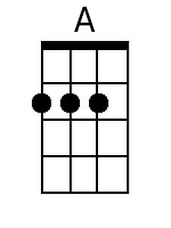 | 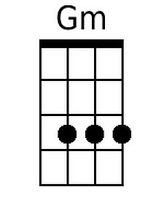 | 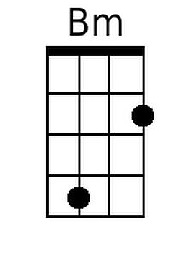 | 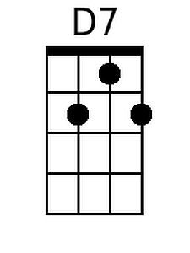

Some Enchanted Evening – Page 2

D G Am D G | D G | Am D |
Who can explain it? Who can tell you why?
D G
Fools give you reasons,
Em A D Gm Bm D7 | D G | Em A | D Gm | Bm D7 |
Wise men never try_______________

G | G G | G G |
Some enchanted evening
Am D | D D | D D |
When you find your true love
G B C | G G | B B | C C |
When you feel her call you __ across a crowded room
G Am | Am G | Am Am |
Then fly to her side
B Em | B B | Em Em |
And make her your own_
G Am D G | C G | Am Am | D D | G G | G G |
Or, all through your life, you may dream all a - lone

D G Am D G | D G | Am D |
Once you have found her, never let her go
D G Am G | D G | Am Am | G G | G G |
Once you have found her, never let her go!

