Some Enchanted Evening (Rodgers & Hammerstein, 1949)
Some Enchanted Evening by Ezio Pinza (Original Broadway cast recording)

Intro | G | G7| C | Am D 7 |  G | G G | G G |  Some enchanted evening  D7 D | D D | D D |  You may see a stranger  G G7 C | CC | C C |  You may see a stranger __ across a crowded room  D Am | Am D | Am Am |  And somehow you know  D Em C | C D | Em Em |  You'll know even then  Em Am  That somewhere you'll see her,  D G | C G | G G |  Again and a - gain  G | G G | G G |  Some enchanted evening  D 7 D | D D | D D |  Someone may be laughin'  G G7 C | CC | C C |  You may hear her laughin' __ across a crowded room  D Am | Am D | Am Am |  And night after night  D Em | Em C | Em Em |  As strange as it seems  Em Am  The sound of her laughter  D G | G G | GG|  Will sing in __ your dreams |  |  |  |  |  | 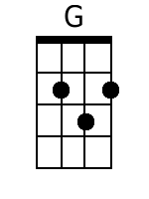 | 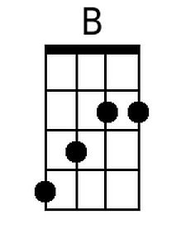
 |  |  |  |  |  | 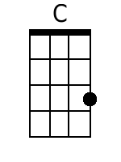 | 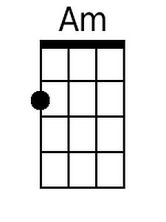
 |  |  |  |  |  | 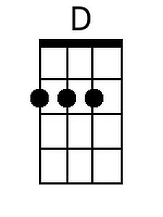 | 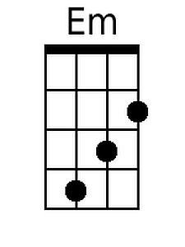
 |  |  |  |  |  | 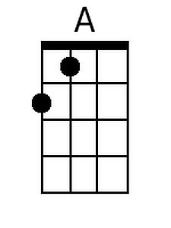 | 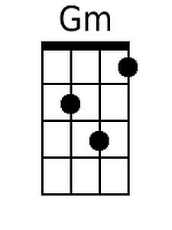
 |  |  |  |  |  | 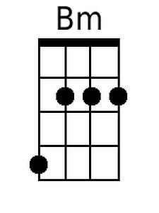 | 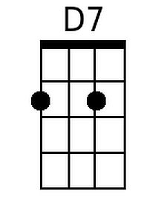
Baritone
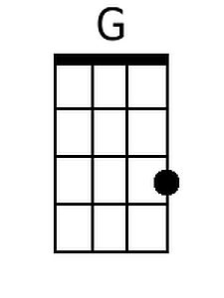 | 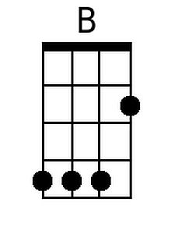 | 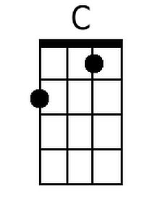 | 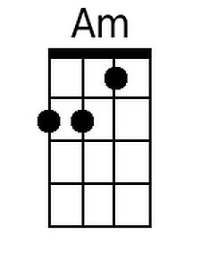 | 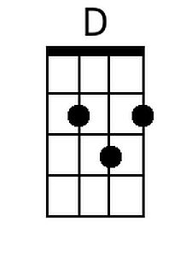
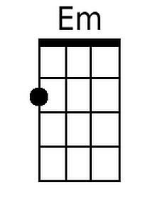 | 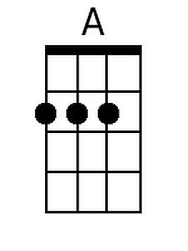 | 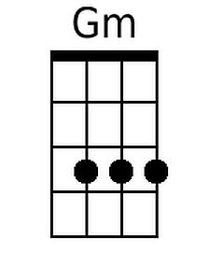 | 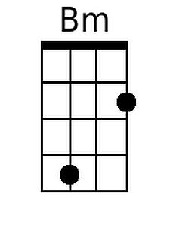 | 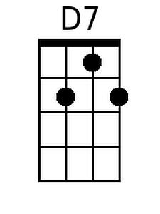

Some Enchanted Evening – Page 2

C G Am G G
Who can explain it? Who can tell you why?
C G
Fools give you reasons,
Em A D D7 | D7 D7 | D7 D7 |
Wise men never try_______________

G | G G | G G |
Some enchanted evening
D7 D | D D | D D |
When you find your true love
G G7 C | CC | C C |
When you feel her call you __ across a crowded room
D Am | Am D | Am Am |
Then fly to her side
D Em | CC | Am Am |
And make her your own_
Em Am D7 G | G G | G G |
Or, all through your life, you may dream all a - lone

C G Am D G | G G |
Once you have found her, never let her go
C G C Am D7 G | D D | G G | G G|
Once you have found her, neeever let her gooo!

