**Some Enchanted Evening (Rodgers & Hammerstein, 1949)**

**Intro:**

**Gsus4 G**

Once you have found her,

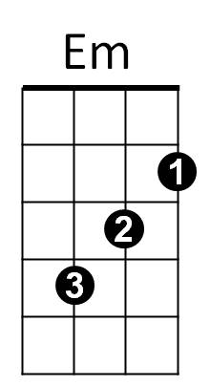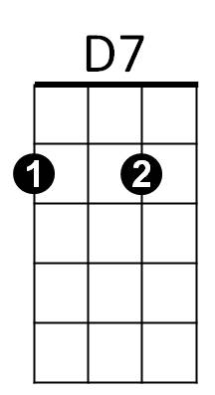**D7 G**

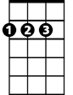

D



C

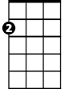

Am

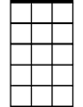

Am7



G

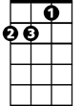

Dm

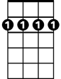

Bm7

Never let her go,

**Gsus4 G**

Once you have found her,

**Am7 Am Am7 D9sus**

Ne - ver let her - .

**G**

Some enchanted evening,

**D7**

You may see a stranger,

**G Gaug**

You may see a stranger

**C Am7**

Across a crowded room,

**Bm7 Am7 D**

And some how you know,

**B7 Em Dm Am7**

You know even then,

**Bm7 Am7**

That somewhere you'll see her

**D7 G D7**

A-gain and a-gain.

**G**

Some enchanted evening,

**D7**

Someone may be laughing,

**G Gaug**

You may hear her laughing

**C Am7**

Across a crowded room

**Bm7 Am7 D**

And night after night,

**B7 Em Dm C**

As strange as it seems,

**Bm7 Am7**

The sound of her laughter

**D7 G**

Will sing in your dreams.

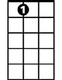

A7

**Gsus4 G**

Who can ex-plain it,

**D7 G**

Who can tell you why?

**Gsus4 G**

**BARITONE**

Fools give you reasons,



G

**A7 Am7 D7**

Wise men never try.

**G**

Some enchanted evening,

**D7**

When you find your true love,

**G Gaug**

When you hear her call you

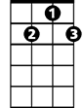

D7

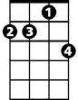

Am7

**C Am7**

Across a crowded room,

**Bm7 Am** **7 D**

Then fly to her side

**B7 Em Dm C**

And make her your own,

**Bm7 Am7**

**Or all through your life



Am

Bm7

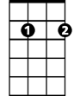

C



D



Em

B7

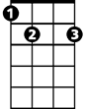

**D7 G**

You ma y dream all a-lone.

**Gsus4 G**

Once you have found her,

**D7 G**

Never let her go,

**Gsus4 G**

Once you have found her,

**Am7 Am Am7 D9sus G**

Ne - ver let her go.

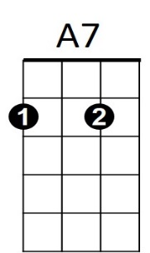

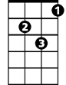

Dm