Some Enchanted Evening (Rodgers and Hammerstein, 1949)
Some Enchanted Evening by Jay and The Americans (1965)

Bb - Am  Once you have found her,  Gm - F  Never let her go.  Bb - Am  Once you have found her,  C Bb  Never let her…  F - FΔ7  Some enchanted evening  C  You may see a stranger,  F  you may see a stranger  Bbm - Gm  Across a crowded room  Fadd9 - Gm C7  And some - how you know,  A - Dm  You know even then  Bb - Gm  That somewhere you'll see her  C - F  A-gain and again.  F - FΔ7  Some enchanted evening  C  Someone may be laughin',  F  You may hear her laughin'  Bbm - Gm  Across a crowded room |  |  | Fadd9 - Gm C7  And night after night,  A - Dm  As strange as it seems  Bb - Gm  The sound of her laughter  C F  Will sing in your dreams.  F - FΔ7  (Some enchanted evening)  C  (You may see a stranger),  F  Oooooooooooh  Bbm - Gm  A-cross a crowded room  Fadd9 - Gm C7  Then fly to her side,  A - Dm  And make her your own  Bb - Gm  Or all through your life you  C F  May dream all a-lone.  Bb - Am  Once you have found her,  Gm - F  Never let her go.  Bb - Am  Once you have found her,  C Bb - F  Never let her go! |  |  |  | 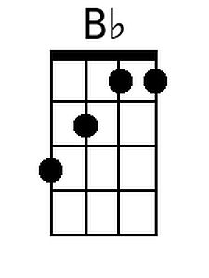 |  | 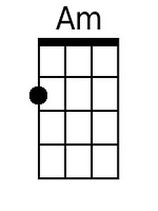
 |  |  |  |  |  |  | 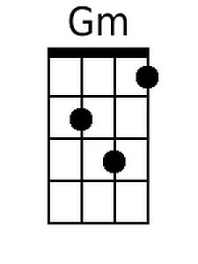 |  | 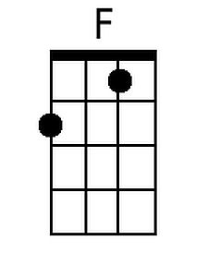
 |  |  |  |  |  |  | 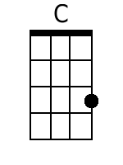 |  | 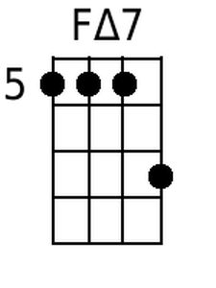
 |  |  |  |  |  |  | 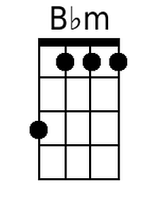 |  | 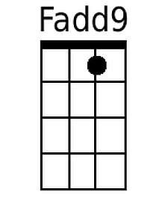
 |  |  |  |  |  |  | 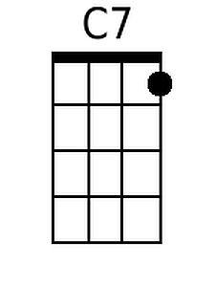 |  | 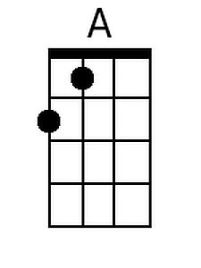
 |  |  |  |  |  |  | 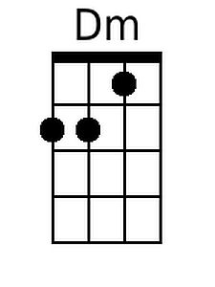
Baritone
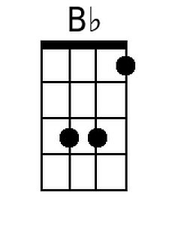 | 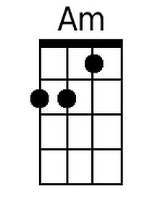 | 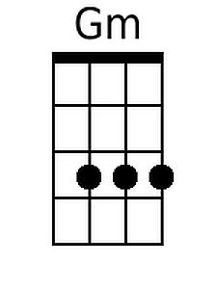 |  | 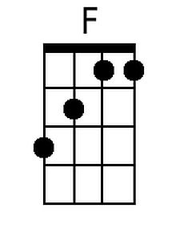 | 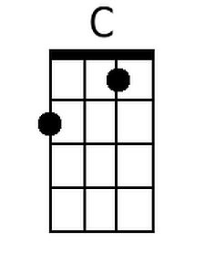 | 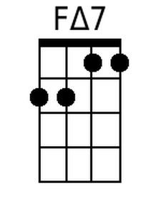
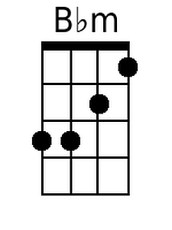 | 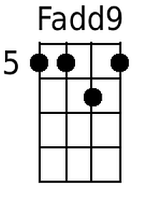 | 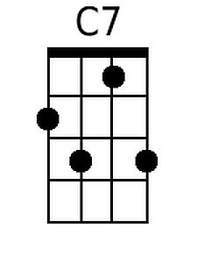 |  | 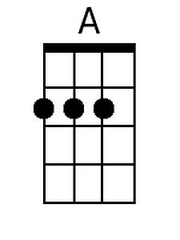 | 