Something (George Harrison) (C)

Intro | F F Eb G |  C Cmaj7  Something in the way she moves,  C7 F G  Attracts me like no other lover.  D D7 G | Am G7 |  Something in the way she woos me.  Chorus  Am Ammaj7 (1000) (2110 -bari)  I don't want to lose her now  Am7 D7 | F F Eb G |  You know I believe and how.  C Cmaj7 (alt bari Cmaj7 2000)  Something in her smile she knows  C7 F G  That I don't need no other lover  D D7 G  Something in her style that shows me. Chorus  Bridge  A C#m7 F#m A  You're asking me will my love grow  D G A  I don't know, I don't know  A C#m7 F#m A  You stick a-round now, it may show  D G C  I don't know, I don't know  (alt for C#maj7 try Amaj7 – 1100) (bari- 2120)  (Instrumental Verse and Chorus)  C Cmaj7  Something in the way she knows  C7 F G  And all I have to do is think of her  D D7 G  Something in the things she shows me. Chorus  Outro F F Eb G | A | F F Eb G | C |  |  |  |  |  | 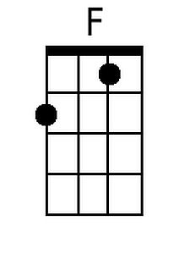 | 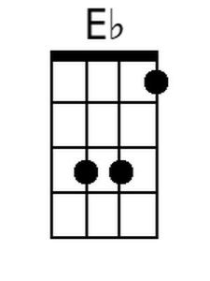 | 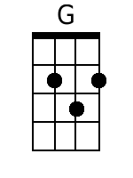
 |  |  |  |  |  | 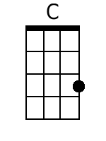 | 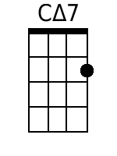 | 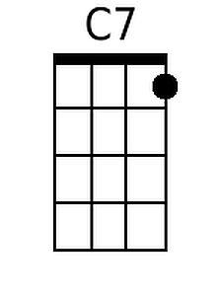
 |  |  |  |  |  | 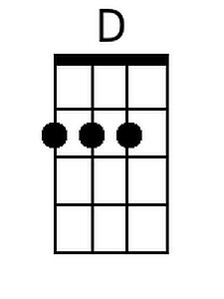 | 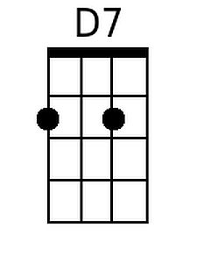 | 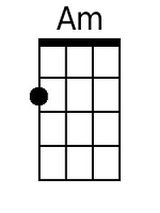
 |  |  |  |  |  | 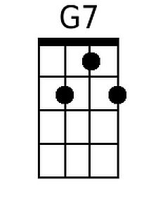 | 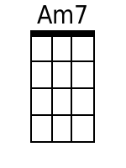 | 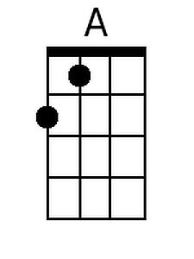
 |  |  |  |  |  | 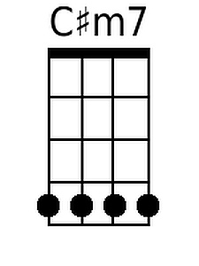 | 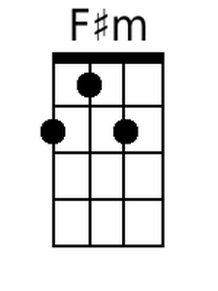
 | Bari | 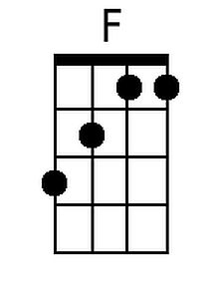 | 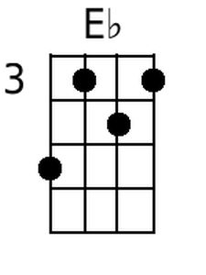 | 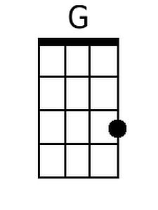 | 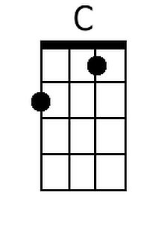 | 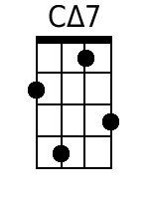 | 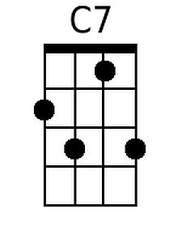 | 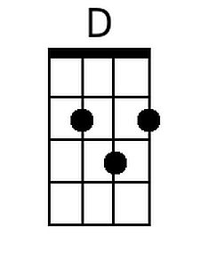
 |  | 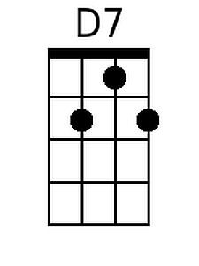 | 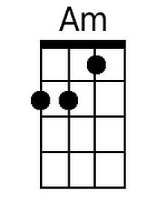 | 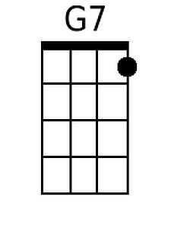 | 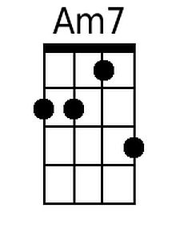 | 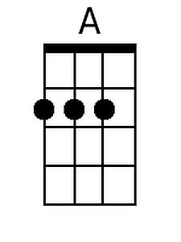 | 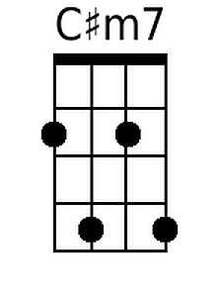 | 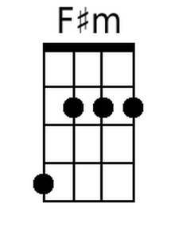

Something (George Harrison) (G)

Intro | C C Bb D |  G Gmaj7  Something in the way she moves,  G7 C  Attracts me like no other lover.  A A7 D | Em D7 |  Something in the way she woos me.  Chorus  Em Em7  I don't want to lose her now  Em A7 | C C Bb D |  You know I believe and how.  G Gmaj7  Something in her smile she knows  G7 C  That I don't need no other lover  A A7 D  Something in her style that shows me. Chorus  Bridge  E G#m7 C#m E  You're asking me will my love grow  A D E  I don't know, I don't know  E G#m7 C#m E  You stick a-round now, it may show  A D G  I don't know, I don't know  G Gmaj7  Something in the way she knows  G7 C  And all I have to do is think of her  A A7 D  Something in the things she shows me. Chorus  Outro C C Bb D | E | C C Bb D | G |  |  |  |  |  |  | 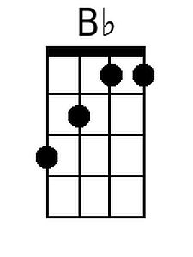
 |  |  |  |  |  |  | 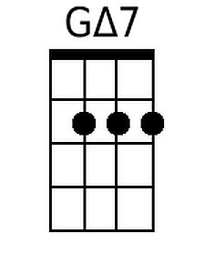
 |  |  |  |  |  |  | 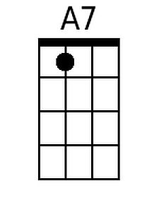 | 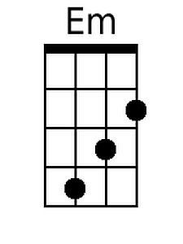
 |  |  |  |  |  |  | 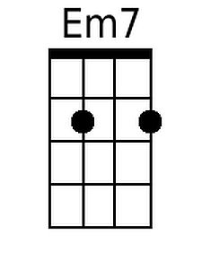 | 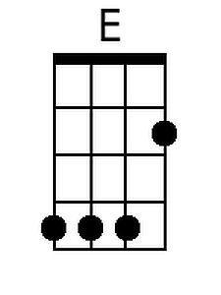
 |  |  |  |  |  | 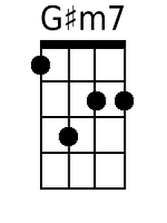 | 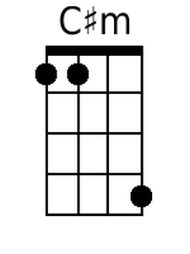
 |  |  |  |  |  | 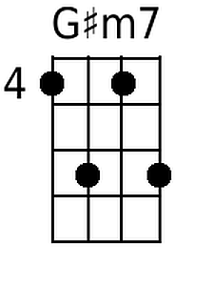 | 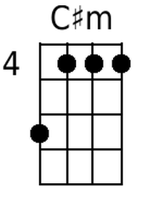
 | Bari |  | 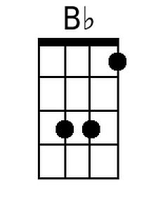 |  |  | 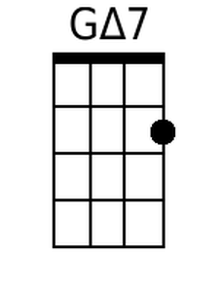
 |  | 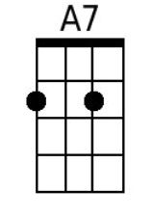 | 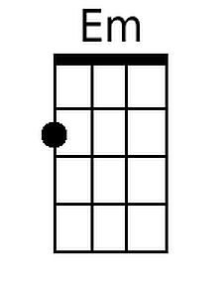 |  | 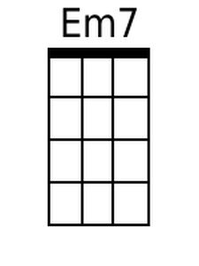 | 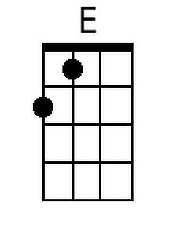 | 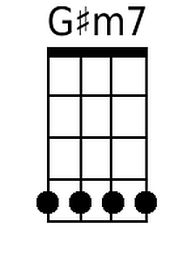 | 