Something (George Harrison, 1968) (C)

Intro | F F Eb G |  C Cmaj7  Something in the way she moves,  C7 F G  __ Attracts me like no other lover.  D D7 G | Am G7 |  Something in the way she woos me.  Chorus  Am Abaug  I don't want to leave her now  Am7 D7 | F F Eb G |  You know I believe and how.  C Cmaj7  Something in her smile she knows  C7 F G  __ That I don't need no other lover  D D7 G  Something in her style that shows me. Chorus  Bridge  A Amaj7 F#m A  You're asking me will my love grow  D G A  I don't know, I don't know  A Amaj7 F#m A  You stick a-round now, it may show  D G C  I don't know, I don't know  C Cmaj7  Something in the way she knows  C7 F G  __ And all I have to do is think of her  D D7 G  Something in the things she shows me. Chorus  Outro F F Eb G | A | F F Eb G | C |  |  |  |  | 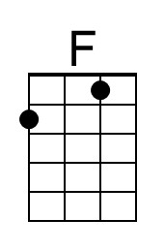 | 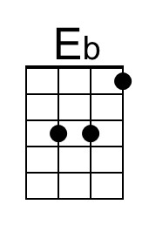 | 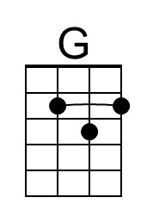
 |  |  |  |  | 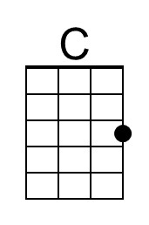 | 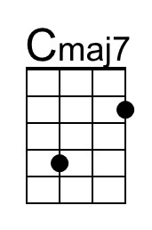 | 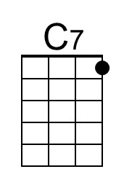
 |  |  |  |  | 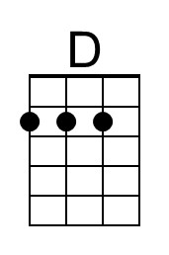 | 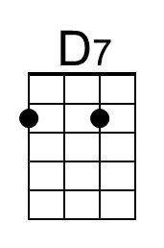 | 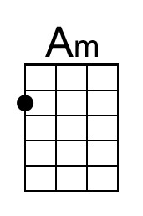
 |  |  |  |  | 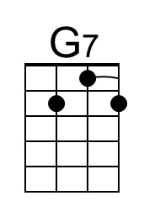 | 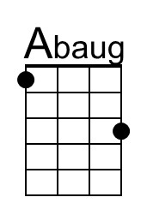 | 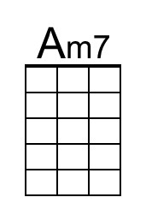
 |  |  |  |  | 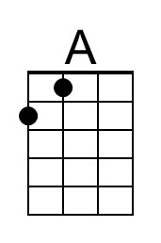 | 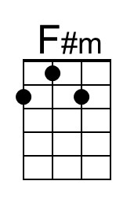
Bari | 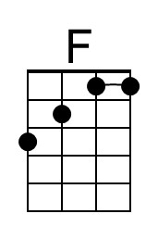 | 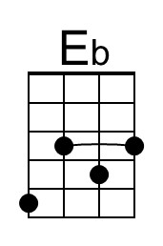 | 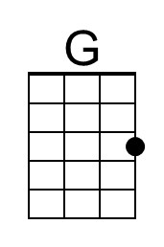 | 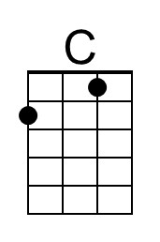 | 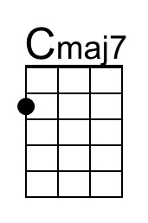 | 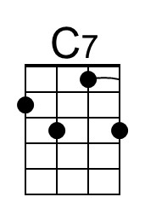 | 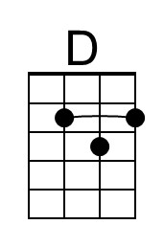
 | 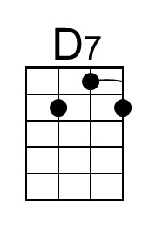 | 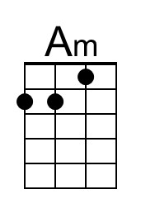 | 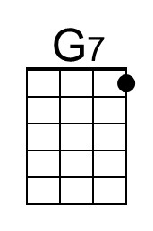 | 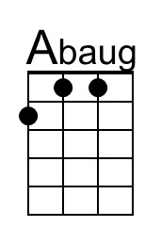 | 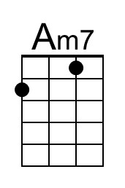 | 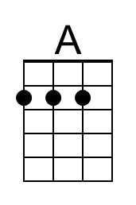 | 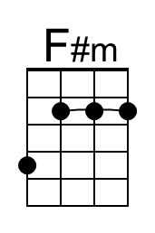

Something (George Harrison, 1968) (G)

Intro | C C Bb D |  G Gmaj7  Something in the way she moves,  G7 C D  __ Attracts me like no other lover.  A A7 D | Em D7 |  Something in the way she woos me.  Chorus  Em D#aug  I don't want to leave her now  Em7 A7 | C C Bb D |  You know I believe and how.  G Gmaj7  Something in her smile she knows  G7 C D  __ That I don't need no other lover  A A7 D  Something in her style that shows me. Chorus  Bridge  E Emaj7 C#m E  You're asking me will my love grow  A D E  I don't know, I don't know  E Emaj7 C#m E  You stick a-round now, it may show  A D G  I don't know, I don't know  G Gmaj7  Something in the way she knows  G7 C D  __ And all I have to do is think of her  A A7 D  Something in the things she shows me. Chorus  Outro C C Bb D | E | C C Bb D | G |  |  |  |  |  | 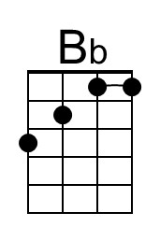
 |  |  |  |  |  | 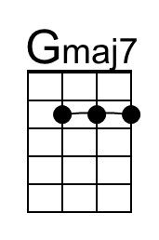
 |  |  |  |  |  | 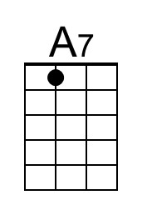 | 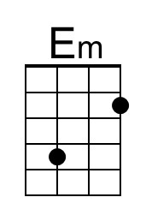
 |  |  |  |  |  | 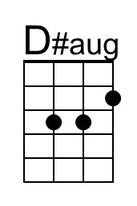 | 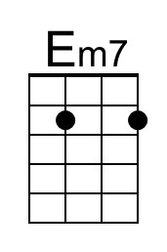
 |  |  |  |  | 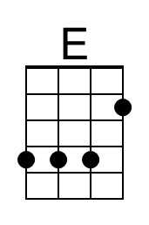 | 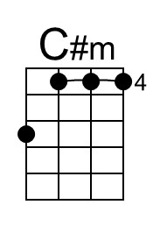
Bari |  | 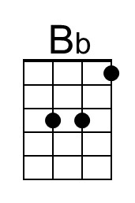 |  |  | 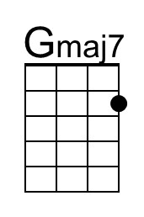
 | 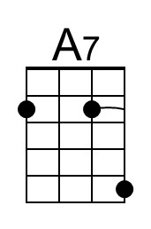 | 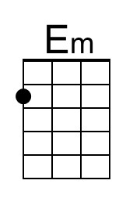 |  | 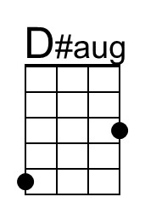 | 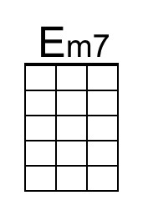 | 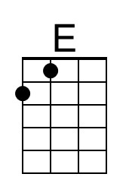 | 