Something Good (Richard Rodgers)

C Cdim

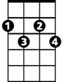

Perhaps I had a wicked childhood
G
Cdim
C
C G
Perhaps I had a miserable youth
C C7 F Fm
But somwhere in my wicked, miserable past
C Cdim G C
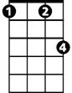

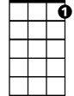
There must have been a moment of truth
Fm
F
C7

F Cdim C
For here you are, standing there, loving me
F Cdim G F
Whether or not you should
C C7 F Fm
So somewhere in my youth or childhood
C Cdim G C
I must have done some - thing good

G
Nothing comes from nothing
F Fm
Nothing ever could
C C7 F Fm
BARITONE
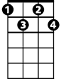
So somewhere in my youth or childhood
C
G
Cdim
C Cdim G C
I must have done some - thing good

F Cdim C
For here you are, standing there, loving me
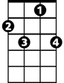
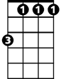

F Cdim G F
C7
Fm
F
Whether or not you should
C C7 F Fm
So somewhere in my youth or childhood
C Cdim G C
I must have done some – thing good

G
Nothing comes from nothing
F Fm
Nothing ever could
C C7 F Fm
So somewhere in my youth or childhood
C Cdim G
I must have done some - thing –
G C
Something good

