**Something Good (Richard Rodgers)**

**C Cdim**

Perhaps I had a wicked childhood



G

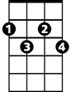

Cdim



C

**C G**

Perhaps I had a miserable youth

**C C7 F Fm**

But somwhere in my wicked, miserable past

**C Cdim G C**

There must have been a moment of truth

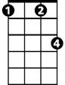

Fm

F

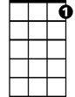

C7

**F Cdim C**

For here you are, standing there, loving me

**F Cdim G F**

Whether or not you should

**C C7 F Fm**

So somewhere in my youth or childhood

**C Cdim G C**

I must have done some - thing good

**G**

Nothing comes from nothing

**F Fm**

Nothing ever could

**C C7 F Fm**

**BARITONE**

So somewhere in my youth or childhood

C



G

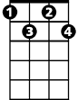

Cdim

**C Cdim G C**

I must have done some - thing good

**F Cdim C**

For here you are, standing there, loving me

**F Cdim G F**

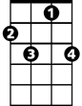

C7

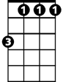

Fm



F

Whether or not you should

**C C7 F Fm**

So somewhere in my youth or childhood

**C Cdim G C**

I must have done some – thing good

**G**

Nothing comes from nothing

**F Fm**

Nothing ever could

**C C7 F Fm**

So somewhere in my youth or childhood

**C Cdim G**

I must have done some - thing –

**G C**

Something good