**Somewhere (Leonard Bernstein and Stephen Sondheim, 1957)**

**G C F Dm**



C



G

F

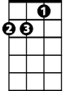

Dm

There’s a place for us

**G C F**

Somewhere a place for us

**G G7 Em Am**

Peace and quiet and open air

**F Bb G**

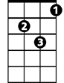

Gm



Bb

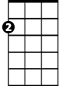

Am

Em

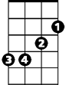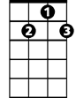

G7

Wait for us somewhere

**G C**  **F Dm**

There's a time for us

**G C F**

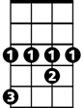

Ab

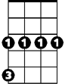

Cm

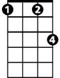

Fm

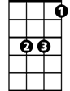

Eb

Someday a time for us

**G G7 Em Am**

Time together a time to spare

**F Bb Gm Eb**

Time to learn, time to care

**BARITONE**

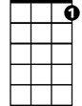

G7



F

**Ab Fm**



Dm

C



G

Someday, somewhere

**Cm Dm Ab**

We'll find a new way of living

**Fm Eb**



Eb

We'll find a way of forgiving



Gm



Bb



Am



Em

**D**

Somewhere

**G C F Dm**

There’s a place for us

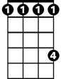

Ab



Cm

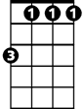

Fm

**G C F**

A time and a place for us

**G G7 Em Am**

Hold my hand and we're halfway there

**F Bb Gm Eb**

Hold my hand and I'll take you there

**Ab Fm C**

Somehow, someday, somewhere