https://www.youtube.com/watch?v=ighSddnnaPE

http://www.traditionalmusic.co.uk/ukulele-songs-chords/song_sung_blue-neil_diamond.htm

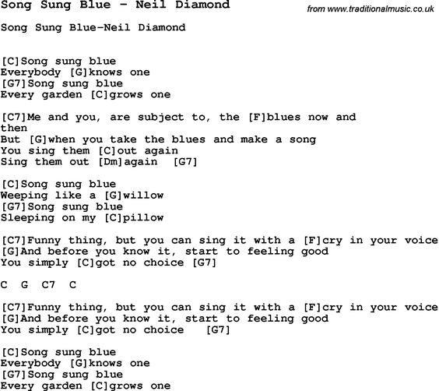

(C) Song sung blue (G) instrumental
(G7) Song sung blue (C) instrumental

Fade out

