**Song Sung Blue (Neil Diamond)**

**C G**



G



C

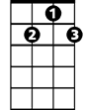

G7

Song sung blue, everybody knows one.

**G7 C**

Song sung blue, every garden grows one.

**C7 F**

Me and you are subject to, the blues now and then,

**G**

But when you take the blues and make a song,

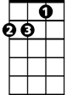

Dm

F

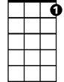

C7

**C Dm G7**

You sing them out again, sing them out again,

**C G**

Song sung blue, weepin' like a willow,

**G7 C**

Song sung blue, sleepin' on my pillow.

**C7 F**

Funny thing, but you can sing it with a cry in your voice,

**G**

And before you know it start to feelin' good,

**C G7**

**BARITONE**

You simply got no choice.

C



G7



G

**(Instrumental Verse first two lines)**

**C7 F**

Me and you are subject to, the blues now and then,

**G**

But when you take the blues and make a song,

**C Dm G7**

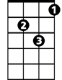

Dm



F

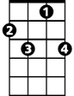

C7

You sing them out again, sing them out again,

**C G**

Song sung blue, weepin' like a willow,

**G7 C**

Song sung blue, sleepin' on my pillow.

**C7 F**

Funny thing, but you can sing it with a cry in your voice,

**G**

And before you know it start to feelin' good,

**C G7**

You simply got no choice.

**Play to fade:**

**C G**

Song sung blue, weepin' like a willow,

**G7 C**

Song sung blue, sleepin' on my pillow.