Spider-man (Am)
Bob Harris & Paul Francis Webster, 1967 – Arrangement by Theresa Miller
Spider-man by The Ramones (1995)

Am  Spider-man, Spider-man, does whatever a spider can.  Dm Am  Spins a web, any size, catches thieves just like flies.  E7 Am - E7  Look out, here comes the Spider-man.  Am  Is he strong? Listen, bud, he's got radioactive blood.  Dm Am  Can he swing from a thread? Take a look overhead.  E7 Am - D7  Hey, there! There goes the Spider-man.  Chorus  G7 C E7 Am  In the chill of the night, at the scene of a crime.  G7 C Dm ↓ ↓ ↓ ↓ E7 ↓ ↓ ↓ ↓  Like a streak of light he ar-rives …… just in time  2nd time through – Kazoo Verse  Am  Spider-man, Spider-man, friendly neighborhood, Spider-man.  Dm Am  Wealth and fame, he ignores, action is his reward.  E7 Am - E7  Look out, here comes the Spider-man.  Am  Spider-man, Spider-man, friendly neighborhood, Spider-man.  Dm Am  Wealth and fame, he ignores, action is his reward.  E7 Am E7 Am  To him, life Is a great big bang up, whenever there's a hang up,  E7 Am  You’ll find the Spider-man. Repeat from Chorus  Outro  E7 A9  You'll find the Spider-man. | 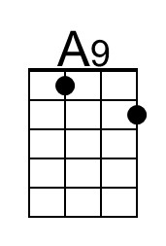
 | Bari
 | 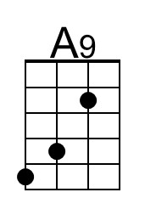

Spider-man (Em)
Bob Harris & Paul Francis Webster, 1967 – Arrangement by Theresa Miller
Spider-man by The Ramones (1995)

Em  Spider-man, Spider-man, does whatever a spider can.  Am Em  Spins a web, any size, catches thieves just like flies.  B7 Em - B7  Look out, here comes the Spider-man.  Em  Is he strong? Listen, bud, he's got radioactive blood.  Am Em  Can he swing from a thread? Take a look overhead.  B7 Em - A7  Hey, there! There goes the Spider-man.  Chorus  D7 G B7 Em  In the chill of the night, at the scene of a crime.  D7 G Am ↓ ↓ ↓ ↓ B7 ↓ ↓ ↓ ↓  Like a streak of light he ar-rives …… just in time  2nd time through – Kazoo Verse  Em  Spider-man, Spider-man, friendly neighborhood, Spider-man.  Am Em  Wealth and fame, he ignores, action is his reward.  B7 Em - B7  Look out, here comes the Spider-man.  Em  Spider-man, Spider-man, friendly neighborhood, Spider-man.  Am Em  Wealth and fame, he ignores, action is his reward.  B7 Em B7 Em  To him, life Is a great big bang up, whenever there's a hang up,  B7 Em  You’ll find the Spider-man. Repeat from Chorus  Outro  B7 E9  You'll find the Spider-man. | 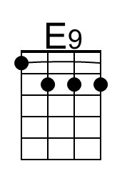
 | Bari
 | 