Spiderman Theme Song (Bob Harris / Paul Francis Webster)
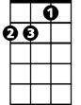
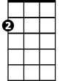
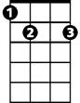
Dm
Am
E7
Am
Spiderman, Spiderman, does whatever a spider can
Dm Am
Spins a web any size, catches thieves just like flies
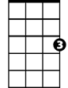
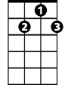
E7 Am
Look out, here comes the Spiderman
C
G7

Am
Is he strong? Listen, bud, he's got radioactive blood
Dm Am
Can he swing from a thread? Take a look overhead
E7 Am
Hey, there! There goes the Spiderman

G7 C E7 Am
In the chill of the night, at the scene of a crime
G7 C Dm E7
Like a streak of light he arrives ………. just in time

Kazoo verse:
Am
Spiderman, Spiderman, frien dly neighborhood, Spiderman
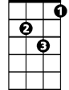
Dm Am
Wealth and fame, he ignores, action is his reward
Dm
Am
BARITONE
E7 Am
Look out, here comes the Spiderman

Am
Spiderman, Spiderman, friendly neighborhood, Spiderman
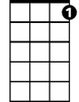
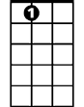
Dm Am
Wealth and fame, he ignores, action is his reward
G7
E7
E7 Am E7 Am
To him, life Is a great big bang up, whenever there's a hang up,
E7 Am
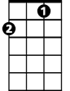
You’ll find the Spiderman
E7 A9 (played like E7, but lift middle finger)
C
You'll find the Spiderman!

