Spirit in the Sky (Norman Greenbaum, 1969) (A)
Spirit in the Sky by Norman Greenbaum (1969) (A – 129 BPM)

Intro (8x) | A | A A D D |

A D
When I die and they lay me to rest, gonna go to the place that's best.
A E7 A
When they lay me down to die, goin’ on up to the spirit in the sky.
A D
_ Goin’ up to the spirit in the sky, That's where I'm gonna go, when I die.
A E7 A
When I die and they lay me to rest, I'm gonna go to the place that's the best.

Instrumental (4x) | A | A A D D |

A D
Prepare yourself, you know it’s a must, gotta have a friend in Jesus.
A E7 A
So you know that when you die, He’s gonna’ recommend you to the spirit in the sky.
E7 A
He’s gonna’ recommend you to the spirit in the sky.
A D
_ Goin’ to recommended you to the spirit in the sky, that's where you’re gonna go, when you die.
A E7 A
When I die and they lay me to rest, I'm gonna go to the place that's the best.

Instrumental (4x) | A | A A D D |

A D
Never been a sinner; I’ve never sinned. I got a friend in Jesus.
A E7 A
So you know that when I die, He’s gonna’ set me up with the spirit in the sky.
A D
Oh, send me up with the spirit in the sky, That's where I'm gonna go, when I die.
A E7 A
When I die and they lay me to rest, I'm gonna go to the place that's the best.

Outro
E7 A
Go to the place that's the best. (2x)

Instrumental (3x) | A | A A D D | A | End on A

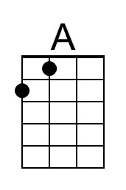 | 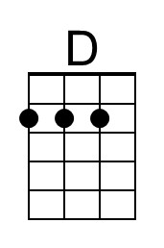 | 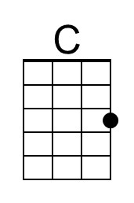 | 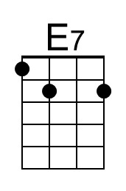 | Bari | 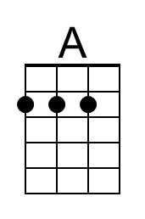 | 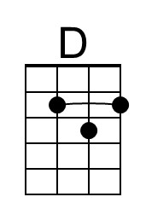 | 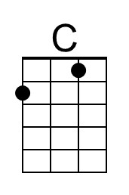 | 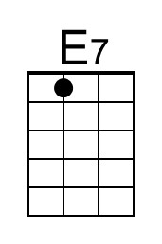

Spirit in the Sky (Norman Greenbaum, 1969) (C)
Spirit in the Sky by Norman Greenbaum (1969) (A – 129 BPM)

Intro (8x) | C | C C F F |

C F
When I die and they lay me to rest, gonna go to the place that's best.
C G7 C
When they lay me down to die, goin’ on up to the spirit in the sky.
C F
_ Goin’ up to the spirit in the sky, That's where I'm gonna go, when I die.
C G7 C
When I die and they lay me to rest, I'm gonna go to the place that's the best.

Instrumental (4x) | C | C C F F |

C F
Prepare yourself, you know it’s a must, gotta have a friend in Jesus.
C G7 C
So you know that when you die, He’s gonna’ recommend you to the spirit in the sky.
G7 C
He’s gonna’ recommend you to the spirit in the sky.
C F
_ Goin’ to recommended you to the spirit in the sky, That's where you’re gonna go, when you die.
C G7 C
When I die and they lay me to rest, I'm gonna go to the place that's the best.

Instrumental (4x) | C | C C F F |

C F
Never been a sinner; I’ve never sinned. I got a friend in Jesus.
C G7 C
So you know that when I die, He’s gonna’ set me up with the spirit in the sky.
C F
Oh, send me up with the spirit in the sky, That's where I'm gonna go, when I die.
C G7 C
When I die and they lay me to rest, I'm gonna go to the place that's the best.

Outro
G7 C
Go to the place that's the best. (2x)

Instrumental (3x) | C | C C F F | End on C

 | 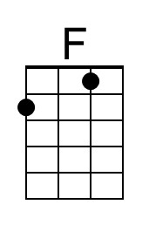 | 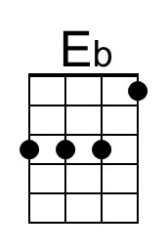 | 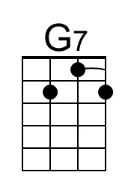 | Bari |  | 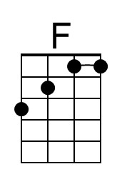 | 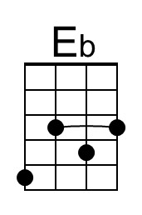 | 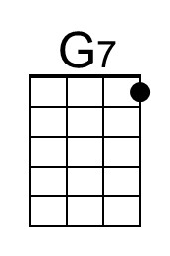

Spirit in the Sky (Norman Greenbaum, 1969) (G)
Spirit in the Sky by Norman Greenbaum (1969) (A – 129 BPM)

Intro (8x) | G | G G C C |

G C
When I die and they lay me to rest, gonna go to the place that's best.
G D7 G
When they lay me down to die, goin’ on up to the spirit in the sky.
G C
_ Goin’ up to the spirit in the sky, That's where I'm gonna go, when I die.
G D7 G
When I die and they lay me to rest, I'm gonna go to the place that's the best.

Instrumental (4x) | G | G G C C |

G C
Prepare yourself, you know it’s a must, gotta have a friend in Jesus.
G D7 G
So you know that when you die, He’s gonna’ recommend you to the spirit in the sky.
D7 G
He’s gonna’ recommend you to the spirit in the sky.
G C
_ Goin’ to recommended you to the spirit in the sky, that's where you’re gonna go, when you die.
G D7 G
When I die and they lay me to rest, I'm gonna go to the place that's the best.

Instrumental (4x) | G | G G C C |

G C
Never been a sinner; I’ve never sinned. I got a friend in Jesus.
G D7 G
So you know that when I die, He’s gonna’ set me up with the spirit in the sky.
G C
Oh, send me up with the spirit in the sky, That's where I'm gonna go, when I die.
G D7 G
When I die and they lay me to rest, I'm gonna go to the place that's the best.

D7 G
Go to the place that's the best. (2x) Outro

Instrumental (3x) | G | G G C C | G | End on G

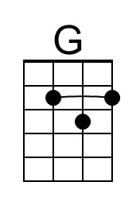 |  | 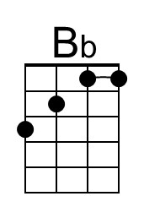 | 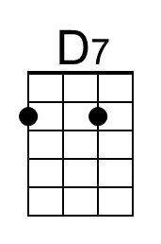 | Bari | 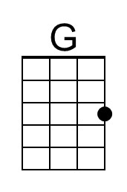 |  | 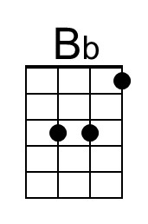 | 