Spirit in the Sky
Norman Greenbaum (1969)
Keys of G, A & C
https://www.youtube.com/watch?v=AZQxH_8raCI

Notes:
"Spirit in the Sky" is a song written and originally recorded2 by Norman Greenbaum and released in late 1969. The single became a gold record, selling two million copies from 1969 to 1970 and reached number three on the US Billboard Hot 100 chart (April 18, 1970), where it lasted for 15 weeks in the Top 100. It also climbed to number one on the UK, Australian and Canadian charts in 1970. Rolling Stone ranked "Spirit in the Sky" No. 333 on its list of the 500 Greatest Songs of All Time.
"Spirit in the Sky" makes several references to Jesus, although Greenbaum is Jewish. In a 2006 interview with the New York Times, Greenbaum told a reporter he was inspired to write the song after watching Porter Wagoner singing a gospel song on TV. Greenbaum said: "I thought, 'Yeah, I could do that,' knowing nothing about gospel music, so I sat down and wrote my own gospel song. It came easy. I wrote the words in 15 minutes." 2
The song's arrangement came together in the studio in San Francisco where lead guitarist Russell DaShiell, bass player Doug Killmer from the band Crowfoot and drummer Norman Mayell from the band Sopwith Camel 5 worked with Greenbaum. According to the New York Times article, Greenbaum used a Fender Telecaster guitar with a fuzz box built into the body to generate the song's characteristic guitar sound. 2
The resulting sound was an "oddly compelling" combination of gospel and hard rock music, 2 with loud drums, distorted electric guitar, clapping hands, and tambourines. The production team brought in the Stovall Sisters, an Oakland-based gospel trio, to sing backing vocals. 2 cause of the song's length and lyrics, the record company was initially reluctant to issue it. When it was finally released as a single it became a worldwide hit, and was at the time the best-selling single ever for the Reprise label.[2]
About the song, Greenbaum has been quoted as saying, "It sounds as fresh today as when it was recorded. I’ve gotten letters from funeral directors telling me that it's their second-most-requested song to play at memorial services, next to 'Danny Boy'."7

Footnotes:
2. McNichol, Tom (December 24, 2006). "A 'Spirit' From the '60s That Won't Die". The New York Times. Retrieved March 13, 2018.
5. Michael Goldberg, Sopwith Camel: Where Are They Now?. Rolling Stone, September 10, 1987. Retrieved 2018-02-05.
7. "Christian Order - Read - Editorials - February 2011". Christianorder.com. Retrieved July 18, 2013.

Source: Wikipedia article “Spirit In The Sky”, https://en.wikipedia.org/wiki/Spirit_in_the_Sky.

Spirit in the Sky
Norman Greenbaum (1969)
Key of G
https://www.youtube.com/watch?v=AZQxH_8raCI

G G G C B♭ x8  G  When I die and they lay me to rest,  C  Gonna go to the place that's best.  G  When they lay me down to die,  D7 G  Goin’ on up to the spirit in the sky.  G  Goin’ up to the spirit in the sky,  C  That's where I'm gonna go, when I die.  G  When I die and they lay me to rest,  D7 G  I'm gonna go to the place that's the best.  C B♭ G x4  G  Prepare yourself, you know it’s a must,  C  Gotta have a friend in Jesus  G  So you know that when you die,  D7 G  It’s gonna’ recommend you to the spirit in the sky. |  |  |  |  |  |  | 
 |  |  |  |  |  |  | 
 |  |  |  |  |  |  | 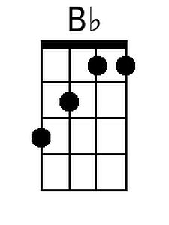
 |  |  |  |  |  |  | 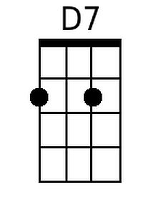
Baritone
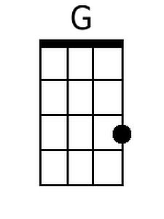 |  | 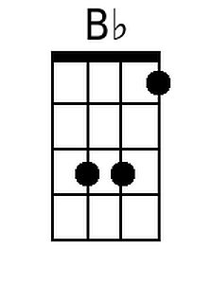 | 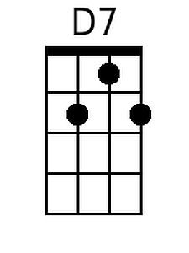

Spirit In The Sky – G – Page 2
G
Gonna’ recommend you to the spirit in the sky,
C
That's where you’re gonna go, when you die.
G
When you die and they lay you to rest,
D7 G
You’re gonna go to the place that's the best.

C B♭ G x4

G
I’ve never been a sinner; I’ve never sinned.
C
I got a friend in Jesus
G
So you know that when I die,
D7 G
It’s gonna’ set me up with the spirit in the sky.

G
Gonna’ set me up with the spirit in the sky,
C
That's where I’m gonna go, when I die.
G
When I die and they lay me to rest,
D7 G
I’m gonna go to the place that's the best

D7 G
Go to the place that's the best.
D7 G
Go to the place that's the best

G G G C B♭ G x4

Spirit in the Sky
Norman Greenbaum (1969)
Key of A
https://www.youtube.com/watch?v=AZQxH_8raCI

A A A D C x8  A  When I die and they lay me to rest,  D  Gonna go to the place that's best.  A  When they lay me down to die,  E7 A  Goin’ on up to the spirit in the sky.  A  Goin’ up to the spirit in the sky,  D  That's where I'm gonna go, when I die.  A  When I die and they lay me to rest,  E7 A  I'm gonna go to the place that's the best.  D C A x4  A  Prepare yourself, you know it’s a must,  D  Gotta have a friend in Jesus  A  So you know that when you die,  E7 A  It’s gonna’ recommend you to the spirit in the sky. |  |  |  |  |  |  | 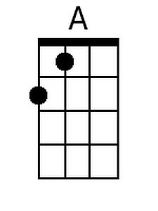
 |  |  |  |  |  |  | 
 |  |  |  |  |  |  | 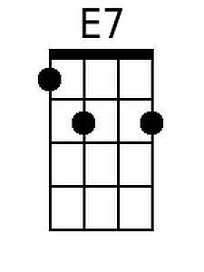
Baritone
 | 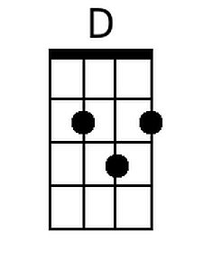 |  | 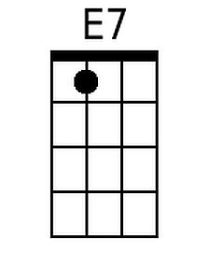

Spirit In The Sky – A – Page 2
A
Gonna’ recommend you to the spirit in the sky,
D
That's where you’re gonna go, when you die.
A
When you die and they lay you to rest,
E7 A
You’re gonna go to the place that's the best.

D C A x4

A
I’ve never been a sinner; I’ve never sinned.
D
I got a friend in Jesus
A
So you know that when I die,
E7 A
It’s gonna’ set me up with the spirit in the sky.

A
Gonna’ set me up with the spirit in the sky,
D
That's where I’m gonna go, when I die.
A
When I die and they lay me to rest,
E7 A
I’m gonna go to the place that's the best

E7 A
Go to the place that's the best.
E7 A
Go to the place that's the best

A A A D C A x4

Spirit in the Sky
Norman Greenbaum (1969)
Key of C
https://www.youtube.com/watch?v=AZQxH_8raCI

C C C F E♭ x8

C
When I die and they lay me to rest,
F
Gonna go to the place that's best.
C
When they lay me down to die,
G7 C
Goin’ on up to the spirit in the sky.

C
Goin’ up to the spirit in the sky,
F
That's where I'm gonna go, when I die.
C
When I die and they lay me to rest,
G7 C
I'm gonna go to the place that's the best.

F E♭ C x4

C
Prepare yourself, you know it’s a must,
F
Gotta have a friend in Jesus
C
So you know that when you die,
G7 C
It’s gonna’ recommend you to the spirit in the sky.

 |  |  |  |  |  |  | 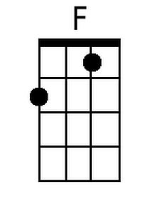
 |  |  |  |  |  |  | 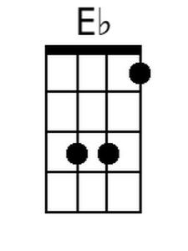
 |  |  |  |  |  |  | 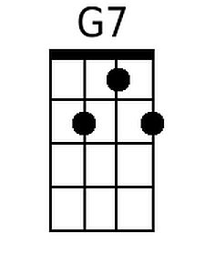
Baritone
 | 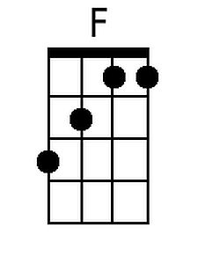 | 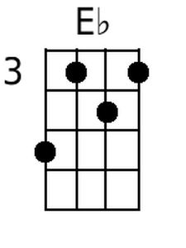 | 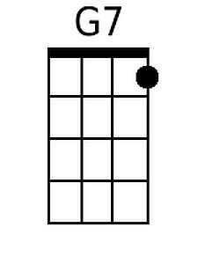

Spirit In The Sky – C – Page 2
C
Gonna’ recommend you to the spirit in the sky,
F
That's where you’re gonna go, when you die.
C
When you die and they lay you to rest,
G7 C
You’re gonna go to the place that's the best.

F E♭ C x4

C
I’ve never been a sinner; I’ve never sinned.
F
I got a friend in Jesus
C
So you know that when I die,
G7 C
It’s gonna’ set me up with the spirit in the sky.

C
Gonna’ set me up with the spirit in the sky,
F
That's where I’m gonna go, when I die.
C
When I die and they lay me to rest,
G7 C
I’m gonna go to the place that's the best

G7 C
Go to the place that's the best.
G7 C
Go to the place that's the best

C C C F E♭ C x4

