**Spirit in the Sky (Norman Greenbaum)**

**Intro: G C Bb / G Bb C**

**G**

When I die and they lay me to rest

**C**

Gonna go to the place that's the best

**G**

When I lay me down to die

**D G**Goin' on up to the spirit in the sky

**G**

Goin' on up to the spirit in the sky

**C**

That's where I'm gonna go when I die

**G**

When I die and they lay me to rest

**D G**I’m gonna go to the place that's the best

**G C Bb / G Bb C**

**G**



G

Prepare yourself you know it's a must

**C**

Gotta have a friend in Jesus

**G**

So you know that when you die

**D**He's gonna recommend you

**G**

To the spirit in the sky

**G**

Gonna recommend you to the spirit in the sky

**C**

That's where you're gonna go when you die

**G**

When you die and they lay you to rest

**D G**You're gonna go to the place that's the best

**G C Bb / G Bb C**

**G**

Never been a sinner I never sinned

**C**

I got a friend in Jesus

**G**

So you know that when I die

**D G**He's gonna set me up with the spirit in the sky

**G**

Oh set me up with the spirit in the sky

**C**

That's where I'm gonna go when I die

**G**

When I die and they lay me to rest

**D G 3X**I'm gonna go to the place that's the best

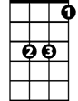

Bb

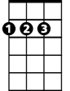

D



Bb

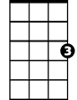

C

**BARITONE**



D

C

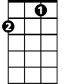

G