**Spooky (Buddy Buie / Harry Middlebrooks / J Cobb / J R Cobb / Mike Shapiro)**

**Intro: Dm ... Em, Dm.....Em**

**Dm**

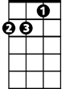

Dm

Em

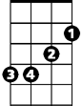

In the cool of the evening

**Em Dm Em**

When everything is gettin’ kind of groovy

**Dm**

I call you up and ask you

**Em Dm Em**

Would I like to go with you and see a movie

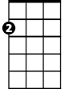

Am

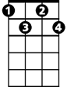

Fdim

**Dm**

First you say no you’ve got some plans for the night

**Em (stop) FdIm**

And then you stop ....and say – “all right”

**Dm Em Dm Am**

Love is kinda crazy with a spooky little girl like you

**Dm**

You always keep me guessin

**Em Dm Em**

I ne-ver seem to know what you are thinkin’

**Dm**

And if a fella looks at you

**Em Dm Em**

It's for sure your little eye will be a winkin’

**Dm**

I get confused I never know where I stand

**Em (stop) FdIm**

And then you smile .... and hold my hand

**Dm Em Dm Am**

Love is kinda crazy with a spooky little girl like you Spooky yeah

**Dm Em / Dm Em / Dm Em / Dm Em**

**BARITONE**



Em

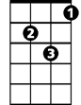

Dm

**Dm**

If you decide

**Em Dm Em**

Some day to stop this little game that you are playin’

**Dm**

I'm gonna tell you all the things

**Em Dm Em**



Am

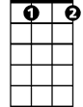

Fdim

My heart's been a dyin’ to be sayin’

**Dm**

Just like a ghost you've been a-hauntin’ my dreams

**Em (stop) FdIm**

So I’ll propose. ...on Halloween

**Dm Em Dm Am**

Love is kinda crazy with a spooky little girl like you Spooky yeah

**Dm Em Dm Em**

Spooky mmm spooky yeah yeah

**Dm Em Dm Em Dm**

Spooky ah ha ha oo spooky ah ha ha