Squeeze Box
Pete Townshend, 1974
Squeeze Box (Pete Townshend, 1974) (C)
Squeeze Box by The Who (1975)

Intro F C (single strum, 4x) strum C 2 measures

C
Mama's got a squeeze box she wears on her chest and when
C
Daddy comes home he never gets no rest 'cause she's
G F
Playing all night and the Music's al----right
G F C [ F C | F C | F C ] (2x)
Mama's got a squeeze box, Daddy never sleeps at Night

C
Well, the kids don't eat and the dog can't sleep
C
There's no escape from the music in the whole damn street
G F
'Cause she's playing all night and the music's alright
G F C [ F C | F C | F C ] (2x)
Mama's got a squeeze box, Daddy never sleeps at night

Chorus
C
She goes in and out, and in and out, and in and out, and in and out
G F
'Cause she's playing all night and the music's alright
G F C [ F C | F C | F C ] (2x)
Mama's got a squeeze box, Daddy never sleeps at night

C
She goes squeeze me, come on and squeeze me, come on and
G F
Tease me like you do, I'm so in love with you
G F C F C | F C | F C
Mama's got a squeeze box, Daddy never sleeps at night

Bridge Chords for last verse

Chorus
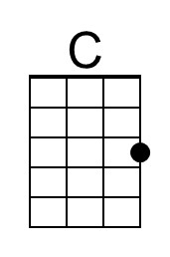 | 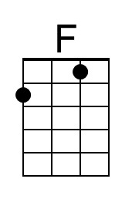 | 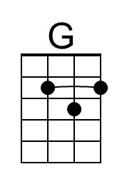 |  | Bari | 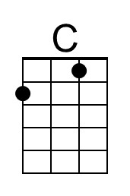 | 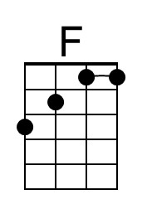 | 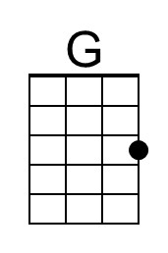

Squeeze Box (Pete Townshend, 1974) (G)
Squeeze Box by The Who (1975)

Intro C G (single strum, 4x) strum G 2 measures

G
Mama's got a squeeze box she wears on her chest and when
G
Daddy comes home he never gets no rest 'cause she's
D C
Playing all night and the Music's al----right
D C G [ C G | C G | C G ] (2x)
Mama's got a squeeze box, Daddy never sleeps at night

G
Well, the kids don't eat and the dog can't sleep
G
There's no escape from the music in the whole damn street
D C
'Cause she's playing all night and the music's alright
D C G [ C G | C G | C G ] (2x)
Mama's got a squeeze box, Daddy never sleeps at night

Chorus
G
She goes in and out, and in and out, and in and out ,and in and out
D C
'Cause she's playing all night and the music's alright
D C G [ C G | C G | C G ] (2x)
Mama's got a squeeze box, Daddy never sleeps at night.

G
She goes squeeze me, come on and squeeze me, come on and
D C
Tease me like you do, I'm so in love with you
D C G C G | C G | C G
Mama's got a squeeze box, Daddy never sleeps at night

Bridge Chords for last verse

Chorus
 |  | 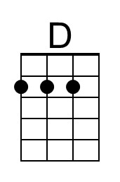 |  | Bari |  |  | 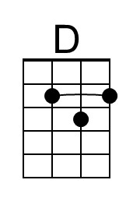
Squeeze Box (Pete Townshend, 1974) (F)
Squeeze Box by The Who (1975)

Intro B♭ F (single strum, 4x) strum F 2 measures

F
Mama's got a squeeze box she wears on her chest and when
F
Daddy comes home he never gets no rest 'cause she's
C B♭
Playing all night and the Music's al----right
C B♭ F [ B♭ F | B♭ F | B♭ F ] (2x)
Mama's got a squeeze box, Daddy never sleeps at Night

F
Well, the kids don't eat and the dog can't sleep
F
There's no escape from the music in the whole damn street
C B♭
'Cause she's playing all night and the music's alright
C B♭ F [ B♭ F | B♭ F | B♭ F ] (2x)
Mama's got a squeeze box, Daddy never sleeps at night

Chorus
F
She goes in and out, and in and out, and in and out, and in and out,
C B♭
'Cause she's playing all night and the music's alright
C B♭ F [ B♭ F | B♭ F | B♭ F ] (2x)
Mama's got a squeeze box, Daddy never sleeps at night

F
She goes squeeze me, come on and squeeze me, come on and
C B♭
Tease me like you do, I'm so in love with you
C B♭ F B♭ F | B♭ F | B♭ F |
Mama's got a squeeze box, Daddy never sleeps at night

Bridge Chords for last verse

Chorus
 | 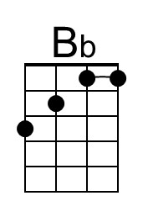 |  |  | Bari |  | 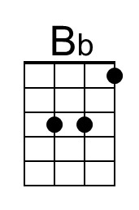
Squeeze Box (Pete Townshend, 1974) (C)
Squeeze Box by The Who (1975)

Intro F C (single strum, 4x) strum C 2 measures

C
Mama's got a squeeze box she wears on her chest and when
C
Daddy comes home he never gets no rest 'cause she's
G F
Playing all night and the Music's al----right
G F C [ F C | F C | F C ] (2x)
Mama's got a squeeze box, Daddy never sleeps at Night

C
Well, the kids don't eat and the dog can't sleep
C
There's no escape from the music in the whole damn street
G F
'Cause she's playing all night and the music's alright
G F C [ F C | F C | F C ] (2x)
Mama's got a squeeze box, Daddy never sleeps at night

Chorus
C
She goes in and out, and in and out, and in and out, and in and out
G F
'Cause she's playing all night and the music's alright
G F C [ F C | F C | F C ] (2x)
Mama's got a squeeze box, Daddy never sleeps at night

C
She goes squeeze me, come on and squeeze me, come on and
G F
Tease me like you do, I'm so in love with you
G F C F C | F C | F C
Mama's got a squeeze box, Daddy never sleeps at night

Bridge Chords for last verse

Chorus
Bari

This page is intentionally blank.

