**St. James Infirmary Blues (Traditional)**

**Am E7 Am**

It was down at old Joe's bar room

**Am F7 C E7**

At the corner by the square

**Am E7 Am**

They were serving drinks as usual

**F7 E7 Am**

And the usual crowd was there

**Am E7 Am**

On my left stood big Joe MacKennedy

**Am F7 C E7**

His eyes were bloodshot red

**Am E7 Am**

And as he looked at the gang around him

**F7 E7 Am**

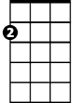

Am

These were the very words he said.

**Am E7 Am**

I went down to St. James Infirmary

**Am F7 C E7**

I saw my baby there

E7

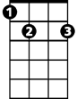

**Am E7 Am**

Stretched out on a long, white table

**F7 E7 Am**

So young, so cold, so fair

**Am E7 Am**

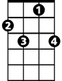

F7

Seventeen coal-black horses

**Am F7 C E7**

Hitched to a rubber-tied hack

**Am E7 Am**

Seven girls goin' to the graveyard

**F7 E7 Am**



C

Only six of them are coming back

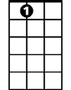

E7

C

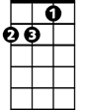

Am

**BARITONE**

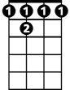

F 7

**Am E7 Am**

Let her go. Let her go, God bless her

**Am F7 C E7**

Wherever she may be

**Am E7 Am**

She may search this wide world over

**F7 E7 Am**

And never find another man like me

**Instrumental Verse**

**Am E7 Am**

When I die just bury me

**Am F7 C E7**

In my high-top Stetson hat

**Am E7** Place a twenty-dollar gold piece

**Am**

on my watch chain

**F7 E7 Am**

To let the Lord know I died standing pat

**Am E7 Am**

I want six crap-shooters for my pall-bearers

**Am F7 C E7**

A chorus girl to sing me a song

**Am E7 Am**

Place a jazz band on my hearse wagon

**F7 E7 Am**

To raise hell as we roll along

**Am E7 Am**

Now that you've heard my story

**Am F7 C E7**

I'll take another shot of booze

**Am E7 Am**

And if anyone here should ask you

**F7 E7 Am**

I've got the gambler's blues

**Instrumental Verse, end on Am**