
St. James Infirmary Blues (Of uncertain origin before 1928) (Am)

Intro (8 Measures): First 2 lines.  Am E7 Am  It was down at old Joe's bar room  Am F7 C E7  At the corner by the square  Am E7 Am  They were serving drinks as usual  F7 E7 Am  And the usual crowd was there  Am E7 Am  On my left stood big Joe MacKennedy  Am F7 C E7  His eyes were bloodshot red  Am E7 Am  And as he looked at the gang around him  F7 E7 Am  These were the very words he said.  Am E7 Am  I went down to St. James Infirmary  Am F7 C E7  I saw my baby there  Am E7 Am  Stretched out on a long, white table  F7 E7 Am  So young, so cold, so fair  Am E7 Am  Seventeen coal-black horses  Am F7 C E7  Hitched to a rubber-tied hack  Am E7 Am  Seven girls goin' to the graveyard  F7 E7 Am  Only six of them are coming back  Strum: 1 2 3&4  D D DUD |  |  |  |  | Am E7 Am  Let her go. Let her go, God bless her  Am F7 C E7  Wherever she may be  Am E7 Am  She may search this wide world over  F7 E7 Am  And never find another man like me  Instrumental Verse  Am E7 Am  When I die just bury me  Am F7 C E7  In my high-top Stetson hat  Am E7  Place a twenty-dollar gold piece  Am  On my watch chain  F7 E7 Am  To let the Lord know I died standing pat  Am E7 Am  I want six crap-shooters for my pall-bearers  Am F7 C E7  A chorus girl to sing me a song  Am E7 Am  Place a jazz band on my hearse wagon  F7 E7 Am  To raise hell as we roll along  Am E7 Am  Now that you've heard my story  Am F7 C E7  I'll take another shot of booze  Am E7 Am  And if anyone here should ask you  F7 E7 Am  I've got the gambler's blues  Instrumental Verse, end on Am
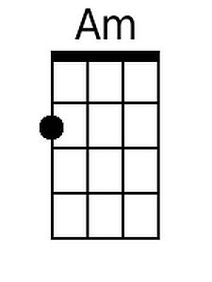 | 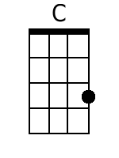 | 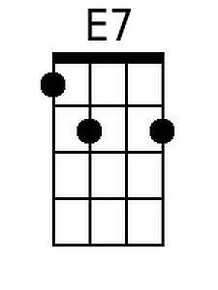 | 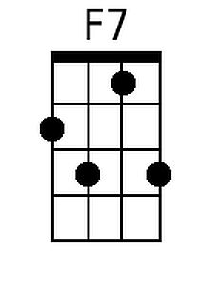 | Bari |  | 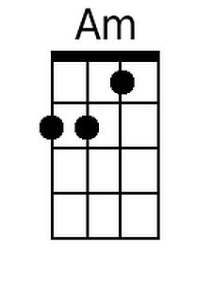 | 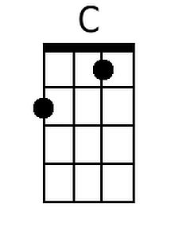 | 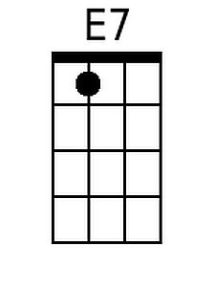 | 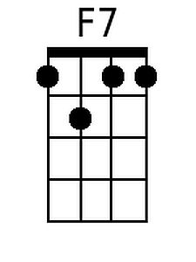

St. James Infirmary Blues (Of uncertain origin before 1928) (Dm)

Intro (8 Measures): First 2 lines.  Dm A7 Dm  It was down at old Joe's bar room  Dm Bb7 F A7  At the corner by the square  Dm A7 Dm  They were serving drinks as usual  Bb7 A7 Dm  And the usual crowd was there  Dm A7 Dm  On my left stood big Joe MacKennedy  Dm Bb7 F A7  His eyes were bloodshot red  Dm A7 Dm  And as he looked at the gang around him  Bb7 A7 Dm  These were the very words he said.  Dm A7 Dm  I went down to St. James Infirmary  Dm Bb7 F A7  I saw my baby there  Dm A7 Dm  Stretched out on a long, white table  Bb7 A7 Dm  So young, so cold, so fair  Dm A7 Dm  Seventeen coal-black horses  Dm Bb7 F A7  Hitched to a rubber-tied hack  Dm A7 Dm  Seven girls goin' to the graveyard  Bb7 A7 Dm  Only six of them are coming back  Strum: 1 2 3&4  D D DUD |  |  |  |  | Dm A7 Dm  Let her go. Let her go, God bless her  Dm Bb7 F A7  Wherever she may be  Dm A7 Dm  She may search this wide world over  Bb7 A7 Dm  And never find another man like me  Instrumental Verse  Dm A7 Dm  When I die just bury me  Dm Bb7 F A7  In my high-top Stetson hat  Dm A7  Place a twenty-dollar gold piece  Dm  On my watch chain  Bb7 A7 Dm  To let the Lord know I died standing pat  Dm A7 Dm  I want six crap-shooters for my pall-bearers  Dm Bb7 F A7  A chorus girl to sing me a song  Dm A7 Dm  Place a jazz band on my hearse wagon  Bb7 A7 Dm  To raise hell as we roll along  Dm A7 Dm  Now that you've heard my story  Dm Bb7 F A7  I'll take another shot of booze  Dm A7 Dm  And if anyone here should ask you  Bb7 A7 Dm  I've got the gambler's blues  Instrumental Verse, end on Am
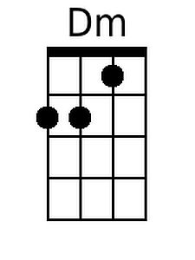 | 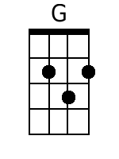 | 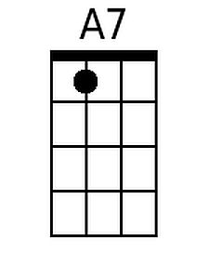 | 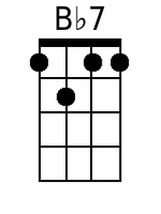 | Bari |  | 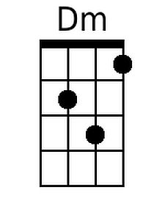 | 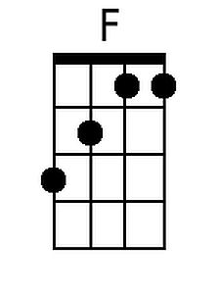 | 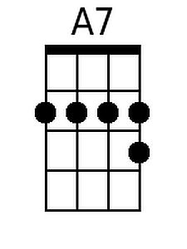 | 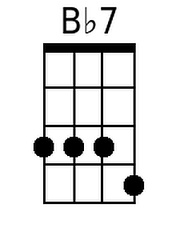

St. James Infirmary Blues (Of uncertain origin before 1928) (Em)

Intro (8 Measures): First 2 lines.  Em B7 Em  It was down at old Joe's bar room  Em C7 G B7  At the corner by the square  Em B7 Em  They were serving drinks as usual  C7 B7 Em  And the usual crowd was there  Em B7 Em  On my left stood big Joe MacKennedy  Em C7 G B7  His eyes were bloodshot red  Em B7 Em  And as he looked at the gang around him  C7 B7 Em  These were the very words he said.  Em B7 Em  I went down to St. James Infirmary  Em C7 G B7  I saw my baby there  Em B7 Em  Stretched out on a long, white table  C7 B7 Em  So young, so cold, so fair  Em B7 Em  Seventeen coal-black horses  Em C7 G B7  Hitched to a rubber-tied hack  Em B7 Em  Seven girls goin' to the graveyard  C7 B7 Em  Only six of them are coming back  Strum: 1 2 3&4  D D DUD |  |  |  |  | Em B7 Em  Let her go. Let her go, God bless her  Em C7 G B7  Wherever she may be  Em B7 Em  She may search this wide world over  C7 B7 Em  And never find another man like me  Instrumental Verse  Em B7 Em  When I die just bury me  Em C7 G B7  In my high-top Stetson hat  Em B7  Place a twenty-dollar gold piece  Em  On my watch chain  C7 B7 Em  To let the Lord know I died standing pat  Em B7 Em  I want six crap-shooters for my pall-bearers  Em C7 G B7  A chorus girl to sing me a song  Em B7 Em  Place a jazz band on my hearse wagon  C7 B7 Em  To raise hell as we roll along  Em B7 Em  Now that you've heard my story  Em C7 G B7  I'll take another shot of booze  Em B7 Em  And if anyone here should ask you  C7 B7 Em  I've got the gambler's blues  Instrumental Verse, end on Am
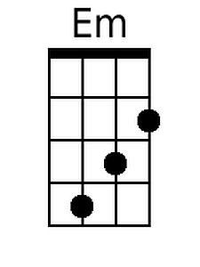 |  | 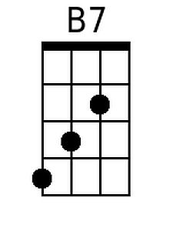 | 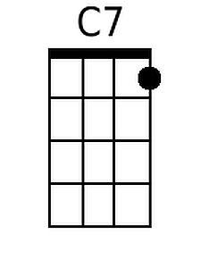 | Bari |  | 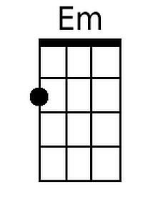 | 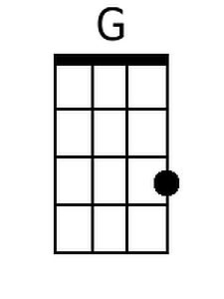 | 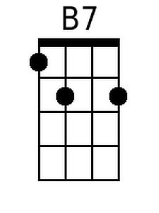 | 