Stand By Me (Ben E. King, Jerry Leiber, Mike Stoller, 1961) (A)
Stand By Me by Ben E. King (1961) (A)
4/4 / 120 bpm

Intro A | A | F#m E | F#m | D | E A | A  A F#m  When the night has come ___ and the land is dark.  D E A | A  And the moon is the only light we'll see.  A F#m  No, I won't be afraid, no, I won't be afraid  D E A  Just as long as you stand, stand by me.  Chorus 1  A | A F#m  So darling, darling, stand by me. Oh oh stand __ by me  D E A | A  Oh stand, __ stand by me __ stand by me.  A F#m  If the sky that we look upon __ should tumble and fall  D E A | A  Or the mountains should crumble in the sea.  F#m  I won't cry I won't cry, no I won't shed a tear,  D E A  Just as long as you stand, stand by me.  Chorus 2  A | A F#m  And darling, darling, stand by me. Oh stand __ by me  D E A | A  Oh stand now, __ stand by me __ stand by me.  Instrumental Verse. Chorus 2.  Outro  A F#m  When ever you're in trouble won't you stand by me,  D E A  Oh oh stand. stand by me stand by me.  D E A  Oh oh stand. stand by me stand by me. | 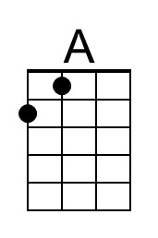
 | 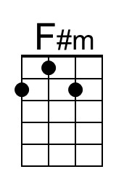
 | 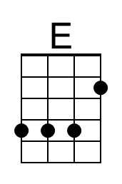
 | 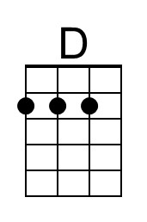
 | Bari
 | 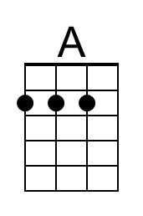
 | 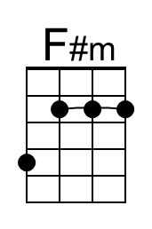
 | 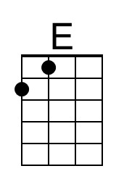
 | 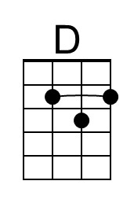

Stand By Me (Ben E. King, Jerry Leiber, Mike Stoller, 1961) (C)
Stand By Me by Ben E. King (1961) (A)
4/4 / 120 bpm

Intro C | C | Am G | Am | F | G C | C  C Am  When the night has come ___ and the land is dark.  F G C | C  And the moon is the only light we'll see.  C Am  No, I won't be afraid, no, I won't be afraid  F G C  Just as long as you stand, stand by me.  Chorus 1  C | C Am  So darling, darling, stand by me. Oh oh stand __ by me  F G C | C  Oh stand, __ stand by me __ stand by me.  C Am  If the sky that we look upon __ should tumble and fall  F G C | C  Or the mountains should crumble in the sea.  Am  I won't cry I won't cry, no I won't shed a tear,  F G C  Just as long as you stand, stand by me.  Chorus 2  C | C Am  And darling, darling, stand by me. Oh stand __ by me  F G C | C  Oh stand now, __ stand by me __ stand by me.  Instrumental Verse. Chorus 2.  Outro  C Am  When ever you're in trouble won't you stand by me,  F G C  Oh oh stand. stand by me stand by me.  F G C  Oh oh stand. stand by me stand by me. | 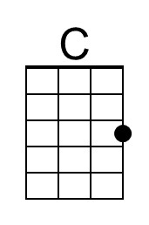
 | 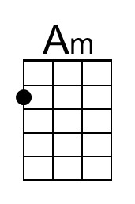
 | 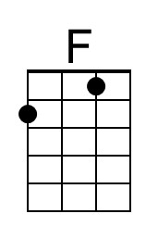
 | 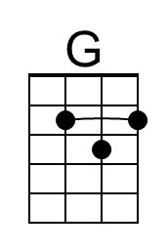
 | Bari
 | 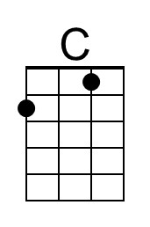
 | 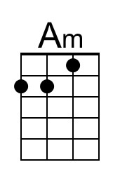
 | 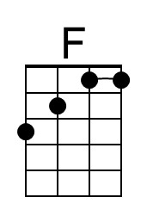
 | 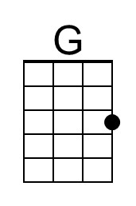

Stand By Me (Ben E. King, Jerry Leiber, Mike Stoller, 1961) (G)
Stand By Me by Ben E. King (1961) (A)
4/4 / 120 bpm

Intro G | G | Em D | Em | C | D G | G

G Em
When the night has come ___ and the land is dark.
C D G | G
And the moon is the only light we'll see.
G Em
No, I won't be afraid, no, I won't be afraid,
C D G
Just as long as you stand, stand by me.

Chorus 1
G | G Em
So darling, darling, stand by me. Oh oh stand __ by me
C D G | G
Oh stand, __ stand by me __ stand by me.

G Em
If the sky that we look upon __ should tumble and fall
C D G | G
Or the mountains should crumble in the sea.
Em
I won't cry I won't cry, no I won't shed a tear
C D G
Just as long as you stand, stand by me.

Chorus 2
G | G Em
And darling, darling, stand by me. Oh stand __ by me
C D G | G
Oh stand now, __ stand by me __ stand by me.

Instrumental Verse. Chorus 2.

Outro
G Em
When ever you're in trouble won't you stand by me,
C D G
Oh oh stand. stand by me stand by me.
C D G
Oh oh stand. stand by me stand by me.

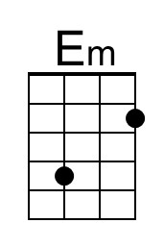
Bari
